Ref. 27/09/2024

Press Release
COPA elects Massimiliano Giansanti as its new President
Today, COPA elected Massimiliano Giansanti (Confagricoltura, Italy) as its new President, to lead the European farmers' organisation for the next two years. M. Giansanti steps into this role at a pivotal moment, as the EU's vision for its agricultural future is taking shape amid heightened concerns on the ground. Together with a team of six newly elected Vice-Presidents, M. Giansanti succeeds Christiane Lambert (FNSEA, France) who has led the organisation for the past four years.
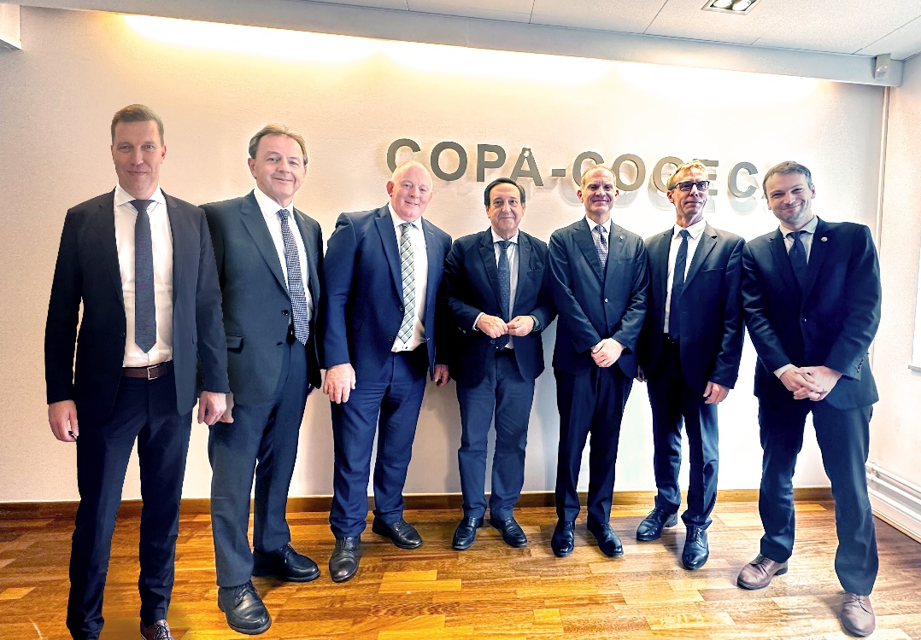
In his first statement following the election, Massimiliano Giansanti expressed: “I am deeply honoured by this vote of confidence and fully aware of the responsibilities of my presidency. The coming months in Brussels will be crucial on many fronts, starting with the presentation of the vision for agriculture and food as outlined by Ursula von der Leyen. We will also be keeping a close watch on any potential announcements from the Commission concerning advancements on trade agreements as Mercosur.”
Massimiliano Giansanti has been the President of Confagricoltura since 2017 and a Vice-President of Copa since 2020. As an agricultural entrepreneur, Mr. Giansanti manages farms with his family mainly producing cereal crops, kiwis, dairy products, and solar energy. Notably, he is a producer of Parmigiano Reggiano and a supplier of high-quality milk to the dairy processor Centrale del Latte di Roma.
Presenting his priorities, Mr. Giansanti addressed the representatives of farming organisations present today, stating: “My aim is to ensure that COPA’s voice is heard loud and clear, and that European institutions recognise the strategic importance of agriculture for our shared future. My presidency will focus on five key priorities: a strong CAP with an adequate budget, a fairer food chain, a coherent trade policy, a new approach to the Green Deal, and a strong emphasis on innovation. These priorities all have a common goal: to strengthen the income, competitiveness and attractiveness of our agriculture.”
Massimiliano Giansanti will be supported by the following six Vice-Presidents, who were also elected today: Nikolaus Berlakovich (LKÖ, Austria), Søren Søndergard (DAFC, Denmark), Franck Sander (FNSEA, France), Pedro Barato (ASAJA, Spain), Jan Doležal (AKCR, Czech Republic) and Francie Gorman (IFA, Ireland).
Outgoing Copa President, Christiane Lambert said “Over the past four years at the helm of COPA, I can see just how far we have come. We have contributed to a shift in the Commission's approach to agricultural issues, promoting a renewed focus on listening, bringing competitiveness back on the agenda and considering the realities faced by farmers. Yesterday's vote on wolf protection status is a prime example of this positive shift. I know Massimiliano Giansanti very well, having worked closely with him, and I am confident that under his leadership, alongside the new team, COPA will continue to be a strong advocate for European farmers!"

-END-
Translations will be available in DE, ES, FR, IT, PL and RO on the Copa-Cogeca website soon.
You will find further information on Massimiliano Giansanti’s biography and Vice-presidents HERE
Download HD pictures of Massimiliano Giansanti HERE
About us - Copa and Cogeca are the united voice of farmers and agri-cooperatives in the EU. Together, we ensure that EU agriculture is sustainable, innovative and competitive, while guaranteeing food security for 500 million people throughout Europe. >>> More information www.copa-cogeca.eu

For further information, please contact
Patrick Pagani  Deputy Secretary General  patrick.pagani@copa-cogeca.eu | Jean-Baptiste Boucher  Communication Director  +32 474 84 08 36  jean-baptiste.boucher@copa-cogeca.eu

Press Release Mailing List
Unsubscribe
Subscribe

