
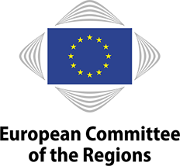
Speeding up the clean energy transition at local and regional level: the impact of the Fit for 55 package

Final Report
28 February 2025

© European Union, 2025
Partial reproduction is permitted, provided that the source is explicitly mentioned.

More information on the European Union and the Committee of the Regions is available online at http://www.europa.eu and http://www.cor.europa.eu respectively.

Catalogue number: ISBN: DOI:

This report has been prepared by Milieu Consulting SRL under Framework Contract No CDR/2021/B2/1/ENVE/1

The views expressed herein are those of the consultants alone and do not necessarily represent the official views of the European Committee of the Regions.

Main authors: Fernando Beamud, Fran Gallego, Margaux Truc, Mariya Gancheva, Martina Ravaglia, Panagiota Pavlou

Milieu Consulting SRL (Belgium),
Chaussée de Charleroi 112, B-1060 Brussels,
tel.: +32 2 506 1000;
web address: www.milieu.be
e-mail: mariya.gancheva@milieu.be and fernando.beamud@milieu.be
Table of contents
Summary 1
Introduction 3
1. Energy transition from LRAs perspective and overview of the Fit for 55 package 4
1.1 Energy transition before the Fit for 55 package 4
1.2 Overview of new provisions in the Fit for 55 package 7
1.3 EU instruments and mechanisms supporting local energy transition 11
2. Local and regional implementation: possible issues, opportunities and good practices 14
2.1 EU cities and regions implementing the revised legislation: possible issues and opportunities 14
2.2 Learning by doing: building on best practices in energy transition 20
3. Country factsheets 24
3.1 Austria 25
3.2 Belgium 26
3.3 Bulgaria 27
3.4 Croatia 29
3.5 Cyprus 30
3.6 Czechia 31
3.Challenges and barriers 32
3.7 Denmark 33
3.8 Estonia 34
3.9 Finland 35
3.10 France 36
3.11 Germany 38
3.12 Greece 39
3.13 Hungary 41
3.14 Italy 42
3.15 Ireland 43
3.16 Latvia 45
3.17 Lithuania 46
3.18 Luxembourg 47
3.19 Malta 48
3.20 The Netherlands 50
3.21 Poland 51
3.22 Portugal 52
3.23 Romania 54
3.24 Slovakia 55
3.25 Slovenia 56
3.26 Spain 57
3.27 Sweden 59
4. Policy recommendations for smooth implementation of energy transition under Fit for 55 legislation 61
4.1 Recommendations for EU institutions and national authorities 61
4.2 Recommendations for LRAs 63
List of references 66
Annex 1: EU funding and support mechanisms for the energy transition 77
Annex 2: Information from the stakeholder survey 87

List of tables
Table 1: Key implementation deadlines and obligations relevant for LRAs 10
Table 2: List of key EU financing sources for the clean energy transition 77
Table 3: Examples of support services for EU financing sources 84

List of figures
Figure 1: Share of renewable energy in the EU in the period 2014-2023 4
Figure 2: Final energy consumption in the EU in the period 2014-2023 5
Figure 3: Timeline of the key EU energy legislation and the EU climate targets 7
Figure 4: Role of LRAs in the implementation of the Fit for 55 package 11
Figure 5: EU funding available for LRAs to finance energy transition 13
Figure 6: Challenges for LRAs in the implementation of the Fit for 55 policies 19
Figure 7: Actions needed to improve the implementation of the Fit for 55 package at regional and local level 20
Figure 8: Percentage of renewable energy and FEC in 2023 by Member State 24
Figure 9: Overview of survey respondents by profile 87
Figure 10: Overview of respondents by country 88
Figure 11: Types of territories represented in the answers 88
Figure 12: Types of territories by country 89
Figure 13: Existence of a plan/strategy for implementation of the Fit for 55 package 90
Figure 14: Existence of a plan/strategy for implementation by type of territory 90
Figure 15: Existence of a climate neutrality target 91
Figure 16: Existence of a climate neutrality target by type of territory 91
Figure 17: Existence of a renewable energy strategy 92
Figure 18: Existence of a renewable energy target 93
Figure 19: Share of energy produced from renewable sources 93
Figure 20: Financial support for regional or local deployment of renewable energy 94
Figure 21: Existence of a strategy for renewable energy communities and self-consumption 95
Figure 22: Benefits of joining or supporting an energy community 96
Figure 23: Challenges for starting an energy community 97
Figure 24: Existence of plans to use renewable energy for heating and cooling in public buildings 97
Figure 25: Existence of plans for the roll-out of energy efficiency policies 98
Figure 26: Existence of an energy efficiency target 98
Figure 27: Financial support for implementing energy efficiency measures 99
Figure 28: Main causes of energy poverty 100
Figure 29: Measures for reducing energy poverty 101
Figure 30: Existence of an energy performance of buildings policy 101
Figure 31: Existence of energy performance of buildings target 102
Figure 32: Financial support for efficient building measures 103
Figure 33: Preparation for ZEB requirements 103
Figure 34: Reasons for not preparing for ZEBs 104
Figure 35: Participation of LRAs in clean energy initiatives 105

List of boxes
Box 1: Examples of OSS 20
Box 2: Examples of regional and local energy agencies and their work 21
Box 3: Examples of international cooperation projects 22

List of abbreviations
CAP | Common Agricultural Policy
CoR  CO₂ | European Committee of the Regions  Carbon dioxide
EAFRD | European Agricultural Fund for Rural Development
EED | Energy Efficiency Directive
EEEF | European Energy Efficiency Fund
EIB | European Investment Bank
EPBD | Energy Performance of Buildings Directive
EPC | Energy performance contracting
ERDF | European Regional Development Fund
ESCO | Energy services company
ESF+ | European Social Fund Plus
ETS | Emissions Trading System
EU | European Union
FEC | Final energy consumption
GHG | Greenhouse gas
JTF | Just Transition Fund
LRAs | Local and regional authorities
LTRS | Long-Term Renovation Strategy
Mtoe | Million tonnes of oil equivalent
NECP  NGO | National Energy and Climate Plan  Non-governmental organisation
NSCP | National Social and Climate Plan
NZEB | Nearly zero-energy building
OSS | One-stop shop
PEC | Primary energy consumption
PPP | Public-private partnership
RED | Renewable Energy Directive
RES | Renewable energy sources
RRF | Recovery and Resilience Facility
ZEB | Zero-energy building

Summary
This report examines the role of local and regional authorities (LRAs) in implementing the Fit for 55 package. The Fit for 55 package revises major European Union (EU) energy directives, such as the Energy Performance of Buildings Directive (EPBD), the Renewable Energy Directive (RED) and the Energy Efficiency Directive (EED). These all impose new obligations on LRAs, including stricter requirements for building renovations, expanded mandates for integrating renewable energy at local level, and binding energy efficiency targets for public sector buildings. In addition, LRAs are required to establish local heating and cooling plans, facilitate renewable energy communities, and ensure the implementation of municipal and regional energy transition strategies. The package also highlights the role of new and existing EU funds as key sources for financing the energy transition, including the Social Climate Fund, the European Regional Development Fund (ERDF), the Just Transition Fund (JTF) and Horizon Europe.

The complexity and scale of these new obligations amplify existing challenges for LRAs, notably financial resources, administrative capacity, local community engagement, and regulatory alignment with national governments. Further challenges stem from the complexity of implementing zero-energy building (ZEB) requirements and energy community provisions at local level. Nevertheless, the implementation of the Fit for 55 package offers LRAs the opportunity to advance green initiatives, with multiple co-benefits for tackling energy poverty and air pollution, and improving transport and spatial management. Multiple cities and regions across the EU are already taking action to advance the energy transition in their territories by supporting local energy communities, establishing one-stop-shops (OSS) for stakeholders, training staff and participating in international cooperation initiatives.

An analysis of Fit for 55 implementation across the Member States reveals significant disparities in LRA capacity, financial resources, and regulatory frameworks. Some Member States with decentralised governance structures provide LRAs with strong financial and policy support, enabling them to take a leading role in the energy transition. By contrast, Member States with centralised energy governance often lack well-defined local implementation frameworks, leaving municipalities without clear mandates. The findings highlight challenges and best practices from different regions, such as municipal energy renovation funds, cross-border energy communities, and local energy and climate plans. These examples illustrate how tailored financial instruments, local cooperation, and targeted capacity-building initiatives can accelerate Fit for 55 implementation.

Finally, the report offers targeted recommendations for policymakers:

EU and national policymakers should:
- Enhance LRA access to EU and national funding and streamline or simplify application procedures to ensure that all LRAs, irrespective of size, can access the funds necessary for the energy transition;
- Strengthen multilevel governance and improve coordination between national and local authorities to ensure that LRAs have clear roles in climate and energy governance and that their feedback is considered in the development of national strategies.
- Provide targeted support for human capacity-building and skills development within LRAs to ensure that they have the human resources and expertise to implement the energy transition.
- Strengthen social inclusion and ensure successful energy transition at local level by providing the necessary guidance and support to LRAs, encouraging the development of regional or local strategies, and mitigating the risks of social exclusion.

Local and regional policymakers should:
- Align local and regional energy strategies with Fit for 55 targets by integrating Fit for 55 objectives into local targets, energy policies and spatial planning;
- Accelerate renewable energy deployment by facilitating the creation of local (including municipal) energy communities and developing municipal-owned renewable energy infrastructure;
- Improve energy efficiency and accelerate building renovation by developing long-term renovation strategies for public buildings, establishing municipal renovation funds and encouraging innovative business models that allow the private sector to invest in energy efficiency;
- Ensure public engagement and community participation in the energy transition by providing information, advice and technical/financial support to local communities, and employing participatory decision-making processes that foster trust and transparency.

Introduction
The EU stands at the forefront of global efforts to combat climate change, having committed to becoming the first climate-neutral continent by 2050. Central to achieving this goal is the Fit for 55 package, a comprehensive set of legislative proposals designed to reduce net greenhouse gas (GHG) emissions by at least 55% by 2030, compared to 1990 levels. This package builds on and updates existing EU climate policies, offering new and more stringent measures across key sectors. LRAs play a pivotal role in the transition to climate neutrality, given their responsibility for implementing approximately 70% of the provisions in the Fit for 55 package. The legislation introduces revised frameworks for energy efficiency, renewable energy, and the energy performance of buildings, areas where LRAs are at the forefront of both policy execution and community engagement​. The success of these measures depends heavily on localised actions that align with the EU's broader climate objectives, as well as the ability of cities and regions to overcome challenges, such as aligning local capacity with new regulatory demands and securing financial and technical support for implementation.

This report examines the Fit for 55 package's impact on LRAs, particularly in energy efficiency, renewable energy, and energy performance of buildings. It highlights existing and newly established financial or technical support mechanisms and best practices and outlines policy recommendations to help LRAs to implement the legislative changes effectively. These insights aim to guide LRAs in overcoming barriers, maximising the opportunities presented by the green transition, and ensuring that the EU remains on track to meet its 2030 and 2050 climate targets.

The analysis is based on a review of literature, policy and legal documents, combined with stakeholder consultation through a survey of LRAs or networks of LRAs. A significant component of the report is the set of 27 country factsheets, which provide a comprehensive, country-by-country overview of the energy transition and Fit for 55 implementation in each Member State. Key findings from the survey are provided in the report and the country factsheets, with additional information in Annex 2.

- Energy transition from LRAs perspective and overview of the Fit for 55 package
This part outlines the key energy transition policies in the EU, together with the main changes introduced by the Fit for 55 package. Particular attention is paid to those changes that might have implications for LRAs’ role in the energy transition.

  - Energy transition before the Fit for 55 package
An important part of the EU’s energy transition approach relies on measures to improve energy efficiency and building performance and increase the use of renewable energy. The foundations were laid with the adoption of the 2020 climate and energy targets, which aimed for a 20% reduction in GHG emissions, 20% share of renewable energy, and 20% improvement in energy efficiency. These objectives were fulfilled (see Figures 1 and 2) and the EU defined more ambitious medium-term and long-term decarbonisation goals. With the adoption of the European Climate Law and the 2050 ambition for climate neutrality, the EU has set intermediate goals of a 55% reduction in GHG emissions, at least 42.5% renewable energy, and 11.7% improvement in energy efficiency by 2030. The Commission also issued a proposal for 2040 that includes a recommended target of 90% net GHG emissions reduction.
Figure 1: Share of renewable energy 2014-2023, EU-27
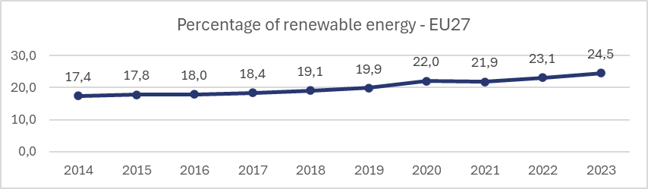
Source: Authors’ elaboration based on 2024 Eurostat data, Share of energy from renewable sources.

The key pieces of energy legislation that aim to deliver on these objectives are the EPBD (2002), the RED (2009), and the EED (2012). These directives have been revised multiple times to reflect the EU’s evolving climate and energy goals, ensuring that they remain robust and fit for purpose. One of the latest updates was in 2016-2019, with the ‘Clean energy for all’ package. This package revised and aligned the EPBD, RED, and EED with the enhanced 2030 climate objectives.
Figure 2: Final energy consumption (FEC), 2014-2023, EU-27
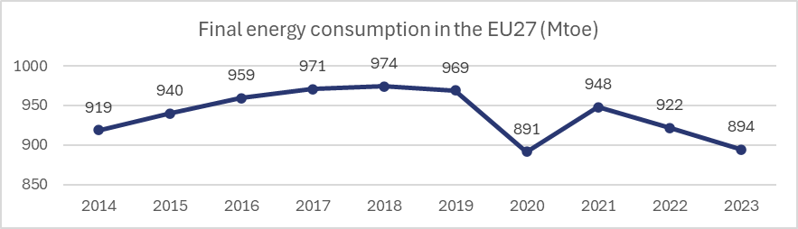
Source: Authors’ elaboration based on 2024 Eurostat data, Energy efficiency - final energy consumption.

The EPBD tackles the decarbonisation of the building sector and defines obligations for Member States to develop long-term renovation strategies (LTRS) to transform existing building stock into highly energy-efficient and decarbonised assets by 2050. It requires the adoption of nearly zero-energy building (NZEB) standards for new construction and encourages the renovation of the worst-performing buildings. Public buildings, in particular, should achieve exemplary energy performance.

The RED defines obligations for Member States to create enabling frameworks for renewable energy projects, including streamlined permitting processes and financial incentives for renewable energy sources (RES). The revised RED (RED II) sets out a binding target of 32% renewables in the EU energy mix by 2030. Member States are required to outline policies and support schemes for renewable energy deployment. It also promotes renewable energy use in heating and cooling systems and sets sub-targets for renewable energy in transport.

The EED requires Member States to implement policies (including financial instruments) that encourage energy efficiency across sectors, including transport, industry, and buildings. It establishes a binding target of 32.5% energy efficiency improvement by 2030. Member States are tasked with implementing energy savings obligations for energy suppliers and distributors, mandating energy audits for large enterprises, and encouraging efficiency improvements in public procurement and infrastructure projects.

The ‘Clean energy for all’ package sought to modernise energy markets, empower consumers, and enhance inclusivity through the recognition of energy communities. Regulated under the Electricity Market Directive, these communities enable citizens, businesses and local authorities to collectively generate, consume and trade renewable energy, fostering decentralised energy systems and strengthening local resilience. The package also introduced the Energy Governance Regulation, which plays a crucial role in ensuring that Member States contribute effectively to the EU’s collective climate and energy targets. It facilitates transparent collaboration between Member States while streamlining planning and reporting obligations to reduce administrative burdens, ensuring coherence between national strategies and EU-wide policies. It also requires Member States to development comprehensive national energy and climate plans (NECPs), outlining the national contributions to EU targets while addressing cross-cutting issues such as energy poverty through targeted measures. The Energy Governance Regulation has been adapted to enhance its effectiveness in meeting the EU’s evolving energy and climate objectives. Key revisions include the introduction of a more structured and integrated approach to planning, ensuring that national contributions are clearly aligned with EU targets.

The REPowerEU plan is a central element in the EU strategy to enhance energy security and accelerate the clean energy transition. Developed in response to disruptions caused by Russia’s war of aggression against Ukraine, the plan builds on the Fit for 55 framework to reduce dependence on Russian fossil fuels through a multifaceted approach. Key objectives include diversifying energy imports, increasing energy efficiency, and accelerating the deployment of RES. By fostering coordinated action among Member States and aligning national investments with EU-wide reforms, REPowerEU not only mitigates energy supply risks but also supports long-term climate neutrality goals.

Figure 3 presents a summary of the key moments in the timeline of the EU energy legislation and an overview of EU climate targets.
Figure 3: Timeline of key EU energy legislation and climate targets
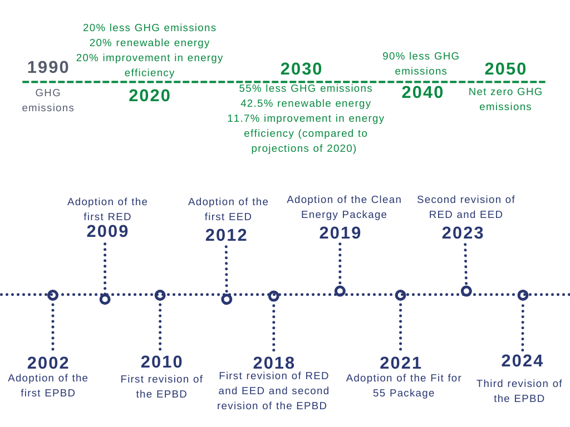
Source: Authors’ elaboration.

  - Overview of new provisions in the Fit for 55 package
Introduced in July 2021, the Fit for 55 package is the cornerstone of the EU's commitment to achieving its 2050 climate neutrality target. The package is distinguished by its integrated approach, which combines regulatory standards, market-based instruments, and support mechanisms to drive emissions reductions while fostering economic innovation and social cohesion. Unlike previous efforts, which often relied on sector-specific or incremental adjustments, the Fit for 55 package adopts a holistic framework to ensure coherence across the EU's climate and energy policies.

The implementation timeline for the Fit for 55 package is structured to ensure gradual but consistent progress toward the 2030 targets. The revised EPBD must be transposed by May 2026, setting the groundwork for ambitious building renovation targets. The updated RED (RED III), which entered into force on 20 November 2023, has an 18-month transposition period, with a deadline on July 2024 for provisions related to renewable permitting (Articles 15 and 16) and May 2025 for the rest. Similarly, the revised EED must be transposed by 11 October 2025, aligning national frameworks with the revised efficiency targets. The Hydrogen and Decarbonisation Package, with a transposition deadline in mid-2026, will facilitate the adoption of renewable and low-carbon gases, including hydrogen. Within this framework, LRAs are assigned a central role, with direct obligations that necessitate their active involvement.

Firstly, under the revised EPBD, Member States are required to develop national building renovation plans to reduce energy consumption in residential buildings. These plans must include clear trajectories for non-residential buildings and are to be developed in consultation with local governments, ensuring that LRAs play a central role in identifying priorities and implementing measures (Article 3). The EPBD also introduces obligations for public buildings, mandating that all new public buildings must meet ZEB standards by 1 January 2028 and all new buildings by 1 January 2030 (Article 7).

The EPBD stipulates that certain existing building roofs must be equipped with solar panels by 31 December 2027 for buildings with a floor area over 2,000 metres (m)², with scaled requirements for smaller buildings by 31 December 2030 (Article 10). New provisions for sustainable mobility infrastructure require all non-residential buildings with over 20 parking spaces to have at least one recharging point for every 10 parking spaces by 1 January 2027, while public buildings must be pre-cabled for 50% of parking spaces by 1 January 2033 (Article 14). It also mandates the establishment of OSS for building renovations, with a target of one shop per 80,000 inhabitants, to simplify access to information and support (Article 18). This provision is particularly relevant to LRAs, as they often manage or coordinate local services and can use these structures to ensure compliance and engage communities effectively.

Secondly, the revised EED reinforces the role of the public sector in setting a specific target for energy efficiency improvements. Public bodies, including local and regional governments, are required to achieve an annual reduction in energy consumption of 1.9% compared to 2021 data (Article 5) and renovate at least 3% of the total floor area of public buildings of over 250m² that are not nearly to nearly zero-energy standards as of 1 January 2024 (Article 6). These obligations place significant demands on LRAs to plan, finance, and execute energy-saving measures in public infrastructure such as include schools, hospitals, and municipal buildings. For buildings not owned by public bodies, the EED encourages negotiations on energy improvements during key moments, such as lease renewals, fostering cooperation between property owners and local authorities (Article 6).

Municipalities with populations exceeding 45,000 inhabitants must prepare local heating and cooling plans under the EED, supported by financial and technical assistance from Member States (Article 25(6)). These plans aim to integrate RES into district heating and cooling systems, reduce dependency on fossil fuels, and enhance the resilience of local energy systems. LRAs are not only implementers, but also strategic planners, requiring them to mobilise resources, engage stakeholders, and align local actions with national and EU-level targets.

Thirdly, RED III integrates renewable energy into urban and regional planning, requiring cities and regions to include RES in their energy strategies and actively promote renewable-based heating and cooling systems (Article 15). It encourages LRAs to establish energy communities, support self-consumption initiatives, and collaborate with network operators to ensure efficient integration of renewable energy into local grids (Article 15). It promotes public sector leadership, with provisions that allow third parties to use the roofs of public and mixed-use buildings for renewable energy production (Article 15). Member States are also required to map renewable energy deployment by 21 February 2026 and designate ‘renewables acceleration areas’ in coordination with LRAs (Article 15d). The identification of these areas aims to expedite project approval processes, together with the general provision that renewable energy projects are designated as being of ‘overriding public interest’ (Article 16), reducing administrative barriers.

The Hydrogen and Gas Decarbonisation Package establishes a streamlined and integrated legislative framework for accelerating the EU’s energy transition. Under the updated rules, LRAs contribute to 10-year network development plans (Article 55) for hydrogen and natural gas, ensuring site identification for infrastructure and supporting the repurposing of existing networks for hydrogen use. Likewise, hydrogen distribution network operators have the obligation to collaborate with LRAs to develop transparent, integrated network development plans every four years, ensuring system efficiency and alignment with local needs. These plans must consider data from the local heating and cooling plans mandated by Article 25(6) of the EED.

Table 1 summarises the key deadlines and obligations under the Fit for 55 package that are relevant for LRAs.
Table 1: Key implementation deadlines and obligations relevant for LRAs
Directive | Ongoing obligations | Specific obligations
RED III  Transposition by May 2025 | - Foster energy communities and self-consumption initiatives  - Collaborate on renewable-based heating and cooling systems | - Include renewables in energy strategies by May 2025  - Map renewable deployment and designate renewables acceleration areas by 21 February 2026  - Streamline permitting for renewables by July 2024 for projects of ‘overriding public interest’
EED  Transposition by October 2025 | - Achieve annual 1.9% reduction in energy consumption  - Negotiate energy efficiency improvements in private leases during key moments (e.g. renewals) | - Renovate at least 3% of total floor area of public buildings annually to NZEB standards  - Develop local heating and cooling plans for municipalities over 45,000 inhabitants
EPBD  Transposition by May 2026 | - Ensure collaboration on national building renovation plans  - Promote public engagement through OSS for building renovations | - Achieve ZEB status for all public buildings by 1 January 2028 and all new buildings by 1 January 2030  - Install solar panels on buildings with floor area over 2,000m² by 31 December 2027 and smaller roofs by 31 December 2030  - Pre-cable parking spaces for public buildings by 1 January 2033  - Submit the first draft building renovation plan with involvement of LRAs by 31 December 2025
Source: Authors’ elaboration.

Respondents to the survey for this study were given the opportunity to indicate the role they see for LRAs in implementing the package. The majority selected ‘Regions and cities play a central role in the implementation of all clean energy transition policies’, highlighting that the involvement of LRAs is crucial in driving climate and energy policies at sub-national level. The option ‘Regions and cities do not play a significant role as most implementation takes place at national level’ was selected in some countries where governance structures may limit local engagement (Croatia, Czechia, Romania, Slovakia, Slovenia). Some respondents indicated that LRAs have a more sectoral role (see Figure 4).
Figure 4: Role of LRAs in implementing the Fit for 55 package
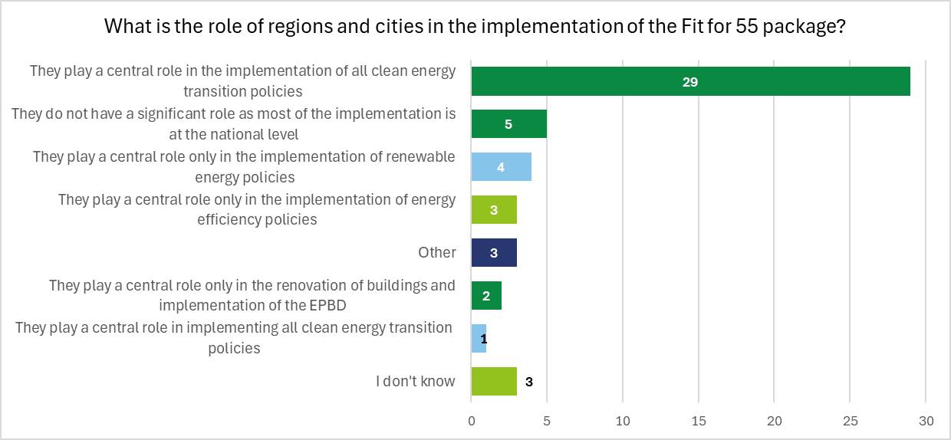
Source: Survey (n=50).

  - EU instruments and mechanisms supporting local energy transition
The EU provides a comprehensive set of funding instruments and mechanisms to support Member States and LRAs to achieve the goals set by the European Green Deal. Most traditional EU funding instruments have been revised to allocate specific percentages towards financing the green transition. New funding instruments have also been introduced to support these efforts.

Some new instruments will be financed with revenue generated from the auctioning of emission allowances under the EU Emissions Trading System (ETS). For example, the dedicated Innovation Fund and the Modernisation Fund will finance the green transition, including renewable energy and low-carbon technologies, and support innovation. Part of the ETS revenue will fund the Social Climate Fund, supporting energy-poor and transport-poor households to address the social impacts of carbon pricing in sectors such as buildings and transport. Member States are required to develop National Social Climate Plans (NSCPs), detailing measures and investments to support vulnerable households, micro-enterprises, and transport users. These plans should be submitted to the European Commission by June 2025, following consultations with LRAs, social partners, and civil society, and disbursements will be contingent on the achievement of specified milestones and targets. The Carbon Border Adjustment Mechanism will also contribute additional resources to the ETS (and potentially the funds it finances) by placing a carbon price on certain imported goods, helping to prevent carbon leakage and incentivising cleaner production outside the EU.

More traditional funding sources for the energy transition include funds financed by the EU budget. This includes Cohesion Policy funds, such as the ERDF (which can fund energy-efficient projects), the European Social Fund Plus (ESF+) (which can support skills development in the energy transition), and the JTF (which targets regions transitioning to low-carbon economies). In addition, Horizon Europe provides supports for clean energy research and innovative projects, such as the EU’s 100 Climate-Neutral and Smart Cities Mission, which aims to support 100 cities to become climate-neutral by 2030 and serve as models for others to follow by 2050. The European Investment Bank (EIB) complements this initiative by offering substantial financial support covering up to 50% of project costs. That EIB support can be particularly valuable for LRAs as it includes tailored loans and guarantees, as well as technical assistance for large-scale projects. EIB funding often acts as a catalyst, attracting additional public and private investment.

Figure 5 presents a summary of key instruments and mechanisms available to LRAs to finance the energy transition, with further details in Annex 1.
Figure 5: EU funding available for LRAs to finance energy transition
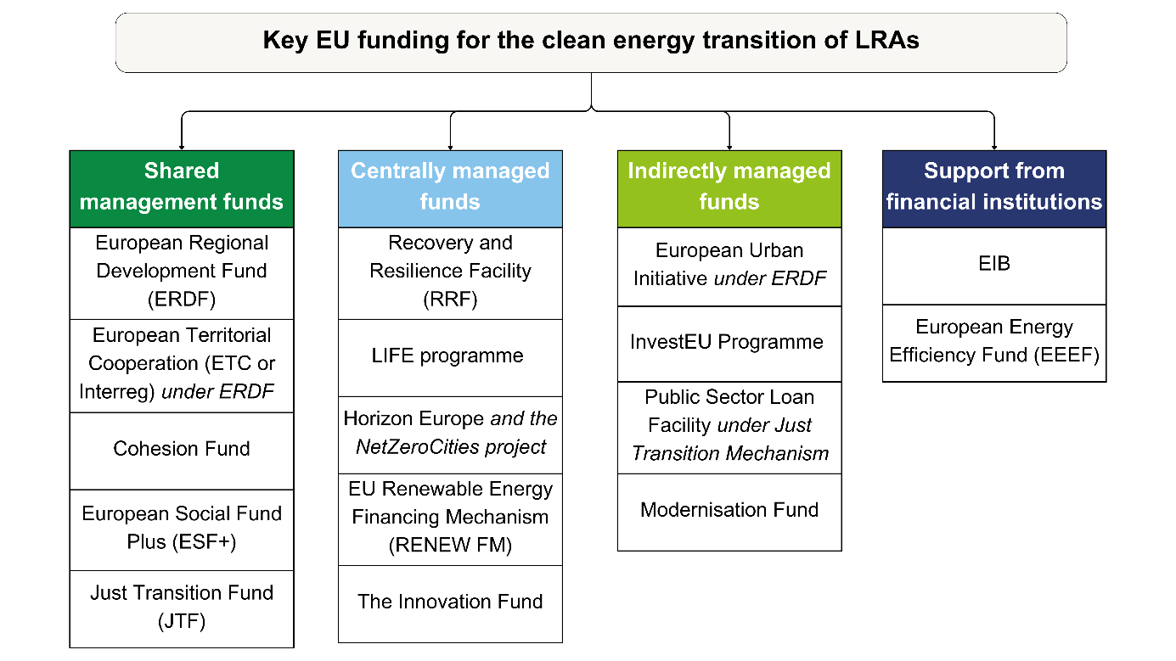
Source: Authors’ elaboration.
Note: Includes the funds that LRAs can access and are most relevant; additional funds (e.g. Social Climate Fund) may also be relevant but only in certain circumstances (see Annex 1).
- Local and regional implementation: possible issues, opportunities and good practices
This part describes possible issues, opportunities and good practices in the implementation of the Fit for 55 package for cities and regions, based on the literature review and survey results for this study.

  - EU cities and regions implementing the revised legislation: possible issues and opportunities
Energy-related policies and initiatives often extend their impact beyond the immediate sector, influencing broader domains such as urban planning, housing, social equity, and economic development. This is supported by the integration of spatial planning with energy strategies, emphasising the alignment of land use, infrastructure, and mobility systems to reduce energy demand. These policies also tackle systemic issues such as energy poverty and disaster risk management, reflecting the interconnected nature of urban resilience and economic development within the energy transition. For instance, improving energy efficiency in buildings contributes to reducing energy poverty, while advancing renewable energy projects can drive job creation and foster innovation in local economies,. The concept of affordable energy is central to these efforts. The European Commission's 'Action Plan on Affordable Energy' is scheduled for presentation on 26 February 2025, as part of the Clean Industrial Deal. The plan outlines measures to reduce energy costs for citizens, businesses, and industries across the EU while promoting decarbonisation and strengthening the Energy Union. It addresses the high energy costs affecting European competitiveness and energy poverty, proposing actions to lower energy bills, increase energy efficiency, and enhance the integration of clean energy sources. Similarly, urban resilience strategies addressing climate risks, such as flooding or extreme heat, often integrate energy considerations with infrastructure and land-use planning. Waste management and circular economy principles also play a significant role, emphasising resource efficiency and sustainability alongside decarbonisation. The energy transition thus represents an opportunity not only to tackle decarbonisation needs but to establish synergies with social, transport, urban, and other policies.

Despite these opportunities, the energy transition faces a number of challenges. A central issue is the inefficiency of the EU’s building stock, with 75% categorised as energy inefficient. This contributes significantly to energy consumption and emissions, exacerbating energy poverty for around 40 million Europeans unable to heat their homes properly, with over 10% spending more than 40% of their income on housing. Vulnerable populations, especially those in rural areas and low-income urban neighbourhoods, face challenges such as rising energy costs and risks of displacement due to so-called ‘renovictions’, after energy upgrades increase rents​. The need to tackle the energy performance of buildings is heightened by the more frequent occurrence of extreme events such as heatwaves, floods and droughts. These events underscore the critical need for cities to integrate disaster risk reduction strategies into their energy policies, ensuring that infrastructure is resilient to future risks, and that energy poverty considers not only heating but also cooling needs.

Securing adequate funding remains a challenge for municipalities tasked with implementing energy transition measures. While EU support is available, these funds remain underutilised for renewable energy investments. Accessing available funding mechanisms often proves complex, with municipalities facing administrative burdens, stringent co-financing requirements, and capacity limitations that hinder their ability to use these resources effectively​​. Smaller municipalities often lack the administrative capacity and expertise to navigate the intricate procedures required to access EU funding. This creates a reliance on external consultants to prepare plans and financing strategies, adding delays and costs and further straining local resources. The coordination of multiple funding streams, including regional, national, and EU programmes (whose timelines are not always adapted to local financing needs), poses additional hurdles for municipalities with limited capacity. Simplified funding application procedures, enhanced technical assistance, and integrated financing strategies are essential to bridge this gap.

Governance misalignment poses a significant challenge to the energy transition, particularly in bridging the gap between national strategies and local realities, which are often underrepresented in national decision-making processes. This disconnection is sometimes compounded by inconsistencies in consultation practices, which often lack depth or are rushed to meet administrative deadlines. This lack of inclusion creates inefficiencies, as national strategies frequently fail to consider the specific socioeconomic and geographical contexts of local areas. The absence of genuine collaboration can lead to policies that are not only misaligned with local priorities but also difficult to enforce effectively​​. The fragmentation of responsibilities across governance levels also exacerbates coordination issues. Many LRAs operate within a complex regulatory environment, where overlapping mandates and insufficient clarity in roles hinder cohesive action, .

Municipalities face significant challenges in building the human capacity necessary to drive the energy transition. Workforce shortages are a critical bottleneck, with many local governments struggling to recruit and retain skilled professionals such as energy analysts, project managers, and urban developers. This issue is compounded by uncompetitive public sector salaries and the difficulty of attracting candidates with specialised expertise in areas like energy infrastructure and climate planning​​. The scale of the problem is substantial: by 2030, European municipalities will need to recruit an estimated additional 214,000 full-time employees to meet the demands of decarbonising the building sector and implementing energy transition projects. Smaller municipalities are particularly disadvantaged, as their limited budgets and administrative capacity make it challenging to create new positions or invest in long-term staffing strategies​​.

Finally, public engagement continues to pose a significant challenge in the energy transition, as insufficient communication and inadequate stakeholder inclusion often result in resistance to energy projects. Many LRAs struggle to involve communities meaningfully in decision-making, with consultations frequently limited to formalities rather than opportunities for genuine input. This can foster distrust, particularly when citizens feel excluded from decisions that directly affect their neighbourhoods and livelihoods​​. The European Commission is working on a Citizens Energy Package that will provide a coherent approach to empower citizens and provide new guidance and tools to promote public engagement.

The technical complexity of energy projects further complicates engagement efforts. Many initiatives are communicated in ways that are inaccessible to the public, leaving communities unsure of the benefits or wary of potential risks. Marginalised groups, including those experiencing energy poverty, are particularly likely to be left out of these processes, as socioeconomic barriers limit their ability to participate. EU networks such as the Covenant of Mayors and the European Climate Pact are actively working to enhance communication strategies and strengthen public engagement. Without clear, inclusive communication, scepticism and resistance to energy transition policies can undermine project success​​.

The Fit for 55 package introduces additional complexity to the energy transition by setting ambitious decarbonisation targets that impose significant demands on municipalities, businesses, and citizens, requiring rapid adjustments in governance, financial systems, and technical capacity. One of the most significant challenges stems from the EPBD, which mandates that all new public buildings meet ZEB standards by 2028 and extends this requirement to all new buildings by 2030. Retrofitting existing structures to comply with minimum energy performance standards is particularly daunting, given the high financial costs and technical expertise required to undertake such projects. Smaller municipalities with limited budgets and administrative capacity often face disproportionate difficulties in managing deep renovations and implementing large-scale renewable energy systems​.

The integration of renewable energy communities presents another layer of complexity. These grassroots initiatives aim to decentralise energy production, enhance public engagement, and strengthen local energy resilience. However, fragmented regulatory frameworks, insufficient financial incentives, and limited public awareness significantly hinder their scalability and alignment with national strategies. This challenge intersects with the provisions in the Electricity Market Directive (Directive (EU) 2019/944), which introduces the concept of citizen energy communities. Notably, Article 16 establishes the right to energy sharing, empowering communities to generate, consume and share energy collectively.

The Fit for 55 package imposes stringent energy savings obligations through the EED, requiring municipalities to achieve annual incremental energy savings of 1.9% by 2030. Meeting this requirement places substantial demands on data collection and monitoring systems, which are often underdeveloped at municipal level.

While the Social Climate Fund aims to mitigate the regressive impacts of carbon pricing on vulnerable populations, the administrative capacity required to design, implement and monitor socially inclusive projects remains limited, particularly in municipalities with fewer resources. This creates barriers to ensuring equitable access and addressing the needs of marginalised communities.

According to survey respondents, the most commonly cited challenge for LRAs to implement the Fit for 55 package is insufficient financial resources, followed by insufficient technical capacity. A lack of specific regional or local plans for implementation and insufficient support from the central government were also identified as barriers, indicating gaps in strategic planning and coordination at subnational level.
Figure 6: Challenges for LRAs in implementing the Fit for 55 policies
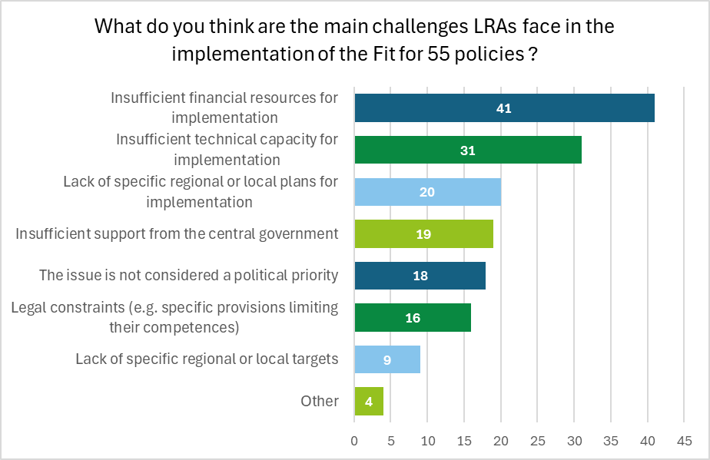
Source: Survey (n=50).
Note: Respondents who selected ‘Other’ pointed to a lack of competence and knowledge about the directives, or permitting challenges.

Respondents were asked to identify key actions that could improve the implementation of the Fit for 55 package at regional or local level. The results highlight several priorities, with financial and capacity support emerging as the most critical needs, underlining the significant financial and capacity constraints faced by LRAs. A support mechanism for vulnerable citizens was also identified by many respondents, highlighting the need for socially inclusive policies to ensure that the transition to clean energy does not disproportionately affect disadvantaged communities.
Figure 7: Actions to improve implementation of the Fit for 55 package at regional and local level
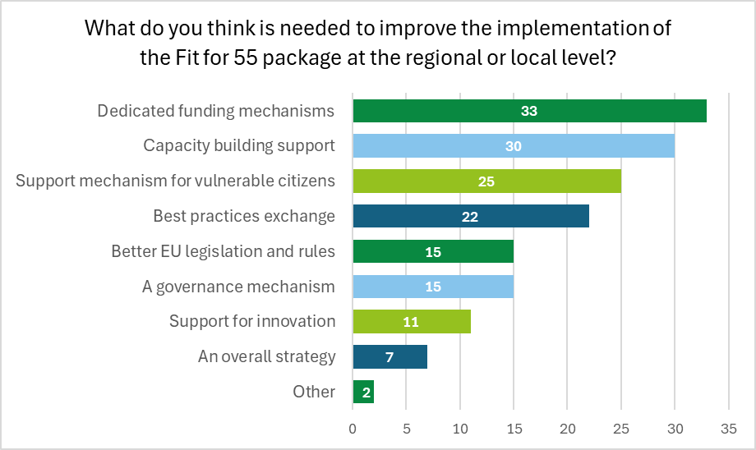
Source: Survey (n=50).

  - Learning by doing: building on best practices in energy transition
Addressing the challenges in implementing the Fit for 55 package requires a multi-pronged approach that incorporates innovative solutions, strategic investments, and inclusive governance. Among the key instruments for achieving these goals are OSS, which serve as bridges between policy frameworks and local-level implementation. They have the potential to transform ambitious targets into actionable results, addressing barriers while fostering trust and cooperation with the local community. OSS are growing rapidly, as outlined in Box 1 and the country factsheets (see section 3).
Box 1: OSS
The Netherlands
Energie Samen demonstrates how a decentralised model can support energy communities through tailored assistance. By working with regional and provincial organisations, or directly assisting communities, Energie Samen ensures tailored support aligned with local political and regulatory contexts. Its services encompass legal and organisational assistance, financing advice, and direct funding, as well as provision of liability insurance through partnerships with financial institutions. It offers management software for its members and capacity-building programmes through its training academy, covering topics such as energy coaching, heating districts, and renewable project management. Energie Samen has supported 345 energy communities since 2018. Its emphasis on aligning local needs with broader national policies provides a replicable framework for integrating energy transition goals into diverse contexts.
Ireland
Electric Ireland Superhomes is an OSS dedicated to home energy renovations. It supports homeowners at every stage of their home energy retrofits, including retrofit design, funding and project implementation (e.g. by providing retrofit specialists that offer guidance and quality assurance). The goal is to ensure that renovations result in low-carbon homes thanks to complete house retrofits (e.g. insulation, advanced ventilation) and installation of renewable energy heat pumps. Established in 2021, the OSS is a joint venture between Tipperary Energy Agency’s Superhomes and Electric Ireland. It builds on pioneering OSS efforts of the Tipperary Energy Agency since 2015, and targets over 30,000 home retrofits by 2030.

Having the right skills and resources to develop regional and local strategies, as well as successful projects, is another important pre-condition for the energy transition at all governance levels. Ensuring that sufficient staff are available and trained within regional and local administrations is vital for both strategic planning and practical implementation of specific projects. Regional and local energy agencies can also provide specialised expertise, as shown in Box 2 and the country factsheets (see section 3).
Box 2: Regional and local energy agencies and their work
Austria
The Energy and Environment Agency of Lower Austria provides technical advice to regional authorities, municipalities, and citizens for renewable energy projects and energy efficiency measures. Its participatory approach integrates stakeholder input early in the decision-making stages, ensuring transparency and mitigating resistance to change. The region of Lower Austria exemplifies how strategic planning and consultation can align local action with national energy and climate goals. For example, the measures in the 2021-2025 Climate and Energy Programme were developed in collaboration with the Climate Protection Project Group, which manages interdisciplinary priorities and promotes stakeholder engagement for achieving climate neutrality.
Germany
The Kommunalrichtlinie programme provides municipalities with funding to support local energy and environmental projects by enabling the temporary hiring of staff. It focuses on assisting municipalities to implement energy transition initiatives, offering resources for one full-time employee per municipality. However, the programme's two-year funding period creates challenges for long-term planning and staff retention, as municipalities must reapply frequently to maintain positions. This short-term approach adds administrative burdens and highlights the need for more sustainable funding mechanisms to address staffing needs in the energy transition.

Important elements of EU energy transition policy include strengthening the role of community energy and combating energy poverty. Advancing the energy transition, from the creation of energy communities and OSS, through carrying out assessment, to combating energy poverty, requires deep understanding of local issues and expertise to implement innovative solutions. While there might be few one-size-fits-all solutions, LRAs can learn from one another. International projects and initiatives for cooperation and knowledge-sharing are important ways to build capacity, develop skills and test different approaches. EU funds are an important source for international cooperation and learning though capacity-building initiatives (see Box 3 and Annex 1).
Box 3: International cooperation projects
IN-PLAN
The Integrated Energy, Climate and Spatial Planning (IN-PLAN) project aims to enable LRAs to effectively implement their sustainable energy, climate, and spatial plans. Funded by the LIFE Programme and implemented by a mix of city networks and local energy agencies, the initiative aims to: integrate energy and climate with spatial planning to ensure a cohesive strategy​​; secure commitment at all political levels through vertical integration, and harmonisation of strategies across governance levels; and link plans to dedicated budgets to ensure practical feasibility and long-term sustainability of measures​. A vital part of IN-PLAN is its capacity-building programme based on a two-step approach: 1) engage 15 LRAs to co-create, implement and refine the IN-PLAN practice, guidelines and capacity-building programme, with 30 additional authorities piloting the practice; and 2) train the trainers and pass knowledge to other LRAs.
POWERPOOR
The POWERPOOR project, financed by Horizon 2020 and implemented by a consortium including local energy agencies and city networks, is a comprehensive initiative to combat energy poverty by empowering local governments and communities to provide targeted support to vulnerable households. By establishing local OSS for vulnerable households, POWERPOOR enables access to energy-saving technologies, funding opportunities, and renewable energy initiatives. Its emphasis on collaboration between municipalities, health and social services, and energy communities ensures tailored strategies that address the unique needs of energy-poor populations. This approach not only advances social equity but also integrates energy poverty alleviation into broader climate and energy transition strategies in different countries.
Handbook on Cross-Border Energy Communities
In January 2025, the European Commission published a Handbook on Cross-border Energy Communities that provides step-by-step guidance for developing cross-border energy communities. It specifically informs and aids local actors, policymakers and stakeholders to understand the legal, technical and administrative challenges of cross-border energy initiatives. It highlights the multiple benefits of cross-border energy communities, such as economic efficiencies, job creation, enhanced energy independence, and reduced carbon footprints and energy costs, supported with evidence from examples such as Calorie Kehl-Strasbourg and Zusamme Solar! Colmar.
- Country factsheets
This part presents country factsheets on the implementation of the Fit for 55 package in each Member State. Figure 8 presents an overview of the state of renewable energy and FEC in 2023.
Figure 8: Percentage of renewable energy and FEC, by Member State, 2023
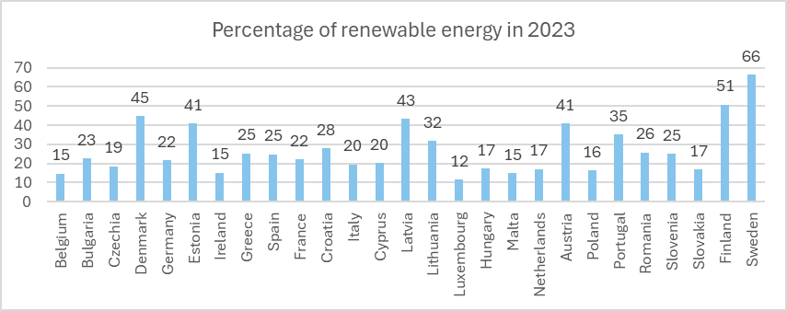
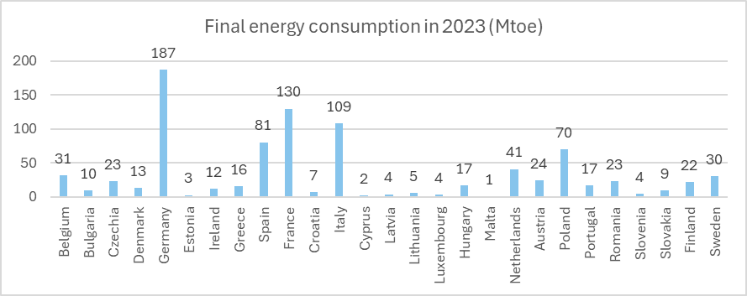
Source: Authors’ elaboration based on 2024 Eurostat data, Share of energy from renewable sources and Energy efficiency - final energy consumption.

Each factsheet provides a short overview of the energy transition progress, based on the 2024 country fiches of the State of the Energy Union report. They also include information on the key energy transition targets and measures based on the updated NECPs (draft or final updated plans available as of December 2024 and the related Commission assessments). Finally, the factsheets describe specific challenges for LRAs and examples of good practice, based on the literature review and survey results for this study.
  - Austria
Austria
1. Overview
The State of the Energy Union fiche indicates that:
- In 2022, renewable energy was 34.7% of the energy mix and 79.1% of the electricity mix;
- In 2022, PEC was 30.2 million tonnes of oil equivalent (Mtoe), 4.6%, and FEC was 26.3 Mtoe, both lower than 2021;
- In 2023, 5.5% of the population experienced difficulties paying their utility bills, while 3.9% were unable to keep their homes adequately warm during cold periods.
The final updated NECP sets out the following targets:
- 2030 renewable energy target: 57%;
- 2030 energy efficiency targets: PEC 25.9 Mtoe; FEC 22 Mtoe.

2. Local and regional implementation
- Renewable energy
Austria is a federal state. Legislative competence across the various sectors is shared between the federal government and the provinces (Länder). In the energy sector, the basic legislation is set at federal level, with implementing legislation at provincial level. Cooperation and dialogue between the two governmental levels is a crucial aspect of the implementation of the updated Austrian NECP.
In addition to the federal targets, Länder have their own climate and energy targets, set out in strategic plans. A platform has been created for continuous dialogue and coordination between federal and provincial administration. The two government levels actively work together to achieve national and Länder targets.
- Energy efficiency
One survey respondent noted that Austria has developed a structured approach to energy efficiency, with local, regional and national plans closely interconnected. LRAs are actively engaged in the implementation phase of energy efficiency policies, which align with strategies and plans at all levels of governance.
Financial support is available for energy efficiency measures, including EU funding from instruments such as the Social Climate Fund, alongside grants and loans for households to enhance energy efficiency.
- Energy performance of buildings
Länder have strategies for building performance, with specific measures and instruments being discussed. In addition to national law, Länder have building codes that are also relevant for the transposition of the EPBD.

3. Challenges and barriers
One survey respondent noted that LRAs in Austria face significant challenges in implementing the Fit for 55 policies, primarily due to insufficient financial resources. Financing the measures required to achieve climate and energy targets remains a critical barrier, compounded by limited personnel capacity to organise and manage implementation effectively.
Another notable challenge is the lack of political willingness to enact or adapt the necessary legislative frameworks, which delays progress and creates uncertainty for local action. LRAs often lack the technical expertise and capacity-building support to navigate the complexities of these policies.

4. Best practices and success stories
Austria has a strong commitment to tackling energy poverty and improving building efficiency, particularly through targeted initiatives in Vienna. To alleviate the impact of rising energy costs, Vienna introduced the Vienna Energy Bonus ’23 and the Wärmefonds (Heating Fund). These initiatives provide financial support to help low-income households to manage soaring energy bills and heating costs during the winter months​​.
For longer-term solutions, Vienna launched the EU-funded RenoBooster project, facilitating residential retrofitting by connecting property owners with certified contractors and service providers. Its Quality Platform streamlines renovation processes by offering financial and technical guidance, promoting large-scale energy efficiency improvements in the housing sector.

  - Belgium
Belgium
1. Overview
The State of the Energy Union fiche indicates that:
- In 2022, renewable energy was 11.2% of the energy mix and 27.2% of the electricity mix;
- In 2022, PEC was 45.2 Mtoe, 7.2% lower than 2021, while FEC was 33.4 Mtoe, 6.8% lower than 2021;
- In 2023, 3.7% of the population experienced difficulties paying their utility bills, while 6.0% were unable to keep their homes adequately warm during cold periods.
The draft updated NECP sets out the following targets:
- 2030 renewable energy target: 21.7%;
- 2030 energy efficiency targets: PEC 36.5 Mtoe; FEC 29.9 Mtoe.

2. Local and regional implementation
- Renewable energy
Belgium is a federal state with three regions. Competence for energy and climate-related matters are divided between federal and regional authorities. Regions have their own renewable targets, with an internal cooperation agreement determining the contributions of each party to 2030 targets being discussed as a priority. However, local authorities are key partners in the establishment and achievement of climate/energy objectives in all regions. Local initiatives include climate plans or strategies set out by municipalities (e.g. Local Energy and Climate Pact in Flanders; Action Plan of Wallonia).
- Energy efficiency
Regions have their own targets and objectives for energy efficiency and municipality plans include measures for energy efficiency. The Brussels government officially affirmed that without the active cooperation of local municipalities, its climate objectives will not be met. According to regional laws, climate measures are to be tackled by local authorities to the extent possible if they are to be most effective.
- Energy performance of buildings
Renovation building plans are set out by local governments with the support of regional authorities. Regional forms of support includes a technical and financial support programme designed to reduce energy consumption in Brussels buildings (RenoClick).

3. Challenges and barriers
Three survey respondents noted that LRAs in Belgium face significant challenges in implementing the Fit for 55 package due to insufficient technical capacity and limited financial resources. Some LRAs claim to lack the necessary knowledge, skills and staff to effectively contribute to the implementation of EU provisions, particularly in building renovations, energy efficiency, and renewable energy deployment.
Regulatory constraints exacerbate the problem, restricting the flexibility of public entities in selecting financing options and hampering the scaling of innovative solutions. The absence of well-integrated regional plans and specific local targets also complicates efforts, particularly in aligning public sector building data with broader energy and mobility strategies.

4. Best practices and success stories
The Flemish Local Energy and Climate Pact empowers municipalities to tackle climate challenges through measurable targets, aiming to establish one renewable energy community per 500 residents by 2030. These communities collectively own and manage renewable energy systems, including solar farms and wind turbines, supported by smart grid technologies. The 100 Neighbourhoods Platform fosters discussion and exchange of practices and guides municipalities to realise the various objectives of the Plan.
Homegrade Brussels serves as a comprehensive OSS supporting residential energy renovations in the Brussels-Capital region. As a key component of the regional Renolution programme, it provides energy audits, insulation guidance, and renewable technology advice, while a digital platform facilitates grant applications, bridging the digital divide.

  - Bulgaria
Bulgaria
1. Overview
The State of the Energy Union fiche indicates that:
- In 2022, renewable energy was 13.8% in the energy mix and 19.1% in the electricity mix;
- In 2022, PEC was 18.9 Mtoe, 2% higher than 2021, while FEC was 9.9 Mtoe, 2.7% lower than 2021;
- In 2023, 17.8% of the population experienced difficulties paying their utility bills, while 20.7% were unable to keep their homes adequately warm during cold periods.
The final updated NECP sets out the following targets:
- 2030 renewable energy target: 34.96%;
- 2030 energy efficiency targets: PEC 13.1 Mtoe.

2. Local and regional implementation
Generally, LRAs, and especially municipalities, are responsible for investments and infrastructural work in local energy projects, and for carrying out energy efficiency policy in municipal buildings, public hospitals and schools.
- Renewable energy
Local authorities will develop and implement schemes to promote the use of renewable energy. Proposed revisions to the Renewable Energy Act include: 1) establishment of administrative service centres in each municipality to provide information on the procedures to develop facilities for RES, storage, heat pumps, connection to the electrical grid and the heat transfer network; 2) limitation of the term for issuing a building permit (required under the Spatial Planning Act and usually issued by the Chief Architect of the municipality) to no more than one month for solar energy facilities (up to 20 kW), including for prosumers and renewable energy communities.
- Energy efficiency
Regional and municipal administrations implement training programmes and various measures to raise consumers’ awareness of their use of electricity, heat and natural gas, and the benefits of implementing energy efficiency measures. Initiatives include the creation of consumer councils, a consumer day, and campaigns in regional and municipal centres. Municipalities will implement one of the measures included in the updated NECP on energy-efficient municipal outdoor artificial lighting systems.
- Energy performance of buildings
The updated NECP outlines several measures to improve the energy efficiency of the building stock, including multi-family residential buildings, commercial buildings and municipal buildings. Municipalities are responsible for implementing these measures in municipality-owned buildings. They also accept and evaluate applications from co-owners of residential buildings who apply for public funding and monitor the implementation of the works. The mayor of each municipality is responsible for the implementation of the entire process of renovation of residential buildings in their territory and for the selection of contractors in accordance with the Public Procurement Act for the implementation of individual activities in the buildings.

3. Challenges and barriers
One of the main challenges in improving energy efficiency, including in buildings, at local level is varying access to funding and national supports. LRAs have complained about the implementation of the national programme for energy efficiency, particularly the criteria and processes for selecting the residential buildings that receive support for renovations. Despite the availability of substantial resources from different funds, including EU funds, not all applications have been accepted, slowing the renovation process. The lack of stability in overall implementation of the energy efficiency programme has also been criticised.

4. Best practices and success stories
The Asenovgrad One-Stop-Shop (OSS) was established in 2020-2021 under the EU-funded UP-STAIRS project to support the creation of citizen energy communities in multi-family residential buildings, particularly those with energy-poor households. The OSS provides end-to-end assistance, including financial guidance, technical support, and legal-administrative facilitation for establishing owners’ associations. It has played a key role in securing funding and promoting inclusive financing mechanisms, ensuring that vulnerable households benefit from energy efficiency improvements.

  - Croatia
Croatia
1. Overview
The State of the Energy Union fiche indicates that:
- In 2022, renewable energy was 28% of the energy mix and 63.5% of the electricity mix;
- In 2022, PEC was 8.2 Mtoe, 0.4% higher than 2021, while FEC was 6.9 Mtoe, 1.1% lower than 2021;
- In 2023, 11.6% of the population experienced difficulties paying their utility bills, while 6.2% were unable to keep their homes adequately warm during cold periods.
The draft updated NECP sets out the following targets:
- 2030 renewable energy target: 42.5%;
- 2030 energy efficiency targets: PEC 8.14 Mtoe; FEC 6.55 Mtoe.

2. Local and regional implementation
- Renewable energy
Targeted campaigns and educational measures on the benefits and the use of renewable energy are planned (e.g. educational programmes in schools; accredited university programmes). Initiatives to complete and strengthen the legal framework are also set out, with a view to encouraging energy-sharing and the establishment of renewable energy communities.
- Energy efficiency
Regional and local self-government units define climate-related measures for their territory through strategic planning. These measures positively contribute to the reduction of energy consumption.
- Energy performance of buildings
To encourage decarbonisation of buildings, the Croatian government established the Open Partner Dialogue, a forum that fosters dialogue and brings together representatives of state and local government, but also the academic community and professionals in the construction and energy sectors.

3. Challenges and barriers
Two survey respondents noted that LRAs in Croatia face a range of barriers in implementing the Fit for 55 policies, including insufficient financial resources and complex access to EU funds. According to stakeholders, a considerable number of LRAs rely heavily on external financing and co-financing, but limited administrative capacities, such as a lack of professional staff and cumbersome bureaucratic processes, hinder their ability to apply for and manage these funds effectively.
A lack of coordination between sectors and between local authorities and the central government further complicates implementation efforts. The outdated technical infrastructure and an incomplete legislative framework, without clear guidelines at all governance levels, limit the ability of LRAs to act decisively. Short-term political interests and the influence of various interest groups also pose challenges to long-term planning.

4. Best practices and success stories
The Programme for Combating Energy Poverty in Residential Buildings in Assisted Areas and Areas of Special State Concern for the Period Until 2025 targets energy renovation and installation of RES. Its scope encompasses 387 out of 413 analysed residential buildings owned and managed by the Central State Office for Reconstruction and Housing Care, in which residents are unable to participate in financing necessary repairs, especially energy renovation.

  - Cyprus
Cyprus
- Overview
The State of the Energy Union fiche indicates that:
- In 2022, renewable energy was 13.7% of the energy mix and 16.8% of the electricity mix;
- In 2022, PEC was 2.5 Mtoe, 7.4% higher than 2021, while FEC was 1.8 Mtoe in 2022, 7.7% higher than 2021;
- In 2023, 9.0% of the population experienced difficulties paying their utility bills, while 16.9% were unable to keep their homes adequately warm during cold periods.
The final updated NECP sets out the following targets:
- 2030 renewable energy target: 28.8%;
- 2030 energy efficiency target: PEC 2.03 Mtoe; FEC 1.8 Mtoe.

2. Local and regional implementation
- Renewable energy:
The NECP highlights the involvement of cities and local authorities across various sectors, including decarbonisation, energy efficiency, transport and renewables. However, Cyprus has not yet established a formal multilevel energy and climate dialogue, such as an annual green transition conference.
- Energy efficiency
Public building renovations aim for 3% annual upgrades from energy class E to B, although inclusions like public transport are unspecified. The NECP describes a mix of energy efficiency obligation schemes and alternative measures, but lacks detailed savings quantifications. A draft LTRS, updated in May 2023, proposes over 40 measures for building upgrades, digital platforms, and regulatory reforms. These include developing a digital OSS platform that streamlines the entire process of renewable energy and renovation projects, connecting building owners, financial institutions, and service providers to foster economic growth and enhance sectoral collaboration.
- Energy performance of buildings
One survey respondent noted that Cyprus is actively implementing policies to enhance the energy performance of buildings. Renewable energy is being integrated into heating and cooling systems for public buildings and energy efficiency policies are in the rollout phase. Financial support for cities and regions is available through EU and private funds. A policy on the energy performance of both residential and non-residential buildings is in place and aligned with national-level strategies and plans.

3. Challenges and barriers
One survey respondent noted that LRAs’ implementation of the Fit for 55 package is hindered by two primary challenges: limited technical capacity and restricted financial resources. Many authorities lack access to skilled personnel with the expertise necessary to plan, implement and oversee green transition initiatives.
Securing financing is another critical obstacle, as the current systems for accessing affordable and accessible funding are insufficient. This limitation makes it difficult for LRAs to commit to long-term investments, which, in practice, could hinder the achievement of Fit for 55 objectives.

4. Best practices and success stories
With over 3,300 hours of sunlight annually, Cyprus has the highest solar energy potential in the EU. In 2021, solar power accounted for 9% of the country’s total energy generation and played a key role in the 15% contribution of renewables. Photovoltaic (PV) technology is central to Cyprus's renewable energy efforts, with over 17,000 PV systems installed through initiatives such as net metering and self-consumption schemes, contributing over 65 MW to the energy grid.

  - Czechia
Czechia
1. Overview
The State of the Energy Union fiche indicates that:
- In 2022, renewable energy was 13.5% of the energy mix and 12% of the electricity mix;
- In 2022, PEC was 38.6 Mtoe, 2.3% lower than 2021, while FEC was 24.9 Mtoe, 4.5% lower than 2021;
- In 2023, 1.9% of the population experienced difficulties paying their utility bills, while 6.1% were unable to keep their homes adequately warm during cold periods.
The final updated NECP sets out the following targets:
- 2030 renewable energy target: 30%;
- 2030 energy efficiency targets: PEC 28.8 Mtoe; FEC 20.2 Mtoe.

2. Local and regional implementation
- Renewable energy
Renewable energy is promoted through territorial planning, facilitating the involvement of local authorities and the reduction of administrative requirements. The government plans to provide financial support to municipalities to encourage the use of renewables in the transport sector.
- Energy efficiency
Municipalities and cities are gradually becoming aware of their pollution impact and have started setting out their voluntary commitments to reduce emissions and enhance energy efficiency. Municipalities are also obliged to carry out energy audits to evaluate and introduce energy efficiency measures. Financial support has been provided for projects to improve energy efficiency of public lighting systems in cities and municipalities.
- Energy performance of buildings
Only larger municipalities develop long-LTRS for buildings in the public sector, while renovations in smaller municipalities take place on an ad-hoc basis. Subsidies are the main source of funding. The NECP indicates that more than three-quarters of municipalities benefit from subsidies.

3.Challenges and barriers
Renewables development is still in the early stages in Czechia. Energy from PV power plants is increasing, but efforts are needed to boost wind energy production and the grid’s ability to manage flexibility needs to be strengthened. There is a lack of local planning: heat production, for example, is highly centralised, but effective decarbonisation and building energy efficiency planning needs to take local needs into account.

4. Best practices and success stories
The New Green Savings Programme, managed by the State Environmental Fund of the Czech Republic, is a flagship initiative supporting energy efficiency and renewable energy in residential buildings. Since its launch, the programme has provided financing support measures such as thermal insulation, passive house construction, solar energy systems, and green infrastructure. The scheme also promotes environmentally friendly heating solutions, including heat pumps, biomass boilers, and wastewater heat recovery. The programme reduces CO₂ emissions, improves housing quality, and boosts the economy. Applications are open until 30 June 2025, or until funds are exhausted.

  - Denmark
Denmark
1. Overview
The State of the Energy Union fiche indicates that:
- In 2022, renewable energy was 44.7% of the energy mix and 83.6% of the electricity mix;
- In 2022, PEC was 16 Mtoe, 2.2% lower than 2021, while FEC was 13.3 Mtoe, 3.8% lower than 2021;
- In 2023, 4.7% of the population experienced difficulties paying their utility bills, while 6.9% were unable to keep their homes adequately warm during cold periods.
The final updated NECP sets out the following targets:
- 2030 renewable energy target: 30%;
- 2030 energy efficiency targets: PEC 28.8 Mtoe; FEC 20.2 Mtoe.

2. Local and regional implementation
- Renewable energy
A number of initiatives were launched to enhance planning processes and expand onshore renewables in municipalities. Financial and technical supports encourage good practices, while measures to streamline and facilitate processing for renewable energy source projects are also set out.
- Energy efficiency
To promote the use of energy services in the public sector, an OSS website has been set up with guidance on how energy services companies’ (ESCO) projects work. Campaigns are also being developed to guide municipal bodies. Municipalities and regions can borrow money for energy efficiency measures from Kommunekredit, the Danish credit institution financing local development and municipal green transition.
- Energy performance of buildings
Under the 2022 Climate Agreement on Green Power and Heat, municipalities were required to draw up heating plans and send information on future green heating options to oil and gas pipe owners in areas currently equipped with gas. On the basis of those heating plans, common and district heating companies have started working on concrete projects, with the ambition to be completed by 2028.
In the Agreement for the Economy of Municipalities 2023 (ØA23), municipalities agreed to try to meet the same requirements as state administration in relation to the renovation and/or energy pair requirement of public buildings. Regions have also set targets, such as a reduction of 75 % of GHG emissions from building operations and transport.

3. Challenges and barriers
One survey respondent noted that LRAs in Denmark encounter several challenges in implementing the Fit for 55 package, including insufficient financial resources, legal constraints limiting their competences, and inadequate support from the central government. These issues create a fragmented framework for the green transition, impeding local action and innovation.
A crucial barrier is the reliance on traditional business models rooted in the fossil economy, which are unsuitable for designing strategies aligned with the goals of the green transition. This mismatch underscores the need for a paradigm shift in how economic models are developed and implemented to achieve climate neutrality.

4. Best practices and success stories
The financial market for dedicated green loans functions well in Denmark. Municipalities can easily borrow via Kommunekredit, a credit institution dedicated to local development and green transition at local and regional level.
To promote the use of energy services in the public sector, the SaveEnergy website has been set up as an OSS. It contains information on how to improve energy consumption, with dedicated sections for municipal actions. It also provides guidance on ESCO projects, as a financing model for major energy renovation, commonly used by municipalities. It is a flexible model which can adapt to different situations, but the principle is that energy renovations are financed through energy savings.

  - Estonia
Estonia
1. Overview
The State of the Energy Union fiche indicates that:
- In 2022, renewable energy was 28.4% of the energy mix and 33.3% of the electricity mix;
- In 2022, PEC was 4.7 Mtoe, 6.1% higher than 2021, while FEC was 2.8 Mtoe, 1.9% lower than 2021;
- In 2023, 4.6% of the population experienced difficulties paying their utility bills, while 4.1% were unable to keep their homes adequately warm during cold periods.
The draft updated NECP sets out the following targets:
- 2030 renewable energy target: 65%;
- 2030 energy efficiency targets: PEC 5.13 Mtoe; FEC 2.59 Mtoe.

2. Local and regional implementation
- Renewable energy
Estonia has recently implemented measures to facilitate energy transition in municipalities and islands. Measures include grants from the Estonian government for local bodies and authorities to develop local, regional and county-level climate and energy plans. The NECP indicates that half of Estonia’s local authorities and major cities have Local Energy and Climate Plans, which include targets on energy savings and renewable energy. The largest islands (Hiumaa, Saaremaa, Muhu, and the municipality of Vorms) have also developed Clean Energy Islands (CE4EUI).
- Energy efficiency
The renovation rate for public buildings is set at 3% by the central government. Specific requirements for the purchase of products, services and buildings with high energy efficiency are set out for the central government authorities. Regional and local authorities are encouraged to follow the same obligations by the central authorities’ sharing best practices and promoting specific activities.
Municipalities participate in energy cooperatives (i.e. energy communities).
- Energy performance of buildings
Financial aid is provided for renovations of small and multi-dwelling buildings that improve energy efficiency, especially in those municipalities/areas where the value of property is lower.

3. Challenges and barriers
Although Estonia is slightly above the EU average for energy poverty, its development strategies do not consider this a standalone issue and no specific mitigation measures are implemented.

4. Best practices and success stories
The establishment of the EISEA has already shown some positive results. It provides advice for municipalities on the renovation of public buildings, finding district heating and public transport solutions, and establishing energy cooperatives. Currently, 12 projects were set to be implemented by the end of 2024, creating primary energy savings and reducing carbon dioxide emissions (CO₂). For example, EISEA is supporting the municipality of Kihnu with the renovation of a public school building with the most efficient energy solutions possible.
TalTech (Tallin University of Technology) partnered with local municipalities and some private companies to create an energy cooperative. The objective was to provide citizens with a pilot that would inspire them to create other energy cooperatives and show them how to reduce dependence on large energy power plants.

  - Finland
Finland
1. Overview
The State of the Energy Union fiche indicates that:
- In 2022, renewable energy was 42.2% of the energy mix and 54.3% of the electricity mix;
- In 2022, PEC was 30.2 Mtoe, 4.1% lower than 2021, while FEC was 23.3 Mtoe, 6.4% lower than 2021;
- In 2023, 7.4% of the population experienced difficulties paying their utility bills, while 2.6% were unable to keep their homes adequately warm during cold periods.
The final updated NECP sets out the following targets:
- 2030 renewable energy target: 62%;
- 2030 energy efficiency targets: PEC 31 Mtoe (forecast) and FEC of 20.6 Mtoe.

2. Local and regional implementation
- Renewable energy
According to two survey respondents, Finland is in the implementation phase of its renewable energy strategy, with different cities and municipalities adopting various plans and strategies, depending on their specific regional needs and priorities. LRAs receive financial support for renewable energy deployment from both EU and national funds. Key funding sources include the JTF, which assists regions to transition away from fossil fuels, funding under the Alternative Fuels Infrastructure Regulation implementation, and national support schemes.
- Energy efficiency
The NECP notes that voluntary energy efficiency agreements between the government and industry or municipalities play an important role in meeting 2030 energy efficiency objectives.
- Energy performance of buildings
Since October 2020, the phasing-out of oil heating in buildings owned by municipalities has been accelerated with grants, which are increased by 5% if the municipality becomes part of a Voluntary Energy Efficiency Agreement. Such agreements are an important part of Finland’s energy and climate strategy since the 1990s, using cooperation between the Government and industrial/municipal associations as a tool to fulfil EU energy efficiency objectives.

3. Challenges and barriers
Three survey respondents noted that the implementation of the Fit for 55 package presents unique challenges for LRAs, given Finland’s large size, sparse population, and significant regional disparities in resources and conditions. The insufficient financial resources available to municipalities, coupled with limited support from the central government, hampers their ability to invest and implement climate measures effectively.
Rigid and overly detailed regulations present a significant obstacle, as they fail to accommodate local conditions or allow LRAs to prioritise the efficient, tailored solutions. This lack of flexibility can lead to inefficient spending and delays in achieving climate targets. Gaps in technical capacity and a shortage of skilled personnel further constrain LRAs’ ability to implement green initiatives.

4. Best practices and success stories
The city of Lappeenranta is a leader in sustainability, being committed to carbon neutrality by 2030 and actively promoting energy-efficient building renovations. Through the RenoWave project, the city supports homeowners and housing associations to upgrade multi-apartment buildings by providing an OSS model for renovation planning, financing, and implementation.

  - France
France
1. Overview
The State of the Energy Union fiche indicates that:
- In 2022, renewable energy was 14.6% of the energy mix and 24.7% of the electricity mix;
- In 2022, PEC was 205.6 Mtoe, 8.6% lower than 2021, while FEC was 138.5 Mtoe, 3.1% lower than 2021;
- In 2023, 7.5% of the population experienced difficulties paying their utility bills, while 12.1% were unable to keep their homes adequately warm during cold periods.
The final updated NECP sets out the following targets:
- 2030 renewable energy target: 41%;
- 2030 energy efficiency target: PEC 158.6 Mtoe; FEC 106.9 Mtoe.

2. Local and regional implementation
- Renewable energy
The NECP’s efforts to streamline renewable energy projects include mapping areas for renewables and accelerating permitting procedures, with support for local authorities. Projections show that renewable electricity will reach 35% by 2030, with solar power becoming the main source, while wind power capacity will double by 2030. An OSS has been established to support project planning and permitting.
- Energy efficiency
In France, the Energy Efficiency Obligation Scheme dedicates over 30% of its savings to energy poverty, offering targeted measures such as energy advice for vulnerable households. Other key measures include the energy voucher (MaPrimeRénov) subsidy scheme for energy renovations and zero-interest eco-loans (ecoPTZ).
- Energy performance of buildings
Preparations are underway for public building renovations and energy performance improvements, with financial support planned for regional and local authorities. The NECP lacks detail on the targeted reduction in energy consumption by public bodies but outlines a new energy savings obligation scheme to deliver savings. It does not increase the ambition of France’s 2020 LTRS, but commits to renovating 600,000 dwellings annually, focusing on the worst-performing buildings. New measures include a ban on renting thermal sieves, energy efficiency improvements for non-residential and public buildings, and a regulation on NZEB.

3. Challenges and barriers
According to two survey respondents, LRAs in France face several challenges in implementing the Fit for 55 package. The most significant barriers are insufficient technical capacity and limited financial resources, which hinder their ability to plan and execute projects effectively. The absence of specific regional or local plans aligned with the package's objectives creates a lack of direction, while legal constraints on LRAs’ competences reduce their autonomy in key areas.
There is considerable local opposition to wind energy projects (‘not in my backyard’), driven by concerns about oversaturation in some regions. This resistance complicates the deployment of renewable energy infrastructure and underscores the need for enhanced communication and public engagement strategies to build support for the energy transition.

4. Best practices and success stories
Grenoble Alpes exemplifies France’s leadership in renewable energy by combining its historical strength in hydroelectric power with innovations in hydrogen and solar energy. As the country’s top hydroelectric region, it operates 38 power plants, providing a strong renewable energy base. The region has also positioned itself as a key hub for hydrogen technology, fostering industrial development. Grenoble is advancing solar energy by equipping 100% of eligible parking lot roofs.

  - Germany
Germany
1. Overview:
The State of the Energy Union fiche indicates that:
- In 2022, renewable energy was 18.7% of the energy mix and 44.8% of the electricity mix;
- In 2022, PEC was 260.6 Mtoe, 4% lower than 2021, while FEC was 202.8 Mtoe, 2.5% lower than 2021;
- In 2023, 5.4% of the population experienced difficulties paying their utility bills, while 8.2% were unable to keep their homes adequately warm during cold periods.
The final updated NECP sets out the following targets:
- 2030 renewable energy target: 41%;
- 2030 energy efficiency target: PEC 193.6 Mtoe; FEC 155.5 Mtoe.

2. Local and regional implementation
- Renewable energy
Four survey respondents noted several programmes and tools supporting renewable energy initiatives. For instance, the state energy agency provides intensive advice, helps with self-organisation, and offers legal support and guidelines. The Renewable Energies Service Centre offers resources and assistance for renewable energy projects. A state network for citizen energy has been established to promote community participation. Local heating networks, community energy cooperatives, and neighbourhood solutions also contribute to renewable energy efforts.
- Energy efficiency
Programmes and tools to reduce energy poverty and improve energy efficiency include the Federal Ministry for the Environment and Consumer Protection Electricity Saving Check, which targets low-income households by sending energy-saving helpers for direct support. Other initiatives promote municipal energy planning over the privatisation of subsidised energy measures. The energy-saving check by Caritas and the Federal Association of Energy and Climate Protection Agencies also contributes to these efforts.
- Energy performance of buildings
Programmes to improve the energy performance of buildings focus on sustainable construction materials, financial incentives and regulatory measures. Policy efforts should promote the use of recycled carbonated concrete to enhance circularity and reduce environmental impact, with public procurement and building permit conditions prioritising sustainable materials. The STARKIII programme supports energy efficiency in buildings at state level. Funding is available for specific measures in existing buildings, but is often limited to heating replacement and lacks strong social differentiation. The KfW efficiency house subsidy provides financial support for energy-efficient construction and renovation.

3. Challenges and barriers
Four survey respondents noted that LRAs in Germany face numerous challenges in implementing the Fit for 55 package, chiefly insufficient technical capacity, limited financial resources, and a lack of specific local plans and targets. These barriers are exacerbated by legal constraints, as the energy transition is not classified as a mandatory municipal task, leaving its financing and implementation dependent on voluntary action by local authorities. This situation undermines the systematic and equitable progress needed for the green transition.
The absence of strategic and operational frameworks hinders LRAs in translating national and EU-level goals into actionable local initiatives. The shortage of personnel and expertise further complicates these efforts, while challenges in gaining public acceptance, particularly for renewable energy projects, slow implementation.

4. Best practices and success stories
Urban heating and cooling systems are prioritised through the Municipal Centre for Heat Planning, which supports cities to transition to sustainable energy sources. The Centre employs advanced data-driven tools and regional heat maps to guide municipalities in aligning heating and cooling infrastructure with locally available renewable energy. By identifying optimal locations for district heating networks and geothermal energy, municipalities can reduce dependence on fossil fuels and enhance energy efficiency. Collaboration between municipalities, regional authorities and stakeholders ensures that heat planning aligns with local conditions and long-term energy transition goals.

  - Greece
Greece
1. Overview
The State of the Energy Union indicates that:
- In 2022, renewable energy was 17% of the energy mix and 42.8% of the electricity mix;
- In 2022, PEC was 20.9 Mtoe, 2.9% higher than 2021, while FEC was 16.1 Mtoe, 6.2% higher than 2021;
- In 2023, 32.9% of the population experienced difficulties paying their utility bills, while 19.2% were unable to keep their homes adequately warm during cold periods.
The final updated NECP sets out the following targets:
- 2030 Renewable energy target: 44%;
- 2030 Energy efficiency target: PEC 17.8 Mtoe; FEC 15.4 Mtoe.

2. Local and regional implementation
- Renewable energy
Greece is implementing renewable energy strategies at local and regional level, but two survey respondents highlighted inconsistencies in planning and execution: both confirmed that renewable energy strategies are in the implementation phase, but one indicated no connection to broader plans, while the other linked it to regional strategies. Similarly, one respondent confirmed an active plan for renewable energy use in heating and cooling public buildings, while the other stated there was no such plan.
- Energy efficiency
Responses on energy efficiency targets and financial support are somewhat inconsistent. One survey respondent stated that there is no specific local or regional target, but contributions are made to the national goal without reporting obligations. Another highlighted the lack of awareness (even among energy professionals) as a major challenge in implementing the EED, and emphasised the need for capacity-building programmes and information campaigns. The other respondent provided no input on the issue.
- Energy performance of buildings
The Greek draft updated NECP outlines milestones and measures for the LTRS, with detailed goals for 2030, 2040 and 2050, covering residential and service sector buildings. The 2030 targets show increased ambition compared to the 2020 NECP, including a rise in the yearly renovation rate for residential buildings (from 1% to 1.4%), improved energy savings (from 70% to 76%), and an increase in heat pump adoption (from 7% to 17%). The draft also includes a 3% annual renovation obligation for public buildings but lacks details on floor area targets and energy consumption reductions for public bodies.

3. Challenges and barriers
According to two survey respondents, financial constraints are a major hurdle, with many LRAs operating under tight budgets that have been further impacted by prolonged economic difficulties. This limits their ability to invest in renewable energy, energy efficiency, and other green transition measures.
A lack of technical expertise and trained personnel further hampers progress, as LRAs struggle to manage climate policies, sustainable urban planning, and energy transition projects. This administrative capacity gap leads to delays and fragmented decision-making, particularly due to misalignment between local, regional, and national strategies. Complex permitting processes and frequent changes in national regulations create uncertainty, deterring long-term planning and project execution.

4. Best practices and success stories
The Crete Renewable Energy Valley is a pioneering initiative showcasing community-led renewable energy integration. By leveraging the island’s rich solar and wind resources, the project promotes decentralised energy solutions that enhance local energy independence and sustainability. A key success factor is its emphasis on community ownership, enabling residents to collectively invest and manage solar PV systems and wind turbines. This model ensures that energy production benefits households, businesses and public facilities, while keeping economic gains within the community. It also incorporates education and capacity-building programmes, equipping residents with the necessary technical skills to manage renewable energy systems effectively.

  - Hungary
Hungary
1. Overview
The State of the Energy Union fiche indicates that:
- In 2022, renewable energy was 14.3% of the energy mix and 22.1% of the electricity mix;
- In 2022, PEC was 23.9 Mtoe, 4.3% lower than 2021, while FEC was 18.3 Mtoe, 4.1% lower than 2021;
- In 2023, 7.3% of the population experienced difficulties paying their utility bills, while 7.2% were unable to keep their homes adequately warm during cold periods.
The final updated NECP sets out the following targets:
- 2030 Renewable energy target: 29%;
- 2030 Energy efficiency target: FEC 17.9 Mtoe; no target reported for PEC.

2. Local and regional implementation
- Renewable energy
According to one survey respondent, Hungary is in the design phase of its renewable energy strategy, which is being developed in coordination with national-level plans. While LRAs support deployment, their efforts remain closely tied to national frameworks. Financial support for renewable energy projects is available through both EU and national funds, with funding channels including sectoral operational programmes, interregional collaborations, and transnational initiatives.
- Energy efficiency
According to one survey respondent, Hungary is also in the design phase of its energy efficiency strategy, which aligns with national policies. However, while a formal energy efficiency target has been set, there is no monitoring system in place to track progress. LRAs receive financial support from both EU and national funds to implement efficiency measures, but their effectiveness is hindered by limited local autonomy.
- Energy performance of buildings
According to one survey respondent, Hungary does not have a dedicated regional or municipal energy performance policy for buildings, as local authorities implement national regulations directly. While there is an energy performance target, it is not accompanied by a monitoring system, making it difficult to assess progress at local level. Hungary is not actively preparing for the requirement that all new public buildings by 2028 and all new buildings by 2030 must meet ZEB standards. This lack of preparation is attributed to reliance on national regulations, technical challenges, funding shortages, and insufficient expertise in ZEB implementation.
3. Challenges and barriers
Energy efficiency has not been a primary focus in Hungary's energy policy. The residential sector accounts for 32% of the country's total FEC, primarily for heating, but renovations are delayed by low energy prices and insufficient financial incentives. As a result, a significant portion of the building stock remaining outdated and energy inefficient.
A substantial portion of Hungary's building stock was constructed before 1980, adhering to low energy performance standards. To meet the 2050 climate targets, 70-90% of these buildings require renovation. However, the current rate of energy efficiency renovations is impeded by legal, technical, and financial barriers that need to be addressed to unlock investment potential.

4. Best practices and success stories
The municipality of Budapest has developed an innovative online solar map, providing the first-ever estimation of the solar potential of every rooftop in the city. This interactive tool allows residents and businesses to assess how much energy they could generate and how much money they could save by installing solar panels on their buildings. The project also plays a crucial role in Budapest’s broader energy transition by serving as an educational tool, raising awareness of the benefits of solar energy, while supporting municipal planning by estimating the city’s total solar energy potential.

  - Italy
Italy
1. Overview
The State of the Energy Union fiche indicates that:
- In 2022, renewable energy was 20% of the energy mix and 36.5% of the electricity mix;
- In 2022, PEC was 139.6 Mtoe, 4.1% lower than 2021, while FEC was 111.7 Mtoe, 2.7% lower than 2021;
- In 2023, 4.1% of the population experienced difficulties paying their utility bills, while 9.5% were unable to keep their homes adequately warm during cold periods.
The final updated NECP sets out the following targets:
- 2030 renewable energy target: 39.4%;.
- 2030 energy efficiency targets: PEC 123 Mtoe; FEC 102 Mtoe.

2. Local and regional implementation
- Renewable energy
According to the Italian constitutional structure, regions have a key role in achieving energy and climate objectives. The role of local authorities is equally important.
Regions develop their energy plans, defining energy objectives (including use of renewables) in line with the national targets and the Decree on Burden-sharing. Local plans are also developed by municipalities.
- Energy efficiency
A mechanism is in place to encourage public administrations to adopt measures that increase energy efficiency and produce thermal energy from renewable sources (Conto Termico). The initiative is particularly successful in the renovation of public buildings, with an update currently underway. The National Fund for Energy Efficiency supports energy efficiency interventions by entities and public administration, especially for buildings, production facilities and processes.
- Energy performance of buildings
The energy performance certificate of buildings is managed by regions, each of which has its own regulations and plans for building renovation.

3. Challenges and barriers
The division of competence between state and region is a recurring challenge in the Italian framework. Regions are competent to regulate energy matters within the limit of the general scheme set by the state, resulting in a variety of sources, rules and practices. There is room to improve coordination between the central government and local authorities, removing overlaps and competitiveness.

4. Best practices and success stories
The Green Energy Community in Bologna is a collaborative, community-driven model for tackling energy poverty and promoting renewable energy adoption. It unites residents, businesses and academic institutions to foster a low-carbon economy and strengthen local resilience. Its strategy centres on decentralised renewable energy production, particularly through solar panels, to meet local demand. The inclusive approach ensures broad community participation, demonstrating how local engagement and collective renewable energy generation can address energy poverty while advancing Fit for 55 objectives.

  - Ireland
Ireland
1. Overview:
The State of the Energy Union indicates that:
- In 2022, renewable energy was 13.6% of the energy mix and 39.8% of the electricity mix;
- In 2022, PEC was 14.2 Mtoe, 3.7% higher than 2021, while FEC was 12 Mtoe, 4.7% higher than 2021;
- In 2023, 7.6% of the population experienced difficulties paying their utility bills, while 7.2% were unable to keep their homes adequately warm during cold periods.
The final updated NECP sets out the following targets:
- 2030 renewable energy target: 43%;
- 2030 energy efficiency target: PEC 11.3 Mtoe; FEC 10.4 Mtoe.

2. Local and regional implementation
- Renewable energy
Ireland is committed to meeting its obligations under RED III and has introduced a range of policies and measures to promote the expansion of renewable energy. At local and regional level, implementation efforts increasingly focus on community engagement and decentralised renewable energy production. Climate Action Regional Offices play a key role in supporting local authorities to scale-up climate action, including public awareness initiatives and local energy planning.
- Energy efficiency
The Climate Action Plan is Ireland’s overarching framework for achieving energy efficiency objectives, aligning with the requirements of the EED. The government has committed to implementing the Energy Efficiency First Principle, ensuring that efficiency measures are prioritised in planning, policy, and investment decisions. Ireland is assessing how to integrate this principle into planning, public spending and energy infrastructure governance, and its transposition into national law is expected by October 2025.
- Energy performance of buildings
The NECP reiterates 2030 targets from Ireland’s LTRS, such as retrofitting 500,000 homes to Building Energy Rating B2, installing 600,000 heat pumps (400,000 in existing buildings), and advancing social housing retrofits. No updates to key LTRS elements or milestones are included, but long-term retrofit goals for 2050 target 1.5 million houses retrofitted.

3. Challenges and barriers
According to Ireland’s final updated NECP, delayed infrastructure development is a key barrier, especially for offshore wind projects, which cannot be constructed within the short timeframes needed to align with the Governance Regulation. Similarly, the district heating sector remains underdeveloped, accounting for less than 1% of heat consumption. Structural barriers, including a historic reliance on fossil fuel heating systems, lack of dedicated policy and legislation, and the absence of pipe networks, continue to hinder progress.

4. Best practices and success stories
The Sustainable Energy Authority of Ireland provides large-scale financing and capacity-building programmes to support energy communities in their renewable energy and energy efficiency initiatives. Their activities include the Sustainable Energy Communities Programme, the Renewable Electricity Support Scheme and Community Energy Grants. A key feature is the development of Energy Master Plans with local authorities to assess energy scenarios, relevant technologies, and project pipelines for communities. Capacity-building is an important element of support: through its mentorship programme, the Authority pairs energy communities with dedicated experts who guide them through their projects.
  - Latvia
Latvia
1. Overview
The State of the Energy Union fiche indicates that:
- In 2022, renewable energy was 46.6% of the energy mix and 75.7% of the electricity mix;
- In 2022, PEC was 4.3 Mtoe, 3.6% lower than 2021, while FEC was 4 Mtoe, 2.3% lower than 2021;
- In 2023, 7.0% of the population experienced difficulties paying their utility bills, while 6.6% were unable to keep their homes adequately warm during cold periods.
The final updated NECP sets out the following targets:
- 2030 renewable energy target: 57%;
- 2030 energy efficiency target: PEC 3.09 Mtoe; FEC 3.4 Mtoe.

2. Local and regional implementation
- Renewable energy
According to one survey respondent, Latvia receives financial support for renewable energy from both EU and national funds. A strategy to encourage renewable energy communities and self-consumption is in the design phase. However, the RED is seen as overly detailed, with too many objectives, making it difficult to focus on the main goal and plan cost-effectively.
- Energy efficiency
According to one survey respondent, Latvia is implementing an energy efficiency plan with targets and monitoring. Financial support comes from both EU and national funds. Measures to reduce energy poverty include housing allowances and a sheltered user service. Challenges in implementing the EED stem from delayed and missing recommendations, hindering effective transposition into national law.
- Energy performance of buildings
According to one survey respondent, the Renewal and Resilience Facility has allocated EUR 57.28 million for renovating multi-apartment buildings, while EUR 23.95 million supports energy efficiency in public sector and historic buildings. Under EU Cohesion Policy (2021-2027), additional programmes will provide EUR 173 million for multi-apartment renovations and EUR 34.8 million for public sector buildings, totalling EUR 114.74 million. The goal is to enhance energy efficiency and achieve at least 30% primary energy savings.

3. Challenges and barriers
According to one survey respondent, LRAs in Latvia face significant challenges in implementing the Fit for 55 package, primarily due to insufficient financial resources. The absence of additional funding limits their ability to make the necessary investments in the green transition.
Another key challenge is the lack of public engagement and interest in climate-related initiatives, which reduces the effectiveness of local efforts to implement policies and achieve behavioural changes among citizens.

4. Best practices and success stories
The city of Riga has established itself as a leader in energy-efficient retrofitting through its OSS model, which simplifies administrative processes and provides technical and financial support to property owners. The Riga Energy Agency serves as a centralised hub, offering guidance on energy renovation projects. A standout initiative is the Riga Multi-Apartment Renovation Programme, which addresses deep renovations for the city’s poorest-performing buildings. Its grants cover part of the renovation costs for multi-apartment buildings.

  - Lithuania
Lithuania
1. Overview
The State of the Energy Union fiche indicates that:
- In 2022, renewable energy was 29.9% of the energy mix and 77.4% of the electricity mix;
- In 2022, PEC was 6.3 Mtoe, 4.8% lower than 2021, while FEC was 5.4 Mtoe, 4.7% lower than 2021;
- In 2023, 6.5% of the population experienced difficulties paying their utility bills, while 20.0% were unable to keep their homes adequately warm during cold periods.
The final updated NECP sets out the following targets:
- 2030 renewable energy target: 55%;
- 2030 energy efficiency target: PEC 5.4 Mtoe; FEC 4.4 Mtoe.

2. Local and regional implementation
- Renewable energy
According to one survey respondent, Lithuania has a renewable energy strategy that is already in the implementation phase and is closely linked to local-level plans to ensure an integrated approach. It has also set renewable energy targets, with a dedicated monitoring system to track progress and prompt policy adjustments as needed. Similar to energy efficiency, EU funding plays a key role in financing renewable energy projects.
- Energy efficiency
According to one survey respondent, Lithuania is currently in the design phase of a national energy efficiency plan, which is being developed in coordination with regional-level strategies. This approach ensures that LRAs are aligned with national energy efficiency objectives. To support implementation, Lithuania receives financial assistance through EU funds.
- Energy performance of buildings
According to the updated NECP, by 2022, all Lithuanian municipalities were required to develop plans for installing public recharging points by 2030 in key locations such as densely populated areas and recreational and educational centres. The plan outlines support for municipalities, including a dedicated information hub and targeted services for vulnerable customers with limited online access. Expanded measures include integrating energy assistance into the social network and increasing house renovations, with a goal to refurbish 5,500 multi-apartment buildings by 2030.

3. Challenges and barriers
Despite efforts to improve energy efficiency, Lithuania did not achieve its 2020 FEC target of 4.3 Mtoe. The 2030 target is set at 4.5 Mtoe, necessitating additional measures, particularly in building renovations and the transport sector. Implementation of these measures is contingent on public funding and procurement, as the role of private investments and energy service companies remains limited.
The integration of renewable energy remains a key challenge for sustainable energy development in Lithuania. While nearly one-third of Lithuanian municipalities have joined the Covenant of Mayors and developed Sustainable Energy and Climate Action Plans, there is limited information on their impact on climate change mitigation.

4. Best practices and success stories
Vilnius has successfully implemented major modernisation projects to improve the efficiency and sustainability of its district heating system, making it one of the most advanced in Europe. A key milestone was the development of a combined heat and power plant, with a 164 MW thermal and 70 MW electrical capacity, which has contributed to a 20% reduction in heating costs since 2013. This initiative has also lowered reliance on natural gas, reducing fuel costs and carbon emissions.

  - Luxembourg
Luxembourg
1. Overview
The State of the Energy Union fiche indicates that:
- In 2022, renewable energy was 13.3% of the energy mix and 91.6% of the electricity mix;
- In 2022, PEC was 3.8 Mtoe, 9.3% lower than 2021, while FEC was 3.7 Mtoe, 9.5% lower than 2021;
- In 2023, 4.8% of the population experienced difficulties paying their utility bills, while 2.1% were unable to keep their homes adequately warm during cold periods.
The final updated NECP sets out the following targets:
- 2030 renewable energy target: 37%;
- 2030 energy efficiency target: PEC 3.27 Mtoe; FEC 3.1 Mtoe.

2. Local and regional implementation
- Renewable energy
Luxembourg’s platform for climate action and energy transition (Plateforme climat) facilitates dialogue between local and national authorities, civil society, and other stakeholders, including young people. The NECP also supports municipalities to create local plans for renewable energy deployment, district heating, and further investment in transport electrification and public transit infrastructure.
- Energy efficiency
According to one survey respondent, Luxembourg has an energy efficiency target and monitoring system. Funding for energy efficiency measures comes from various state programmes, including the Climate Bonus Programme, the Ministries of Economic Affairs and Housing, the Climate and Energy Fund, municipal subsidies, and the Energy Efficiency Obligation Scheme. Financial support is available through both national and private funds.
- Energy performance of buildings
Luxembourg’s draft updated NECP addresses energy performance of buildings through a combination of social and energy-focused measures. Energy-focused measures include subsidies for replacing energy-intensive appliances, transitioning from oil or wood-fired heating, housing insulation (with enhanced benefits for low-income households), and low-interest climate loans. Personalised energy advice and mandatory funds for multiple ownership buildings are also featured.

3. Challenges and barriers
One survey respondent noted that insufficient technical capacity is a significant issue for LRAs in Luxembourg, with a lack of manpower and expertise to effectively prioritise and execute measures that align with the package's objectives. This shortage often results in day-to-day operational tasks taking precedence over climate initiatives, delaying progress.
The absence of specific regional or local plans and targets makes it difficult for LRAs to focus on measures with the greatest impact or to adopt an exemplary approach.

4. Best practices and success stories
In compliance with the law of 7 August 2012, Creos Luxembourg installed approximately 300,000 smart meters across the country (250,000 electricity meters and 50,000 gas meters). These smart meters enable detailed monitoring of energy consumption and production, facilitating the development of intelligent networks or smart grids. These grids can efficiently manage decentralised energy production from sources such as wind turbines and PV panels, as well as handling demand peaks associated with electric vehicle charging.

  - Malta
Malta
1. Overview
The State of the Energy Union fiche indicates that:
- In 2022, renewable energy was 7.3% of the energy mix and 12.9% of the electricity mix;
- In 2022, PEC was 0.9 Mtoe, 15.5% higher than 2021, while FEC amounted to 0.7 Mtoe, 19.3% higher than 2021;
- In 2023, 4.9% of the population experienced difficulties paying their utility bills, while 6.8% were unable to keep their homes adequately warm during cold periods.
The final updated NECP sets out the following targets:
- 2030 renewable energy target: 25%;
- 2030 energy efficiency target: PEC 0.96 Mtoe; FEC 0.8 Mtoe.

2. Local and regional implementation
- Renewable energy
Malta faces spatial and physical limitations in developing renewable energy, with onshore wind, hydro, and geothermal energy all deemed unviable due to geographical constraints. Floating offshore wind has been identified as the most suitable option for renewable deployment. The government has launched a preliminary market consultation to attract investment in offshore wind projects within Malta’s Exclusive Economic Zone.
- Energy efficiency
Malta’s energy efficiency measures are supported by national and EU funds, with a focus on public and private sector building renovations and transport electrification. The Recovery and Resilience Plan allocates EUR 60 million for large-scale energy efficiency improvements, including the renovation of public buildings and the construction of near carbon-neutral facilities. Malta participates in the Concerted Action for the Energy Efficiency Directive and the European Energy Network to share best practices and enhance cooperation on energy efficiency initiatives.
- Energy performance of buildings
Malta’s building renovation strategy focuses on reducing emissions through large-scale renovations and energy-efficient construction projects. The Recovery and Resilience Plan includes plans to develop near carbon-neutral public buildings and renovate a total of 42,687m² of government properties.

3. Challenges and barriers
Malta faces significant challenges in implementing the Fit for 55 package, primarily due to its economic dependence on carbon-intensive sectors, limited renewable energy diversification, and governance constraints at local level. The dominance of construction and tourism has led to high emissions, urban sprawl, and increased pressure on infrastructure, while the slow expansion of wind and other renewables has hindered progress towards energy diversification.
A centralised governance model restricts the role of local councils in climate action. Despite their legal mandate under the Local Councils Act, these authorities lack financial autonomy and technical capacity, limiting their ability to implement community-driven energy transition projects.

4. Best practices and success stories
The project, Establishing a Framework for Net Zero Buildings in Malta was launched by the Malta Chamber of Commerce in partnership with a local entity and represents a key initiative towards achieving national climate goals. Focused on reducing operational carbon emissions from buildings, the project uses a net-zero building in Qormi as a model to develop a blueprint for net-zero office buildings across the country. By promoting sustainable practices in business buildings, this initiative reduces companies’ carbon footprint and supports them to meet their environmental, social and governance (ESG) compliance targets, contributing to Malta’s broader decarbonisation efforts.

  - The Netherlands
The Netherlands
- Overview
The State of the Energy Union fiche indicates that:
- In 2022, the share of renewable energy was 13.8% in the energy mix and 41.3% in the electricity mix;
- In 2022, PEC was 56.1 Mtoe, 7.7% lower than 2021, while FEC was 43.4 Mtoe, 7.1% lower than 2021;
- In 2023, 1.1% of the population experienced difficulties paying their utility bills, while 6.9% were unable to keep their homes adequately warm during cold periods.
The final updated NECP sets out the following targets:
- 2030 renewable energy target: 39%;
- 2030 energy efficiency target: PEC 54.4 Mtoe; FEC 44.7 Mtoe.

2. Local and regional implementation
- Renewable energy
Through Regional Energy Strategies across 30 energy regions, municipalities, provinces and water boards collaborate with industry and civil society to plan renewable projects. This process targets at least 35 TWh of renewable energy generation on land by 2030, with current regional offers reaching 55 TWh. Public participation is a key component, ensuring local engagement in site selection for solar and wind energy projects.
- Energy efficiency
The National Insulation Programme aims to insulate 2.5 million homes by 2030, prioritising poorly performing buildings (E, F, G energy labels). Municipalities receive financial support for large-scale insulation efforts, focusing on low-income households. The Netherlands promotes high-efficiency co-generation through auction-based subsidies, white certificates, and district heating modernisation.
- Energy performance of buildings
The Netherlands focuses on reducing emissions from the built environment through insulation, heat pump deployment, and sustainable heating solutions. Municipalities lead area-based heating transition programmes, funded by the National Programme for Local Heating Transition. The goal is to retrofit 2.5 million dwellings by 2030. From 2026, hybrid heat pumps will become the standard for heating systems, contributing to the phasing-out of natural gas in residential and commercial properties.

3. Challenges and barriers
Two survey respondents noted that LRAs face challenges such as insufficient technical capacity and limited financial resources that restricting their ability to develop and implement effective climate strategies. High energy infrastructure costs, a national CO₂ levy, and the absence of a budget for indirect cost compensation hinder the development of positive business cases for green projects. These financial and structural challenges are compounded by legal constraints that limit LRAs’ competences and add administrative complexity.

4. Best practices and success stories
Amsterdam’s Weesp Sustainable Programme exemplifies how OSS can accelerate retrofitting efforts and address energy poverty. This initiative provides free energy coaching at home, delivering tailored advice and minor insulation services. In collaboration with the FIXbrigade, a team assisting with installations, it ensures that economically disadvantaged households benefit from energy-saving measures.

  - Poland
Poland
1. Overview
The State of the Energy Union fiche indicates that:
- In 2022, the share of renewable energy was 14% in the energy mix and 21.4% in the electricity mix;
- In 2022, PEC was 98.6 Mtoe, 5.2% lower than 2021, while FEC was 72.4 Mtoe, 3.6% lower than 2021;
- In 2023, 4% of the population experienced difficulties paying their utility bills, while 4.7% were unable to keep their homes adequately warm during cold periods.
The draft updated NECP sets out the following targets:
- 2030 renewable energy target: 29.8%;
- 2030 energy efficiency target: PEC 79.93 Mtoe; FEC 58.5 Mtoe.

2. Local and regional implementation
- Renewable energy
Poland is strengthening energy clusters and cooperatives to support distributed energy development, particularly in rural areas. Transparent cooperation rules, administrative reforms, and dedicated support schemes all promote energy self-sufficiency within local communities. A dedicated handbook is being developed to guide investors through the renewable energy investment process.
- Energy efficiency
Poland’s energy efficiency measures include the promotion of high-efficiency co-generation and district heating modernisation. Financial instruments such as co-generation premiums, auction-based subsidies, and white certificates incentivise energy savings and efficiency improvements. The white certificate system certifies energy savings from efficiency investments and facilitates their trade on the commodity exchange.
- Energy performance of buildings
Poland aims to phase out coal in household heating by 2040, with efforts focused on thermal renovation and the deployment of heat pumps paired with PV installations in new buildings. Increasing the share of renewable energy in district heating systems is encouraged to enable the connection of new buildings to existing networks.

3. Challenges and barriers
Two survey respondents noted that LRAs in Poland encounter multiple obstacles in implementing the Fit for 55 package, notably insufficient financial resources and a lack of specific regional or local targets hind. Compounding these issues is the fact that energy transition is often not regarded as a political priority, resulting in limited support from the central government.
Staff shortages, particularly specialists and accredited technicians, significantly impede progress. There is a notable lack of human resources and training programmes to manage projects effectively. Additional challenges include outdated electricity tariffs, inadequate approaches to upgrading heat sources, and a lack of monitoring and energy management systems to track and optimise energy consumption. Support mechanisms for energy-intensive enterprises are also insufficient to facilitate their transition.

4. Best practices and success stories
The Wisloka River Basin Association spearheaded a transformative solar energy initiative from 2012 to 2017, installing solar collectors on over 8,000 homes and public buildings across 22 municipalities. Funded by national and European sources, the project significantly expanded renewable energy use in rural areas, focusing on sustainable domestic water heating.

  - Portugal
Portugal
1. Overview
The State of the Energy Union fiche indicates that:
- In 2022, the share of renewable energy was 30.7% in the energy mix and 59.8% in the electricity mix;
- In 2022, PEC was 20.8 Mtoe, 6.3% higher than 2021, while FEC was 16.7 Mtoe, 6.6% higher than 2021;
- In 2023, 3.8% of the population experienced difficulties paying their utility bills, while 17.4% were unable to keep their homes adequately warm during cold periods.
The final updated NECP sets out the following targets:
- 2030 renewable energy target: 51%;
- 2030 energy efficiency target: PEC 16.71 Mtoe; FEC 14.3 Mtoe (not revised from 2020 NCEP).

2. Local and regional implementation
- Renewable energy
Portugal is developing a sectoral programme (‘Accelerating areas for renewables’) to identify onshore and offshore sites suitable for renewable energy installations, with minimal environmental impact. This initiative aligns with REPowerEU and Fit for 55 objectives. The programme is coordinated by the National Energy and Geology Laboratory, in collaboration with multiple national agencies, and will be implemented under the Legal Regime for Territorial Management Instruments. Regional and municipal energy agencies will play a key role in promoting renewable energy deployment by supporting national objectives at local level.
- Energy efficiency
Regional and municipal energy and environment agencies promote energy efficiency and the rational use of energy across sectors. These agencies facilitate awareness-raising, technological adoption, and sustainable local development, contributing to national energy efficiency targets. They assist municipalities in developing and implementing climate action plans, supporting the integration of energy-saving measures at local and regional level.
- Energy performance of buildings
Portugal is preparing a National Plan for the Renovation of Buildings, which will guide building renovation efforts to improve energy performance and align with national and EU climate objectives. Local and regional agencies will support the Plan’s implementation by coordinating efforts with municipalities and facilitating renovation projects to achieve energy efficiency goals.
3. Challenges and barriers
One survey respondent noted that LRAs in Portugal experience insufficient technical capacity and financial constraints, compounded by a lack of adequate support from the central government. These limitations reduce LRAs’ ability to plan and execute renewable energy and energy efficiency projects effectively.
A key challenge specific to Portugal is the high cost of renewable energy technologies, which poses a barrier to adoption in a country with purchasing power below the Eurozone average. This financial burden affects not only lower-income groups but also the general population, creating widespread obstacles to implementing innovative green technologies. Support for improving the energy efficiency of homes also remains insufficient, limiting opportunities to reduce energy consumption and GHG emissions.

4. Best practices and success stories
The Support Programme for More Sustainable Buildings is a government to improve the energy and environmental performance of buildings. It provides financial support for measures that promote rehabilitation, decarbonisation, energy efficiency, water efficiency, and the circular economy. These initiatives are expected to result in an average reduction of at least 30% in primary energy consumption for the buildings undergoing renovation.

  - Romania
Romania
1. Overview
The State of the Energy Union fiche indicates that:
- In 2022, the share of renewable energy was 20.1% of the energy mix and 42.4% of the electricity mix;
- In 2022, PEC was 31 Mtoe, 6.3% lower than 2021, while FEC was 24 Mtoe, 5.3% lower than 2021;
- In 2023, 13.6% of the population experienced difficulties paying their utility bills, while 12.5% were unable to keep their homes adequately warm during cold periods.
The final updated NECP sets out the following targets:
- 2030 renewable energy target: 34%;
- 2030 energy efficiency target: PEC 30.2 Mtoe; FEC 22.5 Mtoe.

2. Local and regional implementation
- Renewable energy
Romania's draft updated NECP outlines measures to expand wind, solar, biomass, and hydropower capacity, with regions like Dobrogea identified for wind energy development. The Just Transition Programme, funded with EUR 2.14 billion, supports renewable projects in six carbon-intensive regions, aiming to reduce emissions by 10 million total CO₂ by 2030 and create approximately 11,000 jobs.
- Energy efficiency
Romania’s national programmes, including the National Recovery and Resilience Plan and Cohesion Policy 2021–2027, provide financing to support energy efficiency investments in various sectors.
- Energy performance of buildings
The LTRS was updated in 2023 and maintains a target to reduce energy consumption in buildings by 9% by 2030 and 65% by 2050, although these are not aligned with Romania’s broader energy efficiency ambitions. Romania established priority actions to accelerate the renovation rate of residential and non-residential buildings. Financing is provided through the different EU funds and national programmes, with reforms targeting a high-efficiency, decarbonised building stock by 2050.

3. Challenges and barriers
According to one survey respondent, a key issue in Romania is the lack of alignment between national and local policy. While Romania has a national climate and energy strategy, many LRAs lack tailored local action plans, making it difficult to implement Fit for 55 provisions effectively. Bureaucratic hurdles and slow approval processes delay the rollout of clean energy projects, preventing municipalities from accessing much-needed funding and technical support.
Financial barriers also pose a major challenge. Implementing Fit for 55 policies requires substantial investment in infrastructure, renewable energy, and workforce development, yet LRAs struggle with limited budgets and inadequate financial support from central institutions.
4. Best practices and success stories
Romania’s NECP includes targeted measures to address energy poverty and support vulnerable consumers. A key initiative involves the creation of an OSS at local and county level, providing technical advice and information on energy efficiency, renewable energy use, and available funding opportunities. These centres will also identify and prioritise energy-poor households for future investment programmes.

  - Slovakia
Slovakia
1. Overview
The State of the Energy Union fiche indicates that:
- In 2022, the share of renewable energy was 14.4% of the energy mix and 22.3% of the electricity mix;
- In 2022, PEC was 2.7 Mtoe, 6.8% lower than 2021, while FEC was 1.3 Mtoe, 9.2% lower than 2021;
- In 2023, 7.2% of the population experienced difficulties paying their utility bills, while 8.1% were unable to keep their homes adequately warm during cold periods.
The draft updated NECP sets out the following targets:
- 2030 renewable energy target: 23%;
- 2030 energy efficiency target: PEC 15.7 Mtoe; FEC 10.27 Mtoe.

2. Local and regional implementation
- Renewable energy
Slovakia continues to support electricity generation from RES through operating aid, surcharges, and feed-in tariffs for installations up to 500kW. Auctions determine eligibility for surcharges, while installations below 250kW receive tariff support until 2033. Efforts to decarbonise heating and cooling focus on integrating RES into district heating and cooling systems. These systems aim to incorporate surplus energy, RES, and waste heat to enhance efficiency and reduce emissions, aligning with Slovakia’s smart city initiatives.
- Energy efficiency
The updated NECP includes measures on renovation of public buildings, industry-driven energy savings, and local tax relief for energy-efficient households. Regional energy centres and sustainable energy hubs coordinate planning and implementation across all regions, addressing capacity gaps at local level. Slovakia’s energy savings obligation primarily relies on industry (57%) and building (28%) sectors.
- Energy performance of buildings
Slovakia's LTRS targets building renovations to improve efficiency and reduce emissions. The plan includes the Renovate Your House programme and REPowerEU measures targeting vulnerable households. EU structural funds support public building renovations, while the Social Climate Fund focuses on energy-poor households. The National State Housing Development Fund oversees multi-apartment renovations, aligning with national decarbonisation strategies.

3. Challenges and barriers
According to one survey respondent, a major challenge is the shortage of skilled professionals at regional and local level, hindering effective planning and execution of energy transition initiatives. The lack of reliable data on regional energy consumption and territorial potential further complicates the formulation of targeted local plans and strategies aligned with Fit for 55 objectives. Coordination between national and local authorities remains problematic: the decentralised management of support mechanisms and delayed decision-making by national institutions create disconnections between regional needs and national policies, limiting the capacity of LRAs to drive local clean energy projects. Finally, the absence of specific regional or local targets and strategic planning restricts LRAs from establishing clear pathways to meet Fit for 55 mandates.

4. Best practices and success stories
Bratislava’s urban greening and water retention projects showcase a holistic approach to sustainability by integrating energy-related measures into broader urban planning. The city has secured over EUR 2.4 million from European Economic Area (EEA) and Norway grants, complemented by municipal funding, to advance these initiatives. Notably, a EUR 50,000 grant scheme supports small-scale sustainable drainage systems, such as green rooftops and walls, to improve building insulation and reduce energy consumption for heating and cooling, contributing to the city’s climate adaptation and energy efficiency goals.

  - Slovenia
Slovenia
1. Overview
The State of the Energy Union fiche indicates that:
- In 2022, the share of renewable energy was 17.6% of the energy mix and 30.5% of the electricity mix;
- In 2022, PEC was 6.2 Mtoe, 2.2% lower than 2021, while FEC was 4.7 Mtoe, 0.1% lower than 2021;
- In 2023, 6.6% of the population experienced difficulties paying their utility bills, while 3.6% were unable to keep their homes adequately warm during cold periods.
The final updated NECP sets out the following targets:
- 2030 renewable energy target: 33%;
- 2030 energy efficiency target: PEC 6.03 Mtoe; FEC 4.43 Mtoe.

2. Local and regional implementation
- Renewable energy
Slovenia aims to achieve a 30-35% share of RES by 2030, with sectoral targets of 52% in electricity, 41% in heating and cooling, and 26% in transport. The NECP and related strategies promote solarisation of public sector roofs, integration of renewables in buildings, and the use of advanced biofuels. Key efforts include simplifying administrative procedures and increasing RES in Natura 2000 areas.
- Energy efficiency
Slovenia supports energy efficiency in transport by promoting e-mobility, cycling infrastructure, and low-emission vehicles. The Market Development Strategy seeks to modernise the electricity distribution network to support these measures. Slovenia also encourages energy efficiency improvements through local planning and community system upgrades, including district heating and cooling systems in high-demand areas.
- Energy performance of buildings
Slovenia's LTRS targets low-carbon energy use in buildings by 2050. The strategy focuses on renovating public and private buildings, with progress indicators and energy savings estimates. Slovenia’s building renovation strategy supports achieving ZEB stock.

3. Challenges and barriers
Three survey respondents noted that the most significant barriers are insufficient technical capacity and limited financial resources, which constrain the ability of LRAs to effectively plan, fund, and execute climate and energy initiatives. Legal constraints on LRAs’ competences limit their autonomy to adapt policies and implement measures that align with local needs.
Regulatory obstacles, such as lengthy and bureaucratic procedures for obtaining grants, further delay the implementation of projects. These inefficiencies make it difficult for LRAs to access essential funding and contribute to the perception that the targets set by the Fit for 55 package are unrealistic and outdated, adding to scepticism about its practical feasibility.

4. Best practices and success stories
Ljubljana has pioneered the use of Energy Performance Contracting (EPC) to finance solar projects and improve energy efficiency. This innovative model involves collaboration with a local energy services company (ESCO), which assumes the financial and technical risks of implementing clean energy solutions. Through EPCs, ESCO finances and installs solar panels on public buildings such as schools, recouping its investment over time through energy cost savings. This approach enables Ljubljana to adopt renewable energy solutions without burdening municipal budgets, significantly advancing its sustainability goals.

  - Spain
Spain
1. Overview
The State of the Energy Union fiche indicates that:
- In 2022, the share of renewable energy was 16.6% of the energy mix and 43% of the electricity mix;
- In 2022, PEC was 113.2 Mtoe, 1.6% higher than 2021, while FEC was 81.2 Mtoe, 1.1% higher than 2021;
- In 2023, 9.6% of the population experienced difficulties paying their utility bills, while 20.8% were unable to keep their homes adequately warm during cold periods.
The final updated NECP sets out the following targets:
- 2030 renewable energy target: 48%;
- 2030 energy efficiency target: PEC 98.4 Mtoe; FEC 71.7 Mtoe.

2. Local and regional implementation
- Renewable energy
Simplified permitting processes and so-called renewables acceleration areas facilitate faster deployment of renewable energy projects. This includes a measure for an exemption from carrying out an environmental impact assessment (EIA) for RES projects.
- Energy efficiency
Spain has extended its 3% annual renovation target to all public sector buildings, ensuring alignment with the revised EED. This initiative includes phased compliance measures for municipalities of varying sizes, ensuring equitable implementation across regions. LRAs are key to implementation, supported by mechanisms such as the information system for energy management of buildings and training for energy managers. Further measures promote efficient heating and cooling networks, self-consumption, renewable energy use, and energy service contracts that leverage savings for funding.
- Energy performance of buildings
LRAs are actively involved in the design phase of energy performance policies for both residential and non-residential buildings. These policies are closely aligned with national strategies and plans, ensuring a coordinated approach to improving building energy efficiency and achieving national climate goals. Financial support for energy-efficient building measures is available to LRAs through EU funds and national funding programmes.

3. Challenges and barriers
According to three survey respondents, LRAs in Spain face significant challenges in implementing the Fit for 55 package. A primary issue is the lack of technical capacity within municipalities, which restricts their ability to design and execute effective climate strategies. This is exacerbated by insufficient financial resources and a lack of specific regional or local plans, which leads to fragmented and inconsistent efforts.
Another key challenge is the absence of territorial planning aligned with national strategic interests. Current planning processes often prioritise economic interests, driven by private capital, rather than a unified national vision that serves the common good.

4. Best practices and success stories
The Save the Homes project in Valencia is a comprehensive strategy to combat energy poverty and promote ecological transition. The project focuses on scaling its OSS operations, targeting 4,913 building refurbishments by 2030. Valencia launched its first energy community in the Castellar L’Oliveral district in 2023, marking a significant step towards decentralised renewable energy systems. The city plans to establish one energy community per neighbourhood. This initiative promotes local energy production and self-consumption, and directly addresses energy poverty, aligning with the city’s broader sustainability goals. Valencia also aims to lower its energy poverty rate to below 5%, blending building renovations with renewable energy solutions,.

  - Sweden
Sweden
1. Overview
The State of the Energy Union fiche indicates that:
- In 2022, the share of renewable energy was 50.9% of the energy mix and 69.3% of the electricity mix;
- In 2022, PEC was 42.5 Mtoe, 2% lower than 2021, while FEC was 30.9 Mtoe, 2.4% lower than 2021;
- In 2023, 3.3% of the population experienced difficulties paying their utility bills, while 5.9% were unable to keep their homes adequately warm during cold periods.
The final updated NECP sets out the following targets:
- 2030 renewable energy target: 65%;
- 2030 energy efficiency target: PEC 41.1 Mtoe; FEC 30 Mtoe.

2. Local and regional implementation
- Renewable energy
Swedish municipalities are required to develop and maintain energy supply and use plans, including measures to promote renewable energy. Municipalities influence renewable energy deployment through spatial planning, infrastructure management, and local development initiatives. County administrative boards coordinate regional energy planning and implementation, facilitating cooperation between municipalities and other stakeholders.
- Energy efficiency
The 2024 Ordinance requires municipal energy and climate advice services to provide guidance on energy efficiency and consumption reduction to individuals, small and medium-sized enterprises (SMEs) and housing associations. Municipalities must reduce energy consumption by 1.9% annually and renovate 3% of public buildings larger than 250m² in accordance with the EED. County administrative boards support regional energy efficiency planning and coordinate actions between local authorities and regional stakeholders.
- Energy performance of buildings
Swedish municipalities implement the Planning and Building Act, which outlines energy performance requirements for new and renovated buildings. The National Renovation Strategy targets deep renovations and improvements to the worst-performing buildings. The National Renovation Centre collaborates with municipalities and regional actors to improve building stock performance. The first national building renovation plan under the recast EPBD is scheduled for submission by 31 December 2026.
3. Challenges and barriers
According to four survey respondents, LRAs in Sweden face several challenges in implementing the Fit for 55 package, notably insufficient technical capacity, limited financial resources, and a lack of specific regional or local plans and targets. The low prioritisation of climate action on the political agenda, coupled with insufficient support from the central government, creates a fragmented framework for implementing the green transition.
Municipal veto power over projects such as wind power expansion poses another significant challenge, as local resistance often prevents necessary developments. There is no clear division of responsibilities or effective cooperation between county administrative boards, regions and municipalities, leading to delays and inefficiencies in project execution.

4. Best practices and success stories
In Sweden, a special tax deducation, the ROT deduction, aims to stimulate labour supply, reduce undeclared work, and encourage property renovations. The scheme offers a 30% tax credit on labour costs for repairs, maintenance, alterations and work on ancillary buildings in dwellings. While initially aimed at broader economic goals, some of the eligible measures also contribute to improved energy efficiency in buildings.

- Policy recommendations for smooth implementation of energy transition under Fit for 55 legislation
This part presents recommendations for improving the implementation of the energy transition at local and regional level.

  - Recommendations for EU institutions and national authorities
Effective implementation of the Fit for 55 package at local and regional level requires strong financial, technical and governance support from both EU institutions and national governments. Despite a comprehensive framework of funding mechanisms, legislative instruments, and advisory services, challenges such as access to funding, administrative complexity, governance misalignment, and human capacity shortages continue to hinder LRAs’ efforts to accelerate the clean energy transition. The following recommendations outline key actions that EU institutions and national governments should take to better support LRAs in delivering Fit for 55 objectives effectively.

Enhance access to EU and national funding and streamline application procedures

Despite the availability of multiple EU funding sources (e.g. Cohesion Policy funds, JTF, InvestEU, Horizon Europe, Social Climate Fund, Modernisation Fund) and specific national funds, LRAs often have limited awareness of funding opportunities and face co-financing constraints or complex application processes that limit their ability to secure and deploy funds efficiently. To maximise the impact of EU and national financing instruments, the following steps could be taken:
- Simplify funding application procedures by using standardised templates and application processes, reducing bureaucratic complexity, aligning timelines with local financing needs, and reducing the assessment and awarding periods;
- Ensure that smaller municipalities have equitable access to funds by lowering co-financing requirements, allowing pooling of smaller projects, or establishing dedicated funding instruments that are specifically designed for smaller municipalities, ensuring they can access simpler, more flexible financing tailored to their needs;
- Enhance LRAs’ awareness of existing financing opportunities and strengthen their capacity to use those funds by promoting technical assistance and support programmes (see Table 3 in Annex 1) to help LRAs in project design, financing, and implementation.

Strengthen multilevel governance and improve coordination between national and local authorities

Misalignment between national strategies and local implementation continues to undermine the effectiveness of the Fit for 55 package. Many LRAs report insufficient consultation, fragmented responsibilities, and a lack of formal cooperation mechanisms between governance levels. To address this, national governments should:
- Institutionalise structured multilevel dialogue for the preparation of NECPs and NSCPs to include mandatory consultation processes with LRAs, ensuring that local priorities are adequately reflected in national strategies. Where such dialogue already exists, strengthen their role to ensure that LRA feedback is taken on aboard in the final plans;
- Establish permanent multilevel climate and energy governance platforms at national and regional level, facilitating ongoing coordination between ministries, LRAs, and key stakeholders in areas such as renewable energy development, energy efficiency, and just transition policies;
- Ensure clarity in the distribution of responsibilities by defining clear mandates for LRAs within national legislation on energy transition governance.

Provide targeted support for capacity-building and skills development

A major bottleneck for the energy transition is the shortage of skilled personnel within LRAs. Smaller municipalities, in particular, lack the technical expertise to manage energy transition projects, apply for EU funds, or implement complex regulatory requirements. EU institutions and national authorities could:
- Expand funding for LRAs to provide for hiring local energy transition experts and training municipal staff on clean energy governance, project financing, and technical implementation;
- Support workforce transition and reskilling programmes by integrating municipal staff training into existing EU initiatives such as the Pact for Skills, ensuring that LRAs have access to a skilled workforce capable of driving the energy transition;
- Facilitate knowledge exchange between municipalities by enhancing and promoting existing EU-funded cooperation projects or existing LRA networks such as the Covenant of Mayors, and the European Climate Pact, enabling cities and regions to learn from best practices across Europe.

Strengthen social inclusion and ensure successful energy transition at local level

The energy transition must be socially inclusive, particularly in addressing energy poverty and the distributional impacts of carbon pricing under the Fit for 55 package. National authorities could:
- Ensure that NECPs, NSCPs and other relevant national strategies provide sufficient resources for local-level implementation, with clear roles for LRAs in delivering energy efficiency subsidies and energy poverty alleviation programmes, implementing energy efficiency measures, or developing energy communities;
- Support and provide guidance to LRAs on setting up and implementing OSS;
- Encourage municipalities to develop local energy poverty strategies, leveraging EU support to finance retrofits of low-income housing, and community-led energy projects that benefit vulnerable households;
- Mitigate risks of ‘renovictions’ and displacement by ensuring that building renovation subsidies and energy performance standards include tenant protection measures, preventing excessive rent increases after energy efficiency upgrades.

  - Recommendations for LRAs
LRAs play a central role in implementing the Fit for 55 package by translating EU and national climate goals into concrete actions that shape the energy transition at local level. However, achieving these targets necessitates overcoming financial, administrative, and technical barriers, while ensuring public engagement, social inclusivity, and intersectoral coordination. The following recommendations provide a roadmap for LRAs to develop an effective, comprehensive and resilient implementation strategy for the energy transition.

Align local and regional energy strategies with Fit for 55 targets

A successful Fit for 55 implementation requires strong political commitment and the integration of EU climate and energy objectives into local development plans. To ensure coherence with EU and national frameworks, LRAs should:
- Integrate energy transition goals into spatial and urban planning policies, ensuring that land-use decisions, building regulations, and transport strategies contribute to emissions reductions and the deployment of renewables;
- Establish sector-specific goals for building decarbonisation, renewable energy deployment, and energy efficiency improvements.

Accelerate renewable energy deployment and facilitate energy communities

Decentralised renewable energy production is a key pillar of the Fit for 55 package, with provisions in RED III and the Electricity Market Directive empowering energy communities and local self-consumption schemes. To take full advantage of these opportunities, LRAs should:
- Support the creation of energy communities, providing technical, financial, and regulatory support to citizens, SMEs and cooperatives to produce, share and consume renewable energy produced locally;
- Develop municipal-owned renewable energy infrastructure, such as solar panels on public buildings, wind farms, district heating networks and battery storage systems to strengthen energy security and self-sufficiency.

Improve energy efficiency and accelerate building renovation

The EED and the EPBD impose ambitious targets for building decarbonisation, requiring all new public buildings to meet ZEB standards by 2028 and extending these requirements to all new constructions by 2030. Retrofitting existing buildings remains one of the most challenging yet impactful measures to achieve energy savings. To accelerate progress, LRAs should:
- Develop LTRS for public buildings, prioritising deep energy retrofits;
- Establish municipal building renovation funds, leveraging EU financing instruments to provide grants, loans, and incentives for private-sector renovations;
- Encourage innovative business models, such as EPC, allowing the private sector to invest in energy efficiency improvements in exchange for future energy savings.

Ensure public engagement and community participation in the energy transition

Public support is crucial for the success of the energy transition, yet many LRAs struggle with citizen engagement, communication barriers, and resistance to renewable energy projects. To foster public trust and participation, LRAs should:
- Establish OSS or similar initiatives that provide information, advice, technical and/or financing support to local communities on energy issues;
- Implement inclusive participatory decision-making processes, ensuring that citizens, businesses, and community groups have a voice in shaping local energy policies;
- Launch awareness campaigns on energy efficiency, renewable energy and sustainable consumption, using accessible language and digital tools to reach diverse audiences;
- Establish local climate assemblies or energy transition councils, enabling citizens to participate in project design, investment decisions, and policy implementation;
- Ensure transparency in municipal energy projects, providing clear communication on project benefits, funding allocation, and environmental impacts to mitigate opposition and ‘not in my backyard’ attitudes.

List of references
All weblinks in the list were accessible as of 28 February 2025.

General sources for Part 1, Part 2, Part 3, Part 4

19th ENVE Commission meeting, Joško KLISOVIC, Towards a multilevel Green Deal governance: the revision of the Governance of the Energy Union and Climate Action Regulation, 29 June 2023, https://webstreaming.cor.europa.eu/en/cor/enve-commission-meeting.
Act for amendment of the Renewable Energy Act from 20.12.2024, https://www.strategy.bg/PublicConsultations/View.aspx?lang=bg-BG&Id=8818.
Bellona, ‘Financing the Fit for 2030 package: Modernisation, Innovation and Social Funds spell the EU’s recipe for the future’, 1 September 2021, https://bellona.org/news/eu/2021-09-financing-the-fit-for-2030-package-modernisation-innovation-and-social-funds-spell-the-eus-recipe-for-the-future.
Committee of the Regions, Division of Powers, Bulgaria – Energy, n.d., https://portal.cor.europa.eu/divisionpowers/Pages/Bulgaria-Energy.aspx.
Committee of the Regions, Stepping up Europe’s 2030 climate ambition towards COP26, Opinion 2021/C440/05, 2021, https://eur-lex.europa.eu/legalcontent/EN/TXT/HTML/?uri=CELEX:52020IR5068#ntr1-C_2021440EN.01002501-E0001.
Committee of the Regions, Commission for the Environment, Climate Change and Energy, Gancheva, M., Vroom, I., Freguglia, P., Muller, M. et al., Green Deal in figures – Understanding Europe’s green transition from a local and regional perspective – Factsheets, 2024, https://data.europa.eu/doi/10.2863/771699.
Communication from the Commission to the European Parliament, the Council, the European Economic and Social Committee and the Committee of the Regions, 'Fit for 55': delivering the EU's 2030 Climate Target on the way to climate neutrality, COM/2021/550 final, https://eur-lex.europa.eu/legal-content/EN/TXT/?uri=CELEX%3A52021DC0550.
Communication from the Commission to the European Parliament, the European Council, the Council, the European Economic and Social Committee and the Committee of the Regions, REPowerEU Plan, COM/2022/230 final, https://eur-lex.europa.eu/legal-content/EN/TXT/?uri=celex:52022DC0230.
Communication from the Commission to the European Parliament, the Council, the European Economic and Social Committee and the Committee of the Regions, Securing Our Future Europe's 2040 Climate Target and Path to Climate Neutrality by 2050: Building a Sustainable, Just and Prosperous Society, COM/2024/63 final, https://eur-lex.europa.eu/legal-content/EN/TXT/?uri=COM%3A2024%3A63%3AFIN.
Covenant of Mayors for Climate and Energy Europe, Building Resilience through Adaptation at the Local Level – Policy Support Facility Final Report, 2024, https://covenantofmayors-epublication.eu/.
Covenant of Mayors Europe, ‘The greenest city in the making: Vilnius decarbonising its district heating’, n.d., https://eu-mayors.ec.europa.eu/en/The-greenest-city-in-the-making-Vilnius-decarbonising-its-district-heating.
Directive (EU) 2018/2001 of the European Parliament and of the Council of 11 December 2018 on the promotion of the use of energy from renewable sources (recast), https://eur-lex.europa.eu/legal-content/EN/TXT/?uri=uriserv:OJ.L_.2018.328.01.0082.01.ENG&toc=OJ:L:2018:328:TOC.
Directive (EU) 2018/2002 of the European Parliament and of the Council of 11 December 2018 amending Directive 2012/27/EU on energy efficiency, https://eur-lex.europa.eu/legal-content/EN/TXT/?uri=uriserv:OJ.L_.2018.328.01.0210.01.ENG&toc=OJ:L:2018:328:TOC.
Directive (EU) 2018/844 of the European Parliament and of the Council of 30 May 2018 amending Directive 2010/31/EU on the energy performance of buildings and Directive 2012/27/EU on energy efficiency, https://eur-lex.europa.eu/legal-content/EN/TXT/?qid=1529483556082&uri=CELEX:32018L0844.
Directive (EU) 2019/944 of the European Parliament and of the Council of 5 June 2019 on common rules for the internal market for electricity and amending Directive 2012/27/EU (recast), https://eur-lex.europa.eu/eli/dir/2019/944/oj.
Directive (EU) 2023/1791 of the European Parliament and of the Council of 13 September 2023 on energy efficiency and amending Regulation (EU) 2023/955 (recast), https://eur-lex.europa.eu/legal-content/EN/TXT/?uri=CELEX%3A32023L1791&qid=1733234263940.
Directive (EU) 2023/2413 of the European Parliament and of the Council of 18 October 2023 amending Directive (EU) 2018/2001, Regulation (EU) 2018/1999 and Directive 98/70/EC as regards the promotion of energy from renewable sources, and repealing Council Directive (EU) 2015/652, https://eur-lex.europa.eu/eli/dir/2023/2413/oj.
Directive (EU) 2024/1275 of the European Parliament and of the Council of 24 April 2024 on the energy performance of buildings (recast), https://eur-lex.europa.eu/legal-content/EN/TXT/?uri=CELEX:32024L1275.
Directive (EU) 2024/1788 of the European Parliament and of the Council of 13 June 2024 on common rules for the internal markets for renewable gas, natural gas and hydrogen, amending Directive (EU) 2023/1791 and repealing Directive 2009/73/EC (recast), https://eur-lex.europa.eu/legal-content/EN/TXT/?uri=OJ:L_202401788.
EcoEnergy, Bulletin, January 2024, https://www.ecoenergy-bg.net/UserFiles/File/BULETIN/2024/Publication%20Jan%202024.pdf.
Energy Cities, Human capacity in local governments: The bottleneck of the building stock transition, 2022, https://energy-cities.eu/wp-content/uploads/2022/05/EnergyCities21_PolicyPaper_CapacityNeeds_EN_FINAL-2.pdf.
Energy Cities, Tangible targets for cities: 33 concrete goals to advance the local ecological transition, 2023, https://energy-cities.eu/wp-content/uploads/2023/09/Energy-Cities-Tangible-targets-for-cities-ENG.pdf.
Energy Communities Repository, Setting Up Community Energy One-Stop-Shops, 2023, https://www.qualenergia.it/wp-content/uploads/2023/11/Energy-Communities-Repository-Guidance.pdf.
Eurocities and Energy Cities, Cities in the European Green Deal Opportunities and Responsibilities, 2024, https://energy-cities.eu/publication/cities-in-the-eu-green-deal/.
Eurocities, Cities social trends paper: Measures to tackle energy poverty in cities, 2023, https://euagenda.eu/publications/download/565103.
Eurocities, Cities social trends paper: Measures to tackle energy poverty in cities, 2023, https://euagenda.eu/publications/download/565103.
European Commission, Directorate-General for Energy, Action Plan for Affordable Energy: Unlocking the true value of our Energy Union to secure affordable, efficient and clean energy for all Europeans, 2025, https://energy.ec.europa.eu/publications/action-plan-affordable-energy-unlocking-true-value-our-energy-union-secure-affordable-efficient-and_en.
European Commission, Directorate-General for Energy, Clean energy for all Europeans package, 2019, https://energy.ec.europa.eu/topics/energy-strategy/clean-energy-all-europeans-package_en.
European Commission, Scaling-up energy efficiency investments in buildings in Hungary, 2019, https://reform-support.ec.europa.eu/what-we-do/green-transition/scaling-energy-efficiency-investments-buildings-hungary_en.
European Commission, EU Mission: Climate-Neutral and Smart Cities, 2024, https://research-and-innovation.ec.europa.eu/funding/funding-opportunities/funding-programmes-and-open-calls/horizon-europe/eu-missions-horizon-europe/climate-neutral-and-smart-cities_en#:~:text=EU%20missions%20are%20commitments%20to,ensuring%20soil%20health%20and%20food.
European Commission, Finance the Green Deal, 2024, https://commission.europa.eu/strategy-and-policy/priorities-2019-2024/european-green-deal/finance-and-green-deal_en.
European Commission, Social Climate Fund, 2024, https://climate.ec.europa.eu/eu-action/eu-emissions-trading-system-eu-ets/social-climate-fund_en.
European Commission, ‘Commission launches toolkit to support social housing in Member States’, 22 April 2024, https://european-social-fund-plus.ec.europa.eu/en/news/commission-launches-toolkit-support-social-housing-member-states.
European Commission, ‘Work begins on the Citizens Energy Package to ensure a fair and inclusive energy transition’, 19 December 2024, https://energy.ec.europa.eu/news/work-begins-citizens-energy-package-ensure-fair-and-inclusive-energy-transition-2024-12-19_en#:~:text=Taking%20place%20in%20the%20first,fair%20and%20inclusive%20energy%20transition.
European Commission, Carbon Border Adjustment Mechanism, 2025, https://taxation-customs.ec.europa.eu/carbon-border-adjustment-mechanism_en.
European Commission, Hydrogen and decarbonisation gas market, 2025, https://energy.ec.europa.eu/topics/markets-and-consumers/hydrogen-and-decarbonised-gas-market_en.
European Commission, Liste des points prévus pour figurer a l'ordre du jour des prochaines réunions de la Commission, 2025, https://ec.europa.eu/transparency/documents-register/api/files/SEC(2025)2511_0/090166e5173c1e45?rendition=false.
European Commission, Renovation Wave, 2025, https://energy.ec.europa.eu/topics/energy-efficiency/energy-efficient-buildings/renovation-wave_en#main-focus-of-the-renovation-wave.
European Investment Bank, Working with Europe's cities and regions 2024, 2023, https://www.eib.org/attachments/lucalli/20240070_working_with_europe_s_cities_and_regions_en.pdf.
European Scientific Advisory Board on Climate Change, EU climate Advisory Board: focus on immediate implementation and continued action to achieve EU climate goals, 2024, https://climate-advisory-board.europa.eu/news/eu-climate-advisory-board-focus-on-immediate-implementation-and-continued-action-to-achieve-eu-climate-goals.
ICLEI Europe, Position Paper on the EU’s 2040 Climate Target, 2024, https://iclei-europe.org/fileadmin/templates/iclei-europe/lib/resources/tools/push_resource_file.php?uid=g2d9ZJqs.
ICLEI Europe, Policy Brief: Transforming Europe’s building stock for a fair, affordable, climate-neutral future., 2024, https://iclei-europe.org/fileadmin/templates/iclei-europe/lib/resources/tools/push_resource_file.php?uid=MROjAUKO.
LIFE Regio1st project, Regio1st mapping on regional development planning cycles and procedures, 2023, https://build-up.ec.europa.eu/system/files/2023-10/D2_1-Mapping-the-regional-planning-procedures-final_checked-1.pdf.
Local Alliance, From policy to action: Unlocking the Potential of Local and Regional Governments in the Social Climate Fund, 2024, https://fedarene.org/wp-content/uploads/2024/12/Local-Alliance-Briefing.pdf.
Local Alliance, Local Alliance: Cities and regional networks urge EU to stay the course on Green Deal implementation, 2024, https://fedarene.org/wp-content/uploads/2024/04/Local-Alliance-Letter-for-Commissionners.pdf.
Malta, Research Innovation Unit, n.d., https://riu.gov.mt/why-is-malta-lagging-behind-in-reaching-its-climate-targets/.
MEHI, Energy efficiency is the neglected stepchild of the Hungarian energy policy, 2023, https://mehi.hu/en/press-release/energy-efficiency-is-the-neglected-stepchild-of-the-hungarian-energy-policy/.
NetZeroCities, Towards climate neutral European cities by 2030, 2024, https://netzerocities.eu/the-netzerocities-project/.
Regulation (EU) 2018/1999 of the European Parliament and of the Council of 11 December 2018 on the Governance of the Energy Union and Climate Action, amending Regulations (EC) No 663/2009 and (EC) No 715/2009 of the European Parliament and of the Council, Directives 94/22/EC, 98/70/EC, 2009/31/EC, 2009/73/EC, 2010/31/EU, 2012/27/EU and 2013/30/EU of the European Parliament and of the Council, Council Directives 2009/119/EC and (EU) 2015/652 and repealing Regulation (EU) No 525/2013 of the European Parliament and of the Council, https://eur-lex.europa.eu/eli/reg/2018/1999/oj.
Regulation (EU) 2021/1119 of the European Parliament and of the Council of 30 June 2021 establishing the framework for achieving climate neutrality and amending Regulations (EC) No 401/2009 and (EU) 2018/1999 (‘European Climate Law’), https://eur-lex.europa.eu/legal-content/EN/TXT/?uri=celex%3A32021R1119.
Republic of Cyprus - Renewable Energy. International Trade Administration, U.S. Department of Commerce, 2021, https://www.trade.gov/energy-resource-guide-republic-cyprus-renewable-energy.
RESCOOP.EU, Renewables acceleration areas: a fast, but also fair design process, 2024, https://www.rescoop.eu/uploads/rescoop/downloads/REScoop.EU-response-to-res-acceleration-areas-call-for-evidence.pdf.
RESCOOP.EU, REScoop.eu briefing on the recast EPBD, 2024, https://www.rescoop.eu/uploads/rescoop/downloads/EPBD-Policy-Briefing-2nd-Generation-of-Energy-Communities-Legislation.pdf.
RESCOOP.EU, REScoop.eu briefing on the revised EED, 2024, https://www.rescoop.eu/uploads/rescoop/downloads/REScoop.EU-briefing-on-the-revised-EED.pdf.
RESCOOP.EU, REScoop.eu briefing on the revised RED, 2024, https://www.rescoop.eu/uploads/rescoop/downloads/REScoop.EU-briefing-on-the-revised-RED_final.pdf.
United States Department of Commerce, International Trade Administration, Republic of Cyprus - Renewable Energy, 2021, https://www.trade.gov/energy-resource-guide-republic-cyprus-renewable-energy.
ОБЩИНСКА МРЕЖА ЗА ЕНЕРГИЙНА ЕФЕКТИВНОСТ ЕКОЕНЕРГИЯ, Крайно време е енергийното обновяване на многофамилните жилищни сгради да се превърне в политика, а не в лотария, 17 January 2024, https://www.eneffect.bg/storage/news/1_db8y5oqaGQ.pdf.
Country reports used for Part 3
Austria
European Commission, Austria - Final updated NECP 2021-2030, 2024, https://commission.europa.eu/document/download/368783a6-2986-46e3-8a93-38beefc3872f_en?filename=AT%20%E2%80%93%20FINAL%20UPDATED%20NECP%202021-2030%20%28English%29.pdf.
European Commission, State of the Energy Union report 2024 – Austria, 2024, https://energy.ec.europa.eu/document/download/e2e28621-a4fc-42fd-bb6c-5c39c7a4dcdf_en?filename=20_AT_SoEUr%20Fiche_2024.pdf.
Belgium
European Commission, Belgium - Draft updated NECP 2021-2030, 2023, https://commission.europa.eu/document/download/592ce466-d54d-4633-a908-ea936aa5269c_en?filename=Belgium%20-%20Draft%20updated%20NECP%202021-2030%20EN.pdf.
European Commission, State of the Energy Union report 2024 – Belgium, 2024, https://energy.ec.europa.eu/document/download/388bdff2-e239-4d2c-9a15-3a9f6e7c8c57_en?filename=01_BE_SoEUr_Fiche_2024.pdf.
Bulgaria
European Commission, Bulgaria - Final updated NECP 2021-2030, 2025, https://commission.europa.eu/document/download/a3370b6f-98f5-4402-acee-df1f2e505437_en?filename=bulgaria-final-updated-necp-2021-2030-submitted-2025_en.pdf.
European Commission, State of the Energy Union report 2024 – Bulgaria, 2025, https://energy.ec.europa.eu/document/download/99564374-dee7-49b9-a7a9-87707a65e0bd_en?filename=02_BG_SoEUr%20Fiche_2024.pdf
Croatia
European Commission, Croatia Draft Updated NECP 2021-2030, 2023, https://commission.europa.eu/document/download/c4a12c32-7c7c-475a-80b9-366a7309bdc8_en?filename=CROATIA_%20DRAFT%20UPDATED%20NECP%202021%202030%20%282%29_0.pdf.
European Commission, State of the Energy Union report 2024 – Croatia, 2024, https://energy.ec.europa.eu/document/download/ac37c627-27eb-4572-9099-94cb2dca6d38_en?filename=11_HR_SoEUr%20Fiche_2024.pdf.
Cyprus
European Commission, Cyprus - Final updated NECP 2021-2030, 2024, https://commission.europa.eu/document/download/3f73ef54-3448-4fbf-8287-98941f7cea2b_en?filename=CY%20%E2%80%93%20FINAL%20UPDATED%20NECP%202021-2030%20%28English%29.pdf.
European Commission, State of the Energy Union report 2024 – Cyprus, 2024, https://energy.ec.europa.eu/document/download/95fd966f-d5c9-4d8f-b9a9-140aeeb14953_en?filename=13_CY_SoEUr%20Fiche_2024.pdf.
Czechia
European Commission, Czechia - Final updated NECP 2021-2030, 2024, https://commission.europa.eu/document/download/3164cc75-45db-4898-bc63-d5f7d989c9c9_en?filename=CZ%20%E2%80%93%20FINAL%20UPDATED%20NECP%202021-2030%20%28English%29.pdf.
European Commission, State of the Energy Union report 2024 – Czechia, 2024, https://energy.ec.europa.eu/document/download/8d9e5c90-4e0a-48bc-a3ea-25336f898e43_en?filename=03_CZ_SoEUr%20Fiche_2024.pdf.
Denmark
European Commission, DK_FINAL UPDATED NECP 2021-2030, 2024, https://commission.europa.eu/document/download/13353c72-43bc-486e-bc82-9e8ea7588734_en?filename=DK_FINAL%20UPDATED%20NECP%202021-2030%20%28English%29.pdf.
European Commission, State of the Energy Union report 2024 – Denmark, 2024, https://energy.ec.europa.eu/document/download/57a9ff4b-d4aa-4655-98a1-147072e0b7ca_en?filename=04_DK_SoEUr%20Fiche_2024.pdf.
Estonia
European Commission, Estonia Draft update of the National Energy and Climate Plan, 2023, https://commission.europa.eu/document/download/81c1c07b-0763-499e-ab8f-068b8e70e018_en?filename=Estonia_Draft_Updated_NECP_2021-2030_en_1.pdf.
European Commission, State of the Energy Union report 2024 – Estonia, 2024, https://energy.ec.europa.eu/document/download/a2f762b0-efdd-42f6-8451-dd2a9f550e8c_en?filename=06_EE_SoEUr%20Fiche_2024.pdf.
Finland
European Commission, FI_FINAL UPDATED NECP 2021-2030, 2024, https://commission.europa.eu/document/download/069886e9-7a50-4df1-b523-9eb7bf7308c3_en?filename=FI_FINAL%20UPDATED%20NECP%202021-2030%20%28English%29.pdf.
European Commission, State of the Energy Union report 2024 – Finland, 2024, https://energy.ec.europa.eu/document/download/74302af6-b344-4291-8418-6299369e5494_en?filename=26_FI_SoEUr%20Fiche_2024.pdf.
France
European Commission, FRANCE – FINAL UPDATED NECP 2021-2030, 2024, https://commission.europa.eu/document/download/ab4e488b-2ae9-477f-b509-bbc194154a30_en?filename=FRANCE%20%E2%80%93%20FINAL%20UPDATED%20NECP%202021-2030%20%28English%29.pdf.
European Commission, State of the Energy Union report 2024 – France, 2024, https://energy.ec.europa.eu/document/download/69535f74-11bc-4daa-8f80-bb9e90d3794a_en?filename=10_FR_SoEUr%20Fiche_2024.pdf.
Germany
European Commission, Germany - Final updated NECP 2021-2030, 2024, https://commission.europa.eu/document/download/cd8ba2d6-1af6-4f37-aa07-059989bb1264_en?filename=GERMANY%E2%80%93FINAL_UPDATED_NECP_2021-2030_%28ENGLISH%29.pdf.
European Commission, State of the Energy Union report 2024 – Germany, 2024, https://energy.ec.europa.eu/document/download/5b56164c-a5f2-47a1-9866-4e9bf1eed8f5_en?filename=05_DE_SoEUr%20Fiche_2024.pdf.
Greece
European Commission, Greece - Final updated NECP 2021-2030, 2025, https://commission.europa.eu/document/download/b2fbbef4-ee32-44fc-acce-49737bf492c8_en?filename=EL%20%E2%80%93%20FINAL%20UPDATED%20NECP%202021-2030%20%28English%29.pdf.
European Commission, State of the Energy Union report 2024 – Greece, 2024, https://energy.ec.europa.eu/document/download/567c4161-20b8-415f-890b-f88cf5fa6332_en?filename=08_EL_SoEUr%20Fiche_2024.pdf.
Hungary
European Commission, Hungary - final updated NECP 2021-2030, 2024, https://commission.europa.eu/document/download/0a2953f8-5789-4f6f-9714-03df3d4cbbab_en?filename=HU_FINAL%20UPDATED%20NECP%202021-2030%20%28English%29.pdf.
European Commission, State of the Energy Union report 2024 – Hungary, 2024, https://energy.ec.europa.eu/document/download/e54bc94a-bcd7-402b-8edc-aaaf912d17ce_en?filename=17_HU_SoEUr%20Fiche_2024.pdf.
Italy
European Commission, IT_FINAL UPDATED NECP 2021-2030, 2024, https://commission.europa.eu/document/download/5ef1819e-1c42-446f-91d0-abb9cf7719e8_en?filename=IT_FINAL%20UPDATED%20NECP%202021-2030%20%28English%29_0.pdf.
European Commission, State of the Energy Union report 2024 – Italy, 2024, https://energy.ec.europa.eu/document/download/60b0fce1-c224-4fb0-a07c-34ac24320cb9_en?filename=12_IT_SoEUr%20Fiche_2024.pdf.
Ireland
European Commission, IE_FINAL UPDATED NECP 2021-2030, 2024, https://commission.europa.eu/document/download/2f11d301-7386-4078-957f-4a82c9b77efe_en?filename=IE_FINAL%20UPDATED%20NECP%202021-2030%20%28English%29.pdf.
European Commission, State of the Energy Union report 2024 – Ireland, 2024, https://energy.ec.europa.eu/document/download/ff8aab1f-e7c5-4e04-82e5-0e3ae74677f5_en?filename=07_IE_SoEUr%20Fiche_2024.pdf.
Latvia
European Commission, LV_FINAL UPDATED NECP 2021-2030, 2024, https://commission.europa.eu/document/download/3e07cbed-22c0-4b69-a8e5-887e0c6aa09e_en?filename=LV_FINAL%20UPDATED%20NECP%202021-2030%20%28English%29_0.pdf.
European Commission, State of the Energy Union report 2024 – Latvia, 2024, https://energy.ec.europa.eu/document/download/35a3de51-c038-49e7-8801-82fa23007b4e_en?filename=14_LV_SoEUr%20Fiche_2024.pdf.
Lithuania
European Commission, Lithuania - final updated NECP 2021-2030, 2024, https://commission.europa.eu/document/download/e4569d35-7ab0-4445-8fa6-017357d04546_en?filename=LT_FINAL%20UPDATED%20NECP%202021-2030%20%28English%29.pdf.
European Commission, State of the Energy Union report 2024 – Lithuania, 2024, https://energy.ec.europa.eu/document/download/cbe61e45-0268-41dd-9cd6-02bc93f56558_en?filename=15_LT_SoEUr%20Fiche_2024.pdf.
Luxembourg
European Commission, LU_FINAL UPDATED NECP 2021-2030, 2024, https://commission.europa.eu/document/download/0256927c-9995-4c53-95c5-b9febf58b7ab_en?filename=LU_FINAL%20UPDATED%20NECP%202021-2030%20%28English%29.pdf.
European Commission, State of the Energy Union report 2024 – Luxembourg, 2024, https://energy.ec.europa.eu/document/download/71dfa7e9-e7d9-45eb-9b51-9fc5d21a2d6d_en?filename=16_LU_SoEUr%20Fiche_2024.pdf.
Malta
European Commission, Malta – Final updated NECP 2021-2030, 2024, https://commission.europa.eu/publications/malta-final-updated-necp-2021-2030-submitted-2025_en.
European Commission, State of the Energy Union report 2024 – Malta, 2024, https://energy.ec.europa.eu/document/download/726801db-a2d6-46d1-af57-e09eb774bfa8_en?filename=18_MT_SoEUr%20Fiche_2024.pdf.
the Netherlands
European Commission, the Netherlands - Final updated NECP, 2024, https://commission.europa.eu/document/download/b6d21e56-4297-4b91-a692-300716209f72_en?filename=NL_FINAL%20UPDATED%20NECP%202021-2030%20%28English%29.pdf.
European Commission, State of the Energy Union report 2024 – the Netherlands, 2024, https://energy.ec.europa.eu/document/download/f9c954d7-2c9b-422f-8d3f-b23671c64af3_en?filename=19_NL_SoEUr%20Fiche_2024.pdf.
Poland
European Commission, Poland - Draft updated NECP 2021-2030, 2024, https://commission.europa.eu/document/download/5118b15e-d380-49ae-b8bb-41cc81a28e15_en?filename=PL_NECPupdate_Projekt_EN.pdf.
European Commission, State of the Energy Union report 2024 – Poland, 2024, https://energy.ec.europa.eu/document/download/8a2e7bc6-f3de-43a6-b7ee-b1d686a28b96_en?filename=21_PL_SoEUr%20Fiche_2024.pdf.
Portugal
European Commission, Portugal - Final updated NECP 2021-2030, 2024, https://commission.europa.eu/document/download/f12fd5f8-605b-481c-9690-6b86fe2d48e3_en?filename=Final%20NECP_20241118_pnec2030_para_aprov_ar_EN.pdf.
European Commission, State of the Energy Union report 2024 – Portugal, 2024, https://energy.ec.europa.eu/document/download/a301fc68-368e-4a13-9371-02827f37c1dd_en?filename=22_PT_SoEUr%20Fiche_2024.pdf.
Romania
European Commission, Romania - final updated NECP 2021-2030, 2024, https://commission.europa.eu/document/download/75df0ac2-ecf9-4212-89ac-2a603bd43e36_en?filename=RO_FINAL%20UPDATED%20NECP%202021-2030%20%28English%29.pdf.
European Commission, State of the Energy Union report 2024 – Romania, 2024, https://energy.ec.europa.eu/document/download/e1691f7a-c47e-4a3d-8b3c-238d2f10b335_en?filename=23_RO_SoEUr%20Fiche_2024.pdf.
Slovakia
European Commission, Slovakia draft updated NECP 2021-2030, 2023, https://commission.europa.eu/document/download/4f373d12-ce73-403a-a2d5-0107bf3e0c24_en?filename=SLOVAKIA%20-%20DRAFT%20UPDATED%20NECP%202021-2030_EN.pdf.
European Commission, State of the Energy Union report 2024 – Slovakia, 2024, https://energy.ec.europa.eu/document/download/912972b0-f413-4b32-9573-71758ad99ba8_en?filename=25_SK_SoEUr%20Fiche_2024.pdf.
Slovenia
European Commission, Slovenia - Final updated NECP 2021-2030, 2025, https://commission.europa.eu/document/download/19e1a8df-ca9a-4a37-9e3e-8d360b75d06c_en?filename=SI%20%E2%80%93%20FINAL%20UPDATED%20NECP%202021-2030%20%28English%29.pdf.
European Commission, State of the Energy Union report 2024 – Slovenia, 2024, https://energy.ec.europa.eu/document/download/7229c691-bc66-4275-b3a1-e6ce0a7cc244_en?filename=24_SI_SoEUr%20Fiche_2024.pdf.
Spain
European Commission, Spain - final updated NECP 2021-2030, 2024, https://commission.europa.eu/document/download/211d83b7-b6d9-4bb8-b084-4a3bfb4cad3e_en?filename=ES%20-%20FINAL%20UPDATED%20NECP%202021-2030%20%28English%29.pdf.
European Commission, State of the Energy Union report 2024 – Spain, 2024, https://energy.ec.europa.eu/document/download/a3f3b465-e9c5-4a02-b9b3-6bd4b658d68c_en?filename=09_ES_SoEUr%20Fiche_2024.pdf.
Sweden
European Commission, SE_FINAL UPDATED NECP 2021-2030, 2024, https://commission.europa.eu/document/download/26d2c93e-641d-489f-a160-a7052fde58bb_en?filename=SE_FINAL%20UPDATED%20NECP%202021-2030%20%28English%29.pdf.
European Commission, State of the Energy Union report 2024 – Sweden, 2024, https://energy.ec.europa.eu/document/download/3e9032c1-22f3-45ea-b85e-33ecfb6bdc50_en?filename=27_SE_SoEUr%20Fiche_2024.pdf.

Annex 1: EU funding and support mechanisms for the energy transition
Table 2: List of key EU financing sources for the clean energy transition
Funding source | Relevance for the energy transition | Financing vehicle | Indicative financing 2021-2027* | Relevance to LRAs
Shared management funds: Cohesion Policy
European Regional Development Fund (ERDF) | Energy efficiency upgrades in buildings, renewable energy projects, and the transition to low-carbon energy systems in regional and urban development | Grants to LRAs and other beneficiaries for eligible projects under national or regional operational programmes | Climate budget: EUR 73 billion for Policy Objective (PO)2 Greener Europe | Supports relevant measures, but specific opportunities depend on Member State or region
Cohesion Fund | Energy-efficient infrastructure and renewable energy deployment, especially in less-developed Member States | Grants to LRAs and other beneficiaries through national or regional operational programmes | Climate budget: EUR 20 billion for PO2 Greener Europe | Supports relevant measures but specific opportunities depend on Member State or region
European Territorial Cooperation (Interreg) under ERDF | Cross-border, transnational, and interregional cooperation in areas financed by the ERDF | Grants to LRAs and other entities for cooperation projects under various Interreg strands (A, B, C, D) | Total budget: EUR 10 billion across the four strands | Promotes cooperation and knowledge-sharing, as well as development of common cross-border strategies
European Social Fund Plus (ESF+) | Training and skills development | Grants to LRAs, public bodies, and non-profit organisations through national or regional operational programmes | Total budget: EUR 95 billion | Can help develop skills and local capacity for implementation of energy transition measures
Just Transition Fund (JTF) | Economic diversification, social inclusion, and sustainable development in transitioning regions; first pillar of the Just Transition Mechanism | Grants to LRAs and other stakeholders in regions heavily impacted by the transition to a low-carbon economy according to approved Just Transition Plans | Total budget: EUR 19.7 billion | Supports relevant measures but specific opportunities depend on Just Transition Plans
Shared management funds: Common Agricultural Policy (CAP)
European Agricultural Fund for Rural Development (EAFRD)** | Sustainable management of natural resources and climate action, and balanced territorial development of rural economies and communities | Grants and financial support to LRAs, farmers, and rural communities through CAP Strategic Plans | Total budget: EUR 95.5 billion | Specific opportunities may include possibility to integrate renewable energy or energy efficiency in rural infrastructure, depending on national CAP Strategic Plan
Centrally management funds
Recovery and Resilience Facility (RRF) | Recovery and resilience, green and digital transition | Grants and loans to different eligible entities to support national recovery plans, including green and resilient infrastructure | EUR 184 billion earmarked for energy-related measures, including:  -EUR 106.5 billion for energy efficiency (EUR 22.5 billion for public buildings; EUR 45 billion for residential buildings)  -EUR 34.2 billion for renewable energy  -EUR 25 billion for strengthening electricity networks | Provides significant financial support for local recovery and green transition projects, but exact scope depends on national Recovery and Resilience Plans
LIFE programme | Environment, climate change mitigation, sustainable development; focus on small-scale energy efficiency and renewable energy pilot projects in urban and rural areas | Grants for pilot and demonstration projects, direct application by LRAs and other entities | Climate budget: EUR 0.95 billion available for the climate strand | Funds innovative projects that directly address local climate challenges, encouraging practical solutions and knowledge-sharing
Horizon Europe | Research and innovation, clean energy transition | Grants for research projects, collaborative projects involving LRAs, research institutions, and private sector entities | Climate budget: EUR 13.5 billion available for the climate, energy & mobility cluster, with EUR 5.6 billion for clean energy transition and achieving climate neutrality by 2050 | Facilitates innovation and research collaboration, enabling LRAs to implement cutting-edge solutions for climate mitigation and energy transition
NetZeroCities project under Horizon Europe | Supports European cities to drastically cut down GHG emissions through climate action and to achieve ‘climate neutrality’ | Grants from Horizon Europe in the form of calls for proposals | In the first cohort, EUR 32 million in grants awarded to 53 cities. The second cohort offered EUR 12-20 million in grants to additional cities. The third cohort provides grants ranging from EUR 0.5-1.5 million per city | Provides a platform for assistance and information exchange; pilot cities programme helps cities test bold and innovative ideas to achieve climate neutrality at city scale
EU Renewable Energy Financing Mechanism (RENEW FM) | Buildings, transport, energy | Grants and financial instruments (equity, bonds, loans, guarantees) | Competitive tenders for grants; no fixed budget specified | Supports public and private sector promoters for renewable energy projects; links contributing and hosting countries for effective rollout
Innovation Fund | Innovative projects in energy-intensive industries, renewable energy, energy storage, carbon capture and storage | Grants for innovative projects in cutting-edge low-carbon technologies | Total budget: EUR 40 billion for 2020-2030 | Any legal entity (public or private) established in an eligible country may apply for funding to support innovative technologies that advance the energy transition
Connecting Europe Facility** | Development of high-performing, sustainable, and efficiently interconnected trans-European networks in transport, energy, and digital services | Grants and financial instruments to support projects of common interest (PCIs) and cross-border initiatives | EUR 5.84 billion allocated to the energy sector | LRAs may not be able to directly access this fund unless they participate in any of the PCIs
Social Climate Fund** | Mitigating social impacts of green transition, addressing energy and mobility poverty | Grants to Member States based on approved Social Climate Plans | Implementation starts in 2026 | Households are direct beneficiaries, but LRAs may have a role in identifying vulnerable households and/or implementing measures, depending on the country
Indirectly managed funds
European Urban Initiative under ERDF | Urban development, innovation, including energy-efficient urban development, and pilot projects for smart grids and renewable energy solutions | Grants (up to 80% co-funding and up to EUR 5 million) for pilot projects implemented by urban authorities (LRAs) to test new and innovative solutions | Total budget: EUR 450 million | Supports urban authorities to test and implement scalable innovative solutions to urban challenges; provides capacity-building and knowledge-sharing
InvestEU Programme | Sustainable infrastructure, innovation, digitisation; includes the second pillar of the Just Transition Mechanism | Loans, guarantees and equity financing provided by the European Investment Bank (EIB) and other implementing partners | Total budget: EUR 26.2 billion EU budget guarantee aiming to mobilise EUR 372 billion in additional investments | Provides comprehensive financial instruments to support a wide array of local projects
Public Sector Loan Facility under Just Transition Mechanism | Economic diversification, social inclusion and sustainable development in transitioning regions; third pillar of the Just Transition Mechanism | Grants and preferential loans (and advisory support) provided by the EIB for projects that do not generate sufficient revenue, especially targeted at public entities in transitioning regions | Total budget: EUR 1.5 billion over four years to 2025 | Provides financing on preferential terms to public entities for just transition projects
LIFE Clean Energy Transition sub-programme | Supports the delivery of EU policies in sustainable energy, notably the European Green Deal, the Energy Union (2030 energy and climate targets) and the EU’s 2050 long-term decarbonisation strategy | Grants for investments in sustainable energy | Total budget: EUR 1 billion over 2021-2027 | Funding through tenders, with awarded projects sent for Commission approval
Modernisation Fund | Renewable energy, energy efficiency, energy storage, energy networks, just transition | Grants for investments in lower-income EU countries | Total budget: EUR 14 billion (2021–2030) | Funding through tenders in Member States, with awarded projects sent for EIB approval; opportunities for LRAs may vary between countries
Support from financial institutions
EIB | Infrastructure development, renewable energy, sustainable urban development | Loans, guarantees, and technical assistance directly to LRAs and other eligible entities; available support includes EIB – Municipal Framework Loans | Projects over EUR 25 million, loans cover up to 50% of total costs | Tailored financing solutions for LRAs, enabling implementation of large-scale and multiannual investment projects in energy and sustainability sectors
European Energy Efficiency Fund (EEEF) | Energy efficiency, small-scale renewable energy, clean urban transport | Loans, equity investments, leasing structures, and technical assistance to municipal, local, and regional authorities, as well as public and private entities acting on their behalf | Specific budget allocations are project-dependent; EEEF operates as a revolving fund to support multiple projects over time | Tailored support to LRAs for sustainable energy projects
Notes: *Provides an indication of the financial allocation available under the fund in the programming period 2021-2027; amounts are indicative and based on allocations rather than spent amounts; budget might not be specifically for energy transition.
**Funds that can in principle support the energy transition but their direct relevance is not clear or LRAs are not directly eligible for funding.
Table 3: Support services for EU financing sources
Service | Support provided | Relevance to LRAs
InvestEU portal | Matching project promoters and potential investors | Facilitates contact with potential investors worldwide
European Investment Advisory Hub at the EIB | Project development support throughout all stages of the project cycle (from pre-feasibility to financing), financial advice | Facilitates access to a wide range of advisory and technical assistance programmes and initiatives in the EU; provides a cooperation platform to leverage, exchange and disseminate expertise; an instrument to assess and address new advisory needs
Joint Assistance to Support Projects in European Regions (JASPERS) at the EIB | Support through the entire project cycle, from planning to execution, as well as technical training, to aid promoters to secure EU funding | Provides free assistance to national, regional and local authorities
European Local ENergy Assistance (ELENA) at the EIB | Technical assistance for energy efficiency and renewable energy investments targeting buildings and innovative urban transport under InvestEU | Provides targeted assistance for the development of energy efficiency and renewable energy investments
Project Development Assistance | Technical and financial advisory support provided by the EIB, especially small-scale projects and projects in lower-income Member States | Helps LRAs to develop their projects, improving their bankability
Green Deal Funding Alert | Monthly newsletter on funding opportunities provided by the Committee of the Regions (CoR) | Keeps LRAs informed of funding opportunities and initiatives that support sustainable development and transition to climate neutrality
Smart Cities Marketplace under Horizon 2020 and Horizon Europe | Technical assistance and matchmaking with investors for urban projects (including urban development, digital economy, energy, environment and biodiversity, integrated urban development) | Facilitates development of smart, sustainable urban projects through technical assistance and investment matching
European City Facility under Horizon 2020 | Grants for developing investment concepts, feasibility studies and other preparatory work for sustainable energy projects and climate action planning | Provides financial resources for the early stages of project development, enabling LRAs to attract further investment for sustainable energy initiatives
NetZeroCities Finance Guidance Tool | Tailored assistance to help users to identify suitable funding sources for projects; users complete a structured questionnaire outlining their specific financing needs and receive guidance on the most relevant funding types, including grants, loans, guarantees, and other financial instruments | Simplifies funding navigation for LRAs, enabling them to match climate-related projects with suitable financial instruments, optimising resources for climate neutrality goals
Covenant of Mayors Financing Opportunities guide | Information on different EU funds and other financing options relevant for investment in the climate measures of signatories | Provides an overview for LRAs to identify the different financing options available and where to find more detailed information
European PPP Expertise Centre | Exchange of good practices and guidance, assistance in policy development for legal and regulatory frameworks on public-private partnerships (PPPs), support for PPP project preparation | Supports public sector entities to deliver PPPs
Financing instruments advisory (fi-compass) | Advice on financial instruments under the EU Cohesion Policy, Common Fisheries Policy and CAP funds | Aimed at managing authorities, but offers information on the functioning and use of financial instruments
ManagEnergy | Supports regional and local energy agencies to become leaders in the energy transition and accelerate sustainable energy investments in regions and cities | Provides information, know-how, visibility, and networking opportunities, masterclasses and expert missions for skill and capacity development in energy agencies
Prospect+ | Capacity-building initiative for LRAs under Horizon 2020, designed to empower LRAs in the financing and execution of sustainable energy plans | Provides a capacity-building programme on introducing innovative financial approaches (beyond subsidies and traditional bank loans) for energy and climate actions
Smart EPC | Horizon 2020-funded project for integration of energy efficiency services with other services, focusing on energy performance contracting (EPC) and the creation of new revenue streams for local authorities | Implemented by a consortium (including city networks), provides know-how, capacity-building and documentation for replication among its services
Regio1st Mentoring programme | Mentoring programme under the Regio1st project to support LRAs in embedding the Energy Efficiency First principle into planning processes | Implemented by a consortium (including a city network), provides knowledge exchange, a community of practices and practical guidance for applicants

Annex 2: Information from the stakeholder survey

Overview
The survey was conducted using EU Survey from 27 November 2024 to 17 January 2025. It was distributed via email to targeted stakeholders who could provide valuable insights into the implementation of the Fit for 55 package at Member State, regional and municipal level. Stakeholders included national and subnational energy agencies, one-stop shops (OSS) for building renovations, and members of city networks and organisations actively engaged in climate and energy initiatives, such as the Covenant of Mayors, Climate Pact, Energy Cities, Fedarene, Rescoop, ENR Network, CCRE, ICLEI Europe, Climate Alliance, Climate KIC, Regions4, Under2, Eurocities, and Green Funding Alert.

The survey collected 50 responses from a diverse group of stakeholders, mainly those involved in energy and governance at different levels (see Figure 9).
Figure 9: Overview of survey respondents, by profile
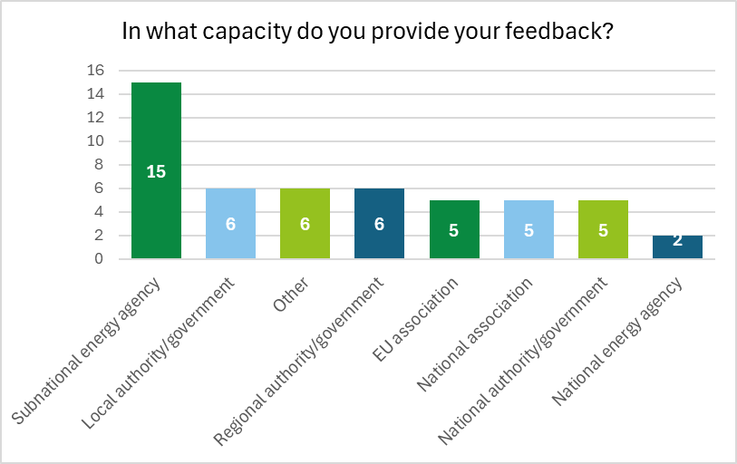
Source: Survey (n=50).

Respondents were from a wide range of European countries (see Figure 10). Some Member States were not represented (Bulgaria, Estonia, Ireland, Malta), indicating potential gaps in geographical coverage and perspectives.
Figure 10: Overview of respondents, by Member State
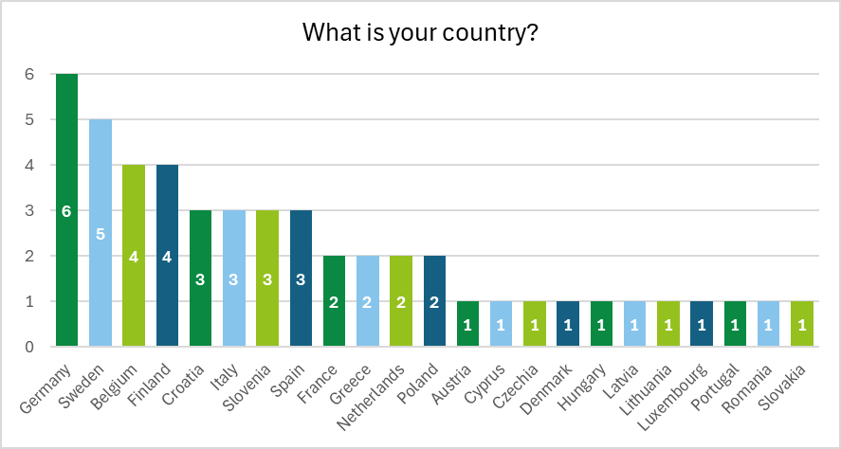
Source: Survey (n=50).

Most respondents represented Member States, with several cities of different sizes (see Figure 11).
Figure 11: Types of territories represented in the answers
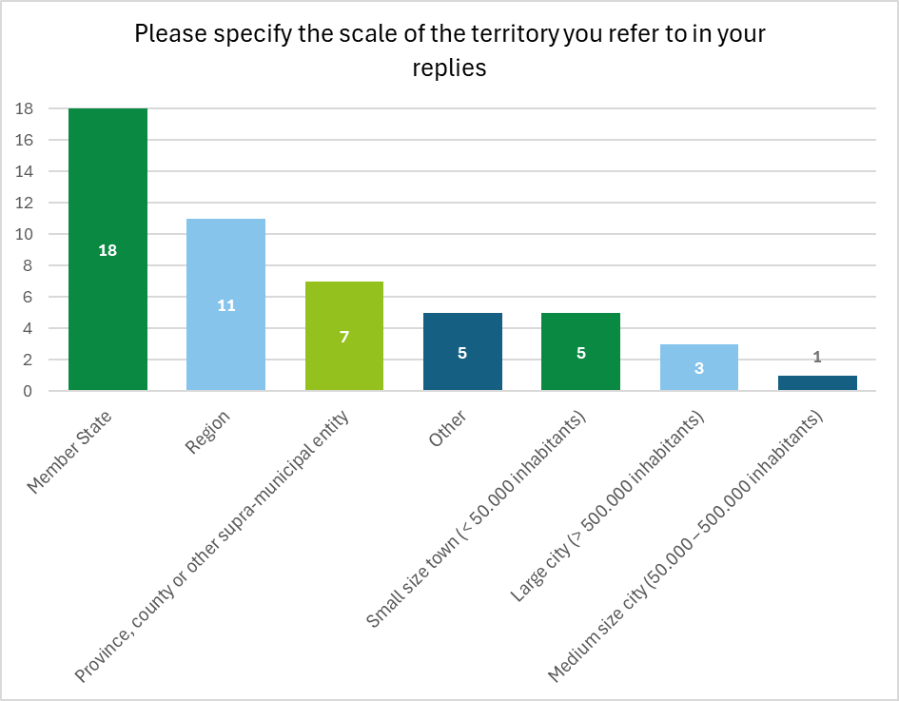
Source: Survey (n=50).

Direct comparisons between countries were difficult because the level at which respondents provided their feedback varied from country to country (see Figure 12).
Figure 12: Types of territories, by country
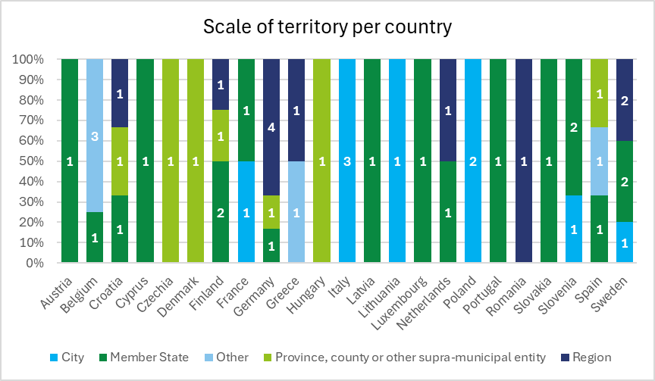
Source: Survey (n=50).

General questions

Territorial plan/strategy for Fit for 55 package implementation
Responses to whether their territory has a specific plan or strategy for the implementation of the Fit for 55 package indicated that the majority have such plans at different stages of implementation. Of the respondents, 18 confirmed that their plans are already in the implementation phase, nine have a plan that is not yet in implementation (in design phase), seven reported that transposition of the legislation is ongoing and there are no plans yet. A smaller group of territories (four) indicated having more than one strategy in place for the Fit for 55 package. The existence of multiple strategies suggests that these entities may be approaching the transition through different sectoral policies rather than a single overarching framework.

Figure 13: Existence of a plan/strategy for implementation of the Fit for 55 package
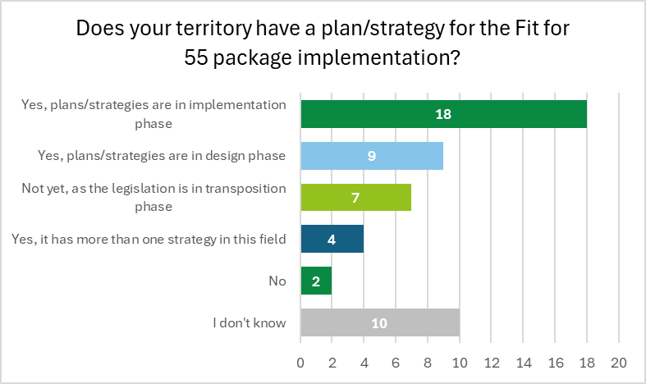
Source: Survey (n=50).

Figure 14 presents the entities and types of territories reporting the existence of a plan/strategy for implementation of the Fit for 55 package.
Figure 14: Existence of a plan/strategy for implementation, by type of territory
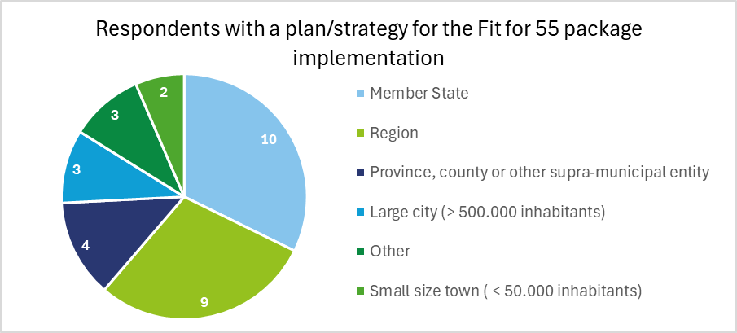
Source: Survey (n=31, only entities with a plan(s)).

Some provided additional details on their specific strategies under the Fit for 55 package, highlighting diverse approaches tailored to regional and national contexts. In Greece, the region of Western Macedonia reported having multiple strategies, including the Just Transition Territorial Plan, which is part of the broader Just Transition Mechanism. In Finland, the province of Pohjois-Karjala outlined several strategic frameworks, including the HINKU project, coordinated by SYKE, which aims for an 80% reduction in emissions between 2007 and 2030 and involves over 80% of municipalities and residents in the region. It also follows the City of Joensuu Climate Programme 2025 and the P-K Climate and Energy Programme 2030, both of which contribute to the territory’s decarbonisation goals. In Latvia, the National Energy and Climate Plan 2021-2023 and the Long-Term Strategy for the Renovation of Buildings provide a framework for energy efficiency improvements and emissions reductions, reflecting a multi-sector approach to Fit for 55 implementation.

Climate neutrality target
Respondents were asked whether their territory has a climate neutrality target to assess the level of commitment to achieving net-zero emissions across different governance levels (see Figure 15). The majority (26 respondents) have a climate neutrality target, while seven others have a climate-related target but not full neutrality. Many respondents were uncertain and one stated that their region or city does not have any climate target.
Figure 15: Existence of a climate neutrality target
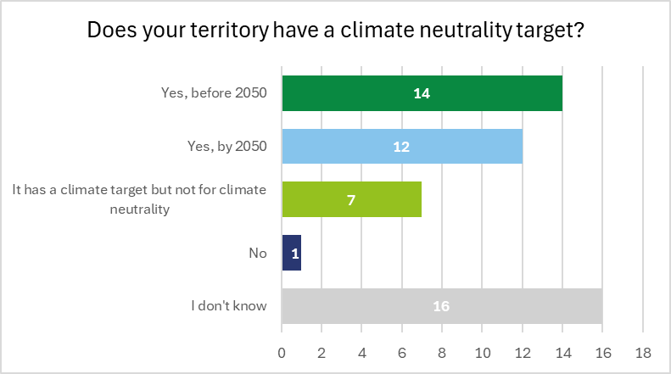
Source: Survey (n=50).

Figure 16 presents climate neutrality targets by scale of territory, with regions emerging as the most represented.
Figure 16: Existence of a climate neutrality target, by type of territory
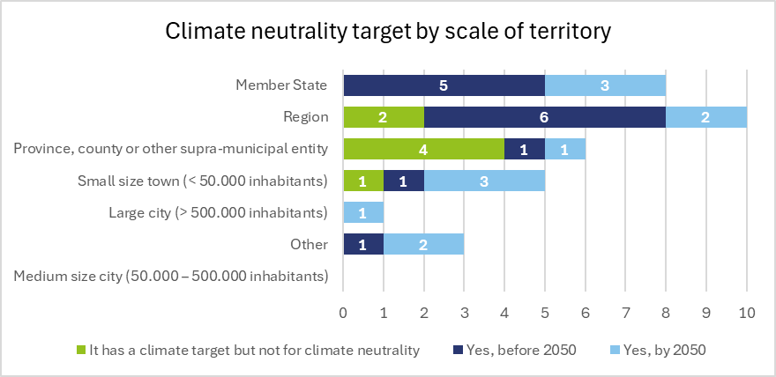
Source: Survey (n=33, only entities with a target).

Specific questions on renewable energy

Renewable energy strategy
Respondents were asked whether their country, region or city has a strategy for the development of renewable energy. The majority (30) reported that such a strategy is currently being implemented. Six indicated that a strategy was in the design phase, while nine respondents indicated that no such strategy existed in their area.
Figure 17: Existence of a renewable energy strategy
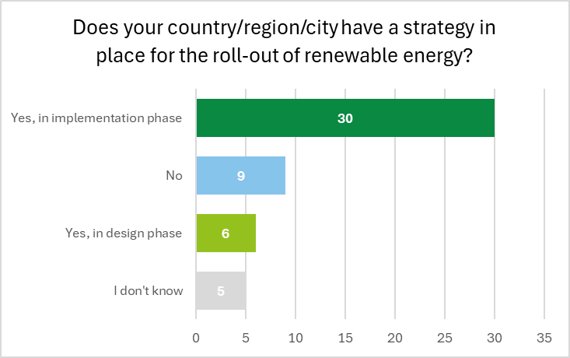
Source: Survey (n=50).

Renewable energy target
Respondents were asked whether their country, region, or city has a renewable energy target. Twenty respondents indicated that such a target exists and is supported by a monitoring system, while an additional eight reported having a renewable energy target but without a monitoring system. Five stated that while their territory does not have its own target, it contributes to a national target through a reporting system, while four others noted their contribution to a national target without reporting obligations. A small number (two) indicated that no renewable energy target exists in their area.
Figure 18: Existence of a renewable energy target
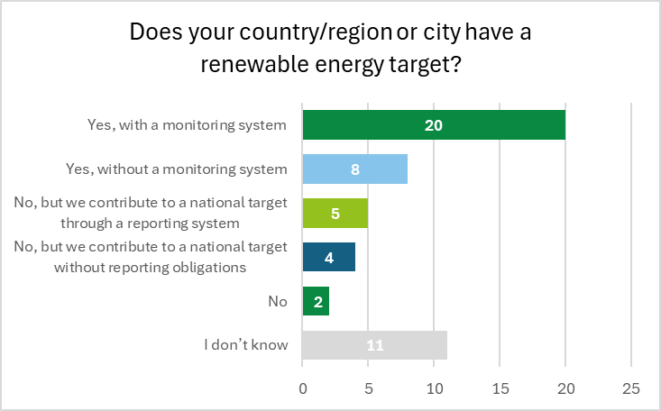
Source: Survey (n=50).

Share of energy from renewable sources
Survey participants were asked about the percentage of total energy produced in their territory from renewable sources such as solar, wind, geothermal, and biomass. The majority indicated that renewables account for between 1% and 30% of total energy production, with many others reporting that between 31% and 70% of their territory’s energy comes from renewable sources.
Figure 19: Share of energy produced from renewable sources
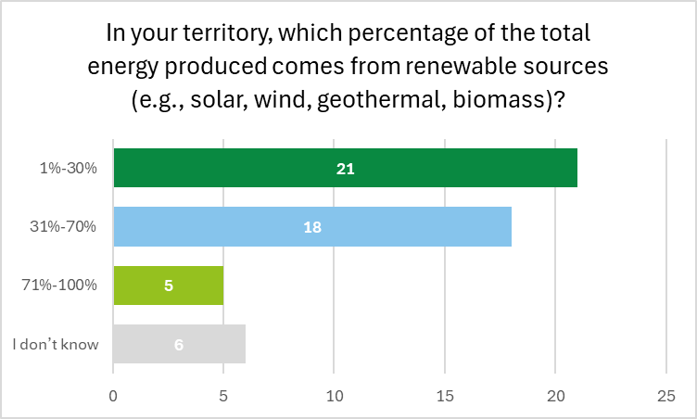
Source: Survey (n=50).

Financial support for renewable energy deployment
Survey respondents were asked whether regions or cities receive financial support for the deployment of renewable energy. Responses indicated that funding is most commonly provided through national funds, followed by support from EU funds.

Some respondents provided additional details on the types of funding sources available for renewable energy deployment. Several national funding schemes were mentioned, including the Renewable Energies Act in Germany, the Green House Programme in Lithuania, the Thermal Rehabilitation of Housing Blocks Programme in Romania, and the Swedish Energy Agency and the Finnish ELY Centres schemes. Key sources include EU funding programmes such as the ERDF, JTF, Modernisation Fund, RRF, the EAFRD, and various Interreg and LIFE programmes. Some respondents highlighted private investments, with subsidies supporting the development of solar, wind, biomass, hydropower, and heat pump projects.
Figure 20: Financial support for regional or local deployment of renewable energy
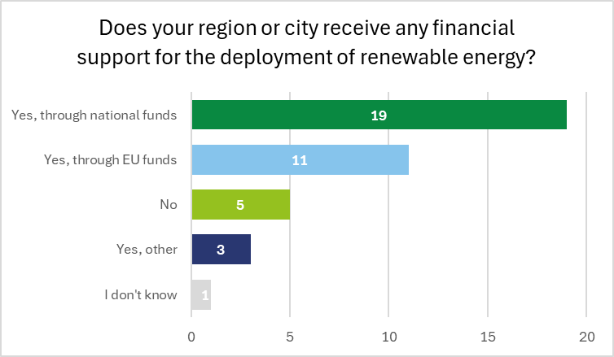
Source: Survey (n=39, only those who responded).

National governments have established various funding mechanisms to support renewable energy initiatives at different levels, ranging from direct financial aid for municipalities to broader incentive schemes:
- Croatia has an active fund for environmental protection and energy efficiency, as well as financial instruments such as those offered by the HBOR (Croatian Bank for Reconstruction and Development);
- Finland offers national support for replacing oil and gas heating with renewables and implementing the Alternative Fuels Infrastructure Regulation;
- Sweden, starting in 2025, will give municipalities central government grants proportional to installed wind power, funded through a redistribution of the wind power property tax, serving as both an incentive and compensation mechanism;
- France supports renewable energy measures in municipalities through the State Climate and Energy Fund (Fonds Climat et Énergie), complementing other state funding programmes, such as the climate bonus for citizens and economic support from the Ministry of Economic Affairs for companies and local governments.

Many regional and local authorities play a key role in financing renewable energy projects. The availability and structure of regional funds vary between countries, but typically come from a mix of EU funding, national government transfers, and locally generated revenue:
- Belgium allows local authorities to manage their own budgets and decide how to allocate resources, with some municipalities developing renewable energy projects independently. Regional authorities receive EU funding to support renewable projects, often in collaboration with local governments;
- Germany foresees federal state funds supporting regional-level energy transition efforts, primarily focused on grid expansion, local renewable energy initiatives, and energy efficiency projects.
In some other cases, financial support is structured through purchase prices and specific calls for tenders (France), while in other regions, funds are collected through contributions from stakeholders (Slovenia), which are then redistributed into special funding programmes.

Strategy for renewable energy communities and self-consumption
Respondents were asked whether a national, regional or local strategy is in place to encourage renewable energy communities and self-consumption. Seventeen respondents indicated that no such strategy exists, while 14 others reported that a strategy is currently in the implementation phase and eight reported a strategy in the design phase.
Figure 21: Existence of a strategy for renewable energy communities and self-consumption
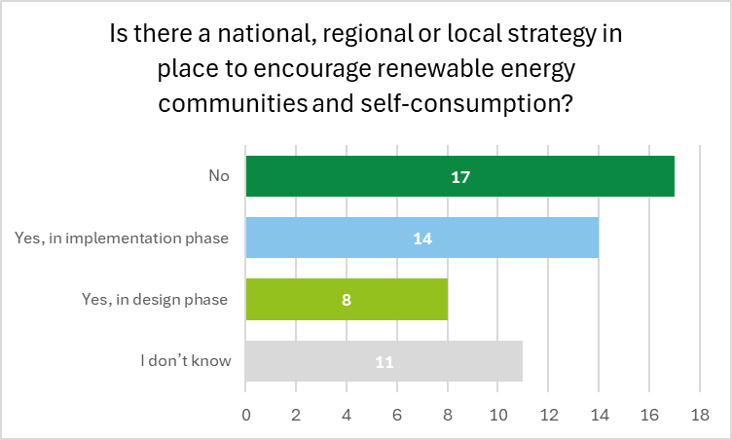
Source: Survey (n=50).

Benefits of joining or supporting an energy community
Respondents were asked to identify the main benefits of joining or supporting an energy community to highlight the key motivations for local and regional engagement. The most commonly cited advantage was lower energy costs for households or businesses (35 respondents), closely followed by increased use of renewable energy as a key benefit (34), alongside improved awareness and knowledge of energy issues in the local community, indicating that energy communities are seen as instrumental in promoting sustainability and education. Community control over energy production was selected by 28 respondents, showing that many value the localised decision-making aspect of energy communities. Additionally, 24 respondents pointed to improved energy efficiency. The ‘other’ (four) responses highlighted cost-sharing for renewable energy installations, grid resilience, and local security of supply, greater acceptance of renewables and community awareness.
Figure 22: Benefits of joining or supporting an energy community
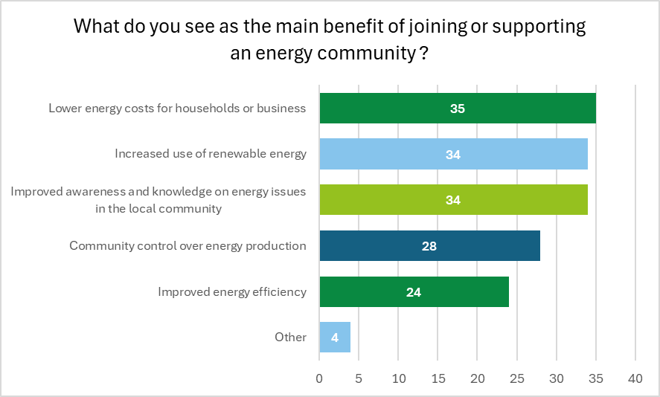
Source: Survey (n=50).

Challenges in starting an energy community
When asked about the biggest challenges in starting an energy community, most respondents highlighted regulatory constraints, insufficient awareness and lack of funding. Respondents who selected ‘other’ highlighted additional challenges, including unclear or restrictive legislation that limits who can establish energy communities, excessive bureaucratic and administrative burdens, and high costs associated with compliance and grid connection. Many communities lack a structured leadership group or the necessary management capacity to navigate these complexities, while financial viability concerns and reluctance to invest without strong incentives further hinder progress. In some areas, energy communities must bear grid upgrade costs, and access to suitable land is restricted, particularly when key locations are privately owned. Incomplete transposition of EU directives in some countries leaves many regulatory uncertainties, making the establishment of energy communities even more challenging.
Figure 23: Challenges in starting an energy community
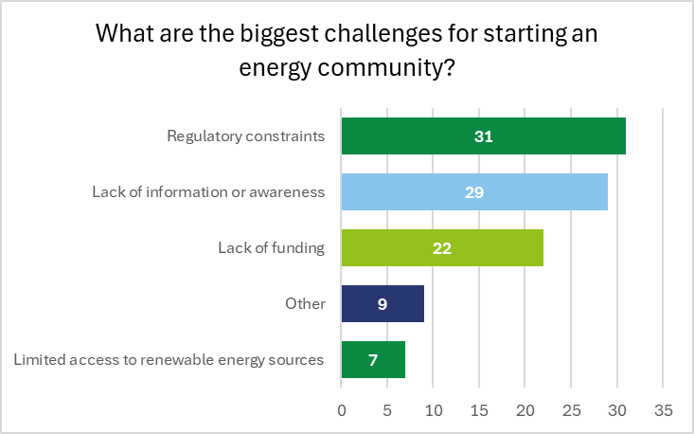
Source: Survey (n=50).

Plans to use renewable energy for heating and cooling in public buildings
Participants were asked whether their country, region, or city has a plan to use renewable energy for heating and cooling in public buildings. Fourteen respondents indicated that such a plan is currently in the implementation phase, with another 10 reporting that a plan is in the design phase and 11 stating that no such plan exists in their area. A significant number of participants were uncertain about such plans.
Figure 24: Existence of plans to use renewable energy for heating and cooling in public buildings
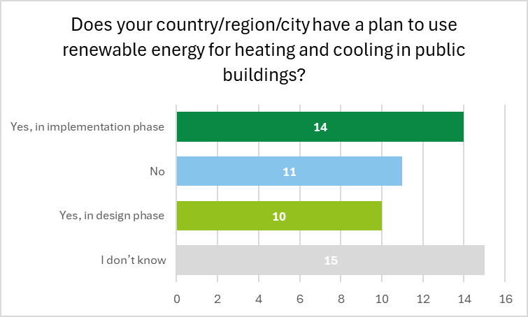
Source: Survey (n=50).

Specific questions on energy efficiency

Energy efficiency strategy
Survey participants were asked whether their country, region or city has a plan to implement energy efficiency policies. Twenty-two respondents stated that such a plan is currently in the implementation phase, while nine indicated that a plan was in the design phase and seven reported that no plan existed in their area.
Figure 25: Existence of plans for the roll-out of energy efficiency policies
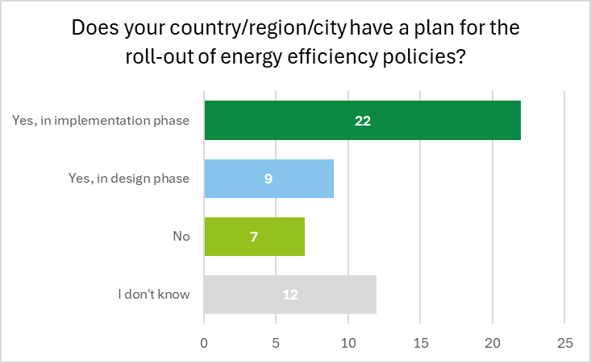
Source: Survey (n=50).

Energy efficiency target
Survey respondents were asked whether their country, region, or city has an energy efficiency target. Twenty respondents indicated that such a target exists and is supported by a monitoring system. Additionally, nine respondents stated that while their territory does not have its own target, it contributes to a national target without reporting obligations. Seven respondents reported having an energy efficiency target but without a monitoring system. Two respondents indicated that no energy efficiency target exists in their area.
Figure 26: Existence of an energy efficiency target
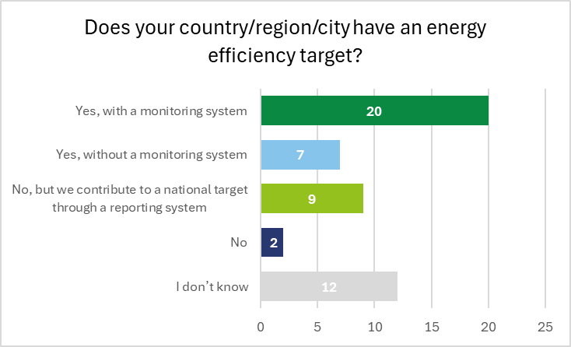
Source: Survey (n=50).

Financial support implementing energy efficiency measures
Survey respondents were asked whether regions or cities receive financial support for the deployment of renewable energy. The most common response indicated that funding is provided through national funds, followed by support from EU funds. When asked to provide examples, respondents referred to various EU funds, such as Horizon Europe, ERDF, Modernisation Fund.
Figure 27: Financial support for implementing energy efficiency measures
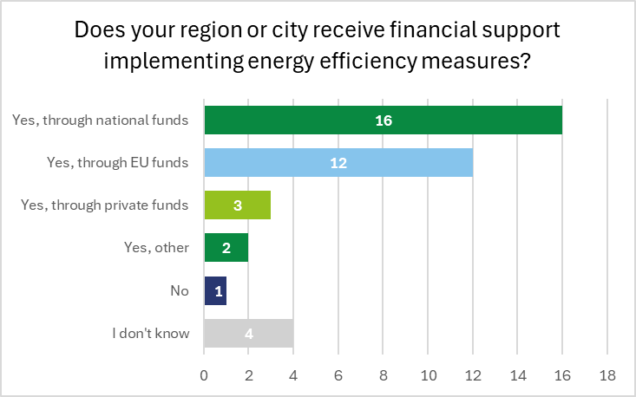
Source: Survey (n=38, only those who responded).

Main causes of energy poverty
Respondents were asked to identify the main causes of energy poverty in their area. Low household income was the main reason (38 respondents), indicating that financial constraints are the main driver of energy poverty. This was closely followed by poor energy efficiency of buildings (35 respondents)with inefficient housing a major contributor, highlighting the need for building renovation and retrofitting. High energy prices were also identified as a significant factor (31 respondents), with rising energy costs a key burden for vulnerable households, as well as lack of access to RES (17 respondents). Finally, six respondents selected ‘other’, focusing on lack of awareness, structural issues, and economic inequality; poor building conditions; or even regional differences, with some areas (e.g. Baden-Württemberg, North Karelia), experiencing unique challenges due to inflation, unemployment, and high energy prices.
Figure 28: Main causes of energy poverty
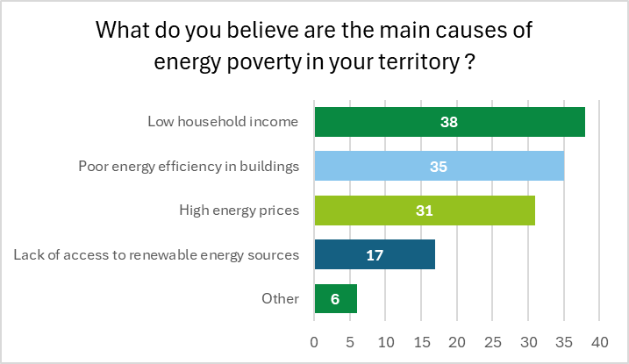
Source: Survey (n=50).

Measures for reducing energy poverty
Respondents were asked to identify measures that would be most effective in reducing energy poverty in their area. The most commonly selected measure was grants or loans for energy efficiency improvements in the home (40 respondents), followed by EU support, such as funding from the Social Climate Fund (28 respondents), energy-saving education programmes (27 respondents), and energy-sharing initiatives, such as energy communities (25 respondents). Smaller numbers selected government subsidies for energy bills (eight respondents) and ‘other’ (nine respondents). The 'other' responses highlighted structural financial barriers, particularly for households in sparsely populated areas, emphasised the role of wider social, educational and economic policies in tackling energy poverty, stressed that energy efficiency and education programmes are more sustainable solutions than direct subsidies, and suggested alternative financial approaches, such as better targeted subsidies, tax reductions and prioritising private investment.

Figure 29: Measures for reducing energy poverty
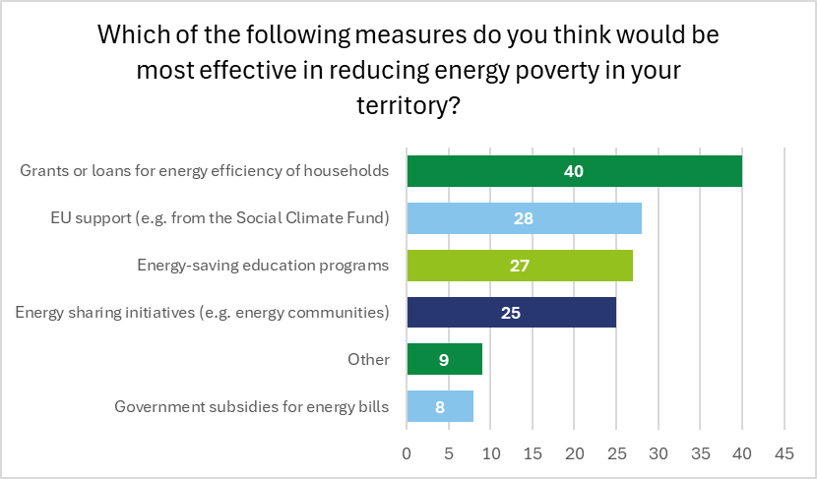
Source: Survey (n=50).

Specific questions on the energy performance of buildings

Energy performance of buildings policy
Survey respondents were asked whether their country, region, or city has an energy performance policy for residential and/or non-residential buildings. Twenty-one respondents reported that such a policy is currently in the implementation phase, with a further five respondents stating that a policy is in the design phase. Nine reported that no policy exists in their area. A significant number (15) were uncertain.
Figure 30: Existence of an energy performance of buildings policy
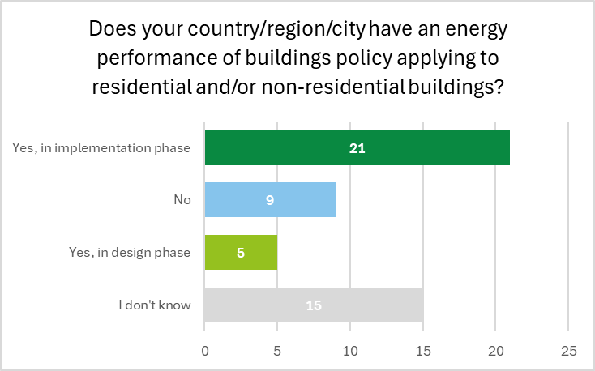
Source: Survey (n=50).

Energy performance of buildings target
Respondents were asked whether there are specific targets for energy performance of buildings in their territory. In most cases, such targets exist with a monitoring system, followed by targets without a monitoring system and those contributing to national targets. Many respondents were uncertain, however, and opted not to answer.
Figure 31: Existence of energy performance of buildings target
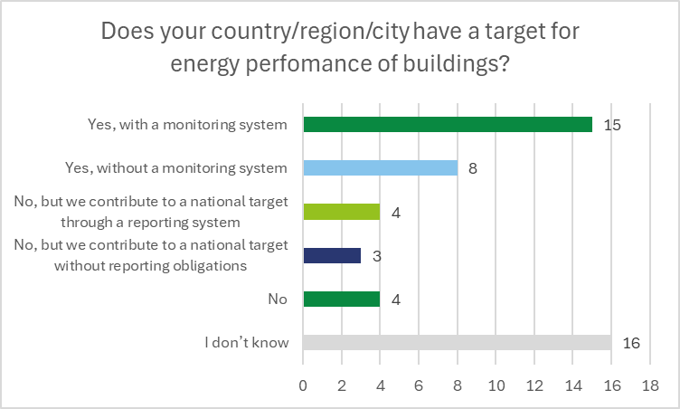
Source: Survey (n=50).

Financial support for efficient building measures
Survey respondents were asked whether their region or city receives financial support for efficient building measures. Thirteen respondents indicated that such funding comes from national funds, 12 reported receiving support through EU funds, and two stated that funding is provided through private sources.

Respondents provided additional details on financial support mechanisms for energy-efficient buildings. Several EU funding sources were mentioned, including ERDF, EAFRD, LIFE, Interreg, and Horizon Europe. Specific national funding schemes include Apva in Lithuania, the ‘Bundesförderung für effiziente Gebäude’ in Germany, the ‘Eco Fund’ in Slovenia, and the ‘Decret Tertiaire’, and ‘Fonds Chaleur’ in France. In Sweden, municipalities and SMEs receive support for voluntary energy audits or large innovative energy investments through the RRF.
Figure 32: Financial support for efficient building measures
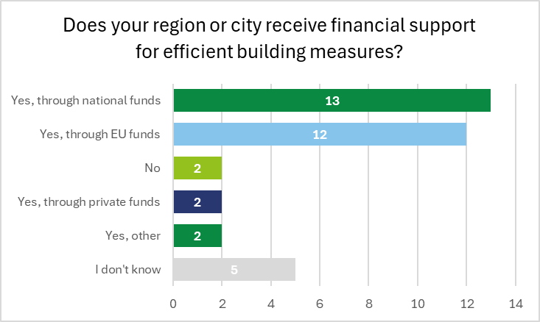
Source: Survey (n=36, only those that responded).

Preparation for ZEB requirements
Survey respondents were asked whether their region or city is preparing for the requirement that all new public buildings by 2028 and all new buildings by 2030 must meet ZEB standards. Twenty-one respondents indicated that preparations are already in the implementation phase, while five reported that preparations are still in the design phase. Nine reported that no such efforts are currently taking place in their area. A significant number (15) were uncertain or unable to answer (e.g. they do not work at that governance level).
Figure 33: Preparation for ZEB requirements
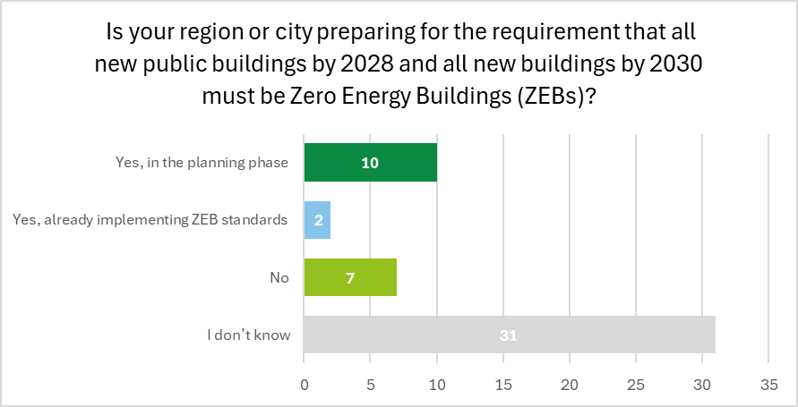
Source: Survey (n=50).

The seven respondents who answered ‘no’ when asked whether their region or city was preparing for the requirement that all new public buildings by 2028 and all new buildings by 2030 should ZEB standards were asked why. Financial constraints and regulatory dependency were both identified as major barriers, followed by a lack of technical knowledge in developing ZEB standards.
Figure 34: Reasons for not preparing for ZEBs
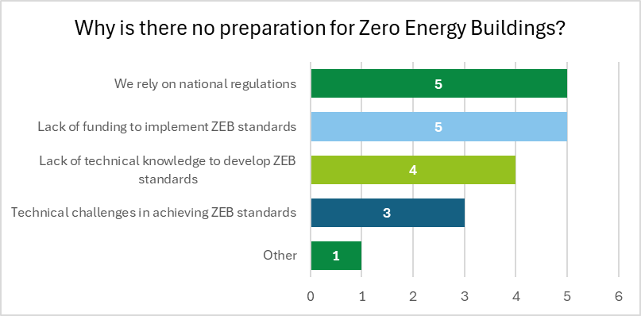
Source: Survey (n=7, those who responded ‘no’ to preparing for ZEBs).

Specific questions for representatives of LRAs – involvement in energy initiatives
Representatives of LRAs were asked whether their city or region participates in initiatives or city networks for advancing the green transition. The majority indicated that they are actively engaged in such initiatives at either national or European level, highlighting a strong commitment to advancing the clean energy transition. Of 27 responding entities (excluding those at Member State level or classified as ‘other’, such as associations and non-governmental organisations (NGOs), to which this question did not apply), 19 confirmed their participation. Looking at the different levels of governance, the trend of engagement remains strong: seven out of 11 regions reported participation, as well as six out of seven provinces, counties or other supra-municipal entities, highlighting that this level of governance is particularly active in implementing clean energy transition initiatives. Four out of five small towns (< 50,000 inhabitants) and two out of three large cities (> 500,000 inhabitants) also reported engagement. A small number of respondents expressed uncertainty suggesting a lack of clarity or communication on participation in clean energy transition initiatives in certain cases.
Figure 35: Participation of LRAs in clean energy initiatives
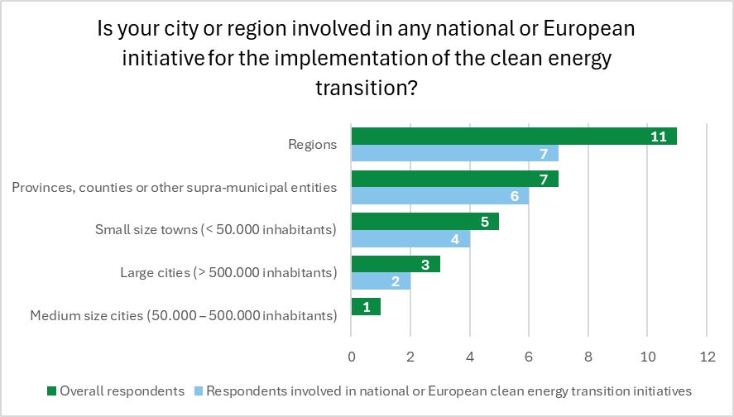
Source: Survey (n=27, only LRAs).

Communication from the Commission to the European Parliament, the Council, the European Economic and Social Committee and the Committee of the Regions, 'Fit for 55': Delivering the EU's 2030 climate target on the way to climate neutrality, COM/2021/550 final, https://eur-lex.europa.eu/legal-content/EN/TXT/?uri=CELEX%3A52021DC0550.
European Committee of the Regions, Stepping up Europe’s 2030 climate ambition towards COP26, Opinion 2021/C440/05, https://eur-lex.europa.eu/legal-content/EN/TXT/?uri=CELEX:52020IR5068
Based on Eurostat data available by 16 January 2025 (including share of renewables, primary energy consumption and final energy consumption). Additional statistics on climate and energy available in: European Committee of the Regions: Commission for the Environment, Climate Change and Energy, Gancheva, M., Vroom, I., Freguglia, P., Muller, M. et al., Green Deal in figures – Understanding Europe’s green transition from a local and regional perspective – Factsheets, European Committee of the Regions, 2024, https://data.europa.eu/doi/10.2863/771699.
Regulation (EU) 2021/1119 of the European Parliament and of the Council of 30 June 2021 establishing the framework for achieving climate neutrality and amending Regulations (EC) No 401/2009 and (EU) 2018/1999 (‘European Climate Law’),. https://eur-lex.europa.eu/legal-content/EN/TXT/?uri=celex%3A32021R1119.
Communication from the Commission to the European Parliament, the Council, the European Economic and Social Committee and the Committee of the Regions, Securing our future Europe's 2040 climate target and path to climate neutrality by 2050 building a sustainable, just and prosperous society, COM/2024/63 final, https://eur-lex.europa.eu/legal-content/EN/TXT/?uri=COM%3A2024%3A63%3AFIN.
European Commission, Directorate-General for Energy, Clean energy for all Europeans package, 2019, https://energy.ec.europa.eu/topics/energy-strategy/clean-energy-all-europeans-package_en.
Directive (EU) 2018/844 of the European Parliament and of the Council of 30 May 2018 amending Directive 2010/31/EU on the energy performance of buildings and Directive 2012/27/EU on energy efficiency, https://eur-lex.europa.eu/legal-content/EN/TXT/?qid=1529483556082&uri=CELEX:32018L0844.
Directive (EU) 2018/2001 of the European Parliament and of the Council of 11 December 2018 on the promotion of the use of energy from renewable sources (recast), https://eur-lex.europa.eu/legal-content/EN/TXT/?uri=uriserv:OJ.L_.2018.328.01.0082.01.ENG&toc=OJ:L:2018:328:TOC.
Directive (EU) 2018/2002 of the European Parliament and of the Council of 11 December 2018 amending Directive 2012/27/EU on energy efficiency, https://eur-lex.europa.eu/legal-content/EN/TXT/?uri=uriserv:OJ.L_.2018.328.01.0210.01.ENG&toc=OJ:L:2018:328:TOC.
Directive (EU) 2019/944 of the European Parliament and of the Council of 5 June 2019 on common rules for the internal market for electricity and amending Directive 2012/27/EU (recast), https://eur-lex.europa.eu/eli/dir/2019/944/oj.
Regulation (EU) 2018/1999 of the European Parliament and of the Council of 11 December 2018 on the Governance of the Energy Union and Climate Action, amending Regulations (EC) No 663/2009 and (EC) No 715/2009 of the European Parliament and of the Council, Directives 94/22/EC, 98/70/EC, 2009/31/EC, 2009/73/EC, 2010/31/EU, 2012/27/EU and 2013/30/EU of the European Parliament and of the Council, Council Directives 2009/119/EC and (EU) 2015/652 and repealing Regulation (EU) No 525/2013 of the European Parliament and of the Council, https://eur-lex.europa.eu/eli/reg/2018/1999/oj.
Communication from the Commission to the European Parliament, the European Council, the Council, the European Economic and Social Committee and the Committee of the Regions, REPowerEU Plan, COM/2022/230 final, https://eur-lex.europa.eu/legal-content/EN/TXT/?uri=celex:52022DC0230.
Directive (EU) 2023/2413 of the European Parliament and of the Council of 18 October 2023 amending Directive (EU) 2018/2001, Regulation (EU) 2018/1999 and Directive 98/70/EC as regards the promotion of energy from renewable sources, and repealing Council Directive (EU) 2015/652, https://eur-lex.europa.eu/eli/dir/2023/2413/oj.
Directive (EU) 2024/1275 of the European Parliament and of the Council of 24 April 2024 on the energy performance of buildings (recast), https://eur-lex.europa.eu/legal-content/EN/TXT/?uri=CELEX:32024L1275.
Eurocities and Energy Cities, Cities in the European Green Deal Opportunities and Responsibilities, 2024, https://energy-cities.eu/publication/cities-in-the-eu-green-deal/.
Directive (EU) 2023/1791 of the European Parliament and of the Council of 13 September 2023 on energy efficiency and amending Regulation (EU) 2023/955 (recast), https://eur-lex.europa.eu/legal-content/EN/TXT/?uri=CELEX%3A32023L1791&qid=1733234263940.
Directive (EU) 2023/2413 of the European Parliament and of the Council of 18 October 2023 amending Directive (EU) 2018/2001, Regulation (EU) 2018/1999 and Directive 98/70/EC as regards the promotion of energy from renewable sources, and repealing Council Directive (EU) 2015/652, https://eur-lex.europa.eu/eli/dir/2023/2413/oj.
European Commission, Hydrogen and decarbonisation gas market, 2025, https://energy.ec.europa.eu/topics/markets-and-consumers/hydrogen-and-decarbonised-gas-market_en.
Directive (EU) 2024/1788 of the European Parliament and of the Council of 13 June 2024 on common rules for the internal markets for renewable gas, natural gas and hydrogen, amending Directive (EU) 2023/1791 and repealing Directive 2009/73/EC (recast), https://eur-lex.europa.eu/legal-content/EN/TXT/?uri=OJ:L_202401788.
European Commission, Financing the Green Deal, 2024, https://commission.europa.eu/strategy-and-policy/priorities-2019-2024/european-green-deal/finance-and-green-deal_en.
Bellona, ‘Financing the Fit for 2030 package: Modernisation, Innovation and Social Funds spell the EU’s recipe for the future’, 1 September 2021, https://bellona.org/news/eu/2021-09-financing-the-fit-for-2030-package-modernisation-innovation-and-social-funds-spell-the-eus-recipe-for-the-future.
The EU ETS is the EU’s primary carbon market, operating since 2005. It follows a ‘cap-and-trade’ principle, setting a limit on GHG emissions and requiring companies to purchase or trade emission allowances, creating an economic incentive to reduce emissions for sectors such as electricity and heat generation, industrial manufacturing; aviation and maritime transport (added in 2024), buildings, road transport, and smaller industrial emitters (covered from 2027) (European Commission, What is the EU ETS?, 2024, https://climate.ec.europa.eu/eu-action/eu-emissions-trading-system-eu-ets/what-eu-ets_en; European Commission, ETS2: buildings, road transport and additional sectors, 2024, https://climate.ec.europa.eu/eu-action/eu-emissions-trading-system-eu-ets/ets2-buildings-road-transport-and-additional-sectors_en).
European Commission, Social Climate Fund, 2024, https://climate.ec.europa.eu/eu-action/eu-emissions-trading-system-eu-ets/social-climate-fund_en.
European Commission, Carbon Border Adjustment Mechanism, 2025, https://taxation-customs.ec.europa.eu/carbon-border-adjustment-mechanism_en.
European Commission, EU Mission: Climate-Neutral and Smart Cities, 2024, https://research-and-innovation.ec.europa.eu/funding/funding-opportunities/funding-programmes-and-open-calls/horizon-europe/eu-missions-horizon-europe/climate-neutral-and-smart-cities_en#:~:text=EU%20missions%20are%20commitments%20to,ensuring%20soil%20health%20and%20food; NetZeroCities, Towards climate neutral European cities by 2030, 2024, https://netzerocities.eu/the-netzerocities-project/.
European Investment Bank, Working with Europe's cities and regions 2024, 2023, https://www.eib.org/attachments/lucalli/20240070_working_with_europe_s_cities_and_regions_en.pdf.
Covenant of Mayors for Climate & Energy Europe, Building Resilience through Adaptation at the Local Level – Policy Support Facility Final Report, 2024, https://covenantofmayors-epublication.eu/.
Eurocities, Cities social trends paper: Measures to tackle energy poverty in cities, 2023, https://euagenda.eu/publications/download/565103.
Energy Cities, Tangible targets for cities: 33 concrete goals to advance the local ecological transition, 2023, https://energy-cities.eu/wp-content/uploads/2023/09/Energy-Cities-Tangible-targets-for-cities-ENG.pdf.
European Commission, Directorate-General for Energy, Action Plan for Affordable Energy: Unlocking the true value of our Energy Union to secure affordable, efficient and clean energy for all Europeans, 2025, https://energy.ec.europa.eu/publications/action-plan-affordable-energy-unlocking-true-value-our-energy-union-secure-affordable-efficient-and_en.
ICLEI Europe, Policy Brief: Transforming Europe’s building stock for a fair, affordable, climate-neutral future, 2024, https://iclei-europe.org/fileadmin/templates/iclei-europe/lib/resources/tools/push_resource_file.php?uid=MROjAUKO.
European Commission, Renovation Wave, 2025, https://energy.ec.europa.eu/topics/energy-efficiency/energy-efficient-buildings/renovation-wave_en#main-focus-of-the-renovation-wave.
European Commission, ‘Commission launches toolkit to support social housing in Member States’, News, 22 April 2024, https://european-social-fund-plus.ec.europa.eu/en/news/commission-launches-toolkit-support-social-housing-member-states.
Eurocities, Cities social trends paper: Measures to tackle energy poverty in cities, 2023, https://euagenda.eu/publications/download/565103.
European Scientific Advisory Board on Climate Change, EU climate Advisory Board: focus on immediate implementation and continued action to achieve EU climate goals, 2024, https://climate-advisory-board.europa.eu/news/eu-climate-advisory-board-focus-on-immediate-implementation-and-continued-action-to-achieve-eu-climate-goals.
LIFE Regio1st project, Regio1st mapping on regional development planning cycles and procedures, 2023, https://build-up.ec.europa.eu/system/files/2023-10/D2_1-Mapping-the-regional-planning-procedures-final_checked-1.pdf.
19th ENVE Commission meeting, Joško KLISOVIC, ‘Towards a multilevel Green Deal governance: the revision of the Governance of the Energy Union and Climate Action regulation’, 29 June 2023, https://webstreaming.cor.europa.eu/en/cor/enve-commission-meeting.
Local Alliance, From policy to action: Unlocking the Potential of Local and Regional Governments in the Social Climate Fund, 2024, https://fedarene.org/wp-content/uploads/2024/12/Local-Alliance-Briefing.pdf.
ICLEI Europe, Position Paper on the EU’s 2040 Climate Target, 2024, https://iclei-europe.org/fileadmin/templates/iclei-europe/lib/resources/tools/push_resource_file.php?uid=g2d9ZJqs.
Local Alliance, ‘Cities and regional networks urge EU to stay the course on Green Deal implementation’, 26 March 2024, https://fedarene.org/wp-content/uploads/2024/04/Local-Alliance-Letter-for-Commissionners.pdf.
Energy Cities, Human capacity in local governments: The bottleneck of the building stock transition, 2022, https://energy-cities.eu/wp-content/uploads/2022/05/EnergyCities21_PolicyPaper_CapacityNeeds_EN_FINAL-2.pdf.
ICLEI Europe, Position Paper on the EU’s 2040 Climate Target, 2024, https://iclei-europe.org/fileadmin/templates/iclei-europe/lib/resources/tools/push_resource_file.php?uid=g2d9ZJqs.
European Commission, ‘Work begins on the Citizens Energy Package to ensure a fair and inclusive energy transition’, 19 December 2024, https://energy.ec.europa.eu/news/work-begins-citizens-energy-package-ensure-fair-and-inclusive-energy-transition-2024-12-19_en#:~:text=Taking%20place%20in%20the%20first,fair%20and%20inclusive%20energy%20transition.
Covenant of Mayors website, https://eu-mayors.ec.europa.eu/en/home.
European Climate Pact website, https://climate-pact.europa.eu/index_en.
Local Alliance, From policy to action: Unlocking the Potential of Local and Regional Governments in the Social Climate Fund, 2024, https://fedarene.org/wp-content/uploads/2024/12/Local-Alliance-Briefing.pdf.
ICLEI Europe, Policy Brief: Transforming Europe’s building stock for a fair, affordable, climate-neutral future, 2024, https://iclei-europe.org/fileadmin/templates/iclei-europe/lib/resources/tools/push_resource_file.php?uid=MROjAUKO.
Eurocities, Cities social trends paper: Measures to tackle energy poverty in cities, 2023, https://euagenda.eu/publications/download/565103.
ICLEI Europe, Policy Brief: Transforming Europe’s building stock for a fair, affordable, climate-neutral future, 2024, https://iclei-europe.org/fileadmin/templates/iclei-europe/lib/resources/tools/push_resource_file.php?uid=MROjAUKO.
ICLEI Europe, Position Paper on the EU’s 2040 Climate Target, 2024, https://iclei-europe.org/fileadmin/templates/iclei-europe/lib/resources/tools/push_resource_file.php?uid=g2d9ZJqs.
RESCOOP.EU, Renewables acceleration areas: a fast, but also fair design process, 2024, https://www.rescoop.eu/uploads/rescoop/downloads/REScoop.EU-response-to-res-acceleration-areas-call-for-evidence.pdf.
RESCOOP.EU, REScoop.eu briefing on the revised EED, 2024, https://www.rescoop.eu/uploads/rescoop/downloads/REScoop.EU-briefing-on-the-revised-EED.pdf.
RESCOOP.EU, REScoop.eu briefing on the revised RED, 2024, https://www.rescoop.eu/uploads/rescoop/downloads/REScoop.EU-briefing-on-the-revised-RED_final.pdf.
Local Alliance, From Policy to Action: Unlocking the Potential of Local and Regional Governments in the Social Climate Fund, 2024, https://fedarene.org/wp-content/uploads/2024/12/Local-Alliance-Briefing.pdf.
Energy Communities Repository, Setting Up Community Energy One-Stop-Shops, 2023, https://www.qualenergia.it/wp-content/uploads/2023/11/Energy-Communities-Repository-Guidance.pdf.
Energy Communities Repository, Setting Up Community Energy One-Stop-Shops, 2023, https://www.qualenergia.it/wp-content/uploads/2023/11/Energy-Communities-Repository-Guidance.pdf.
Boza-Kiss, B., Bertoldi, P., Della Valle, N. and Economidou, M., One-stop shops for residential building energy renovation in the EU, Analysis & policy recommendations, Joint Research Centre (JRC) Science for Policy Report, European Commission, 2021, https://publications.jrc.ec.europa.eu/repository/handle/JRC125380.
LIFE Regio1st project, Regio1st mapping on regional development planning cycles and procedures, 2023, https://build-up.ec.europa.eu/system/files/2023-10/D2_1-Mapping-the-regional-planning-procedures-final_checked-1.pdf.
Energy Cities, Human capacity in local governments: The bottleneck of the building stock transition, 2022, https://energy-cities.eu/wp-content/uploads/2022/05/EnergyCities21_PolicyPaper_CapacityNeeds_EN_FINAL-2.pdf.
European Commission, State of the energy union report 2024 - country fiches, 2024, https://energy.ec.europa.eu/publications/state-energy-union-report-2024-country-fiches_en.
European Commission, National Energy and Climate Plans, 2025, https://commission.europa.eu/energy-climate-change-environment/implementation-eu-countries/energy-and-climate-governance-and-reporting/national-energy-and-climate-plans_en.
Energy Communities Repository, Setting Up Community Energy One-Stop-Shops, 2023, https://www.qualenergia.it/wp-content/uploads/2023/11/Energy-Communities-Repository-Guidance.pdf.
CoR, Division of Powers, Bulgaria – Energy, n.d., https://portal.cor.europa.eu/divisionpowers/Pages/Bulgaria-Energy.aspx.
Act for amendment of the Renewable Energy Act from 20.12.2024, text available on the Portal for Public Consultations, https://www.strategy.bg/PublicConsultations/View.aspx?lang=bg-BG&Id=8818.
ОБЩИНСКА МРЕЖА ЗА ЕНЕРГИЙНА ЕФЕКТИВНОСТ ЕКОЕНЕРГИЯ, 2024, Крайно време е енергийното обновяване на многофамилните жилищни сгради да се превърне в политика, а не в лотария, 17 January 2024, https://www.eneffect.bg/storage/news/1_db8y5oqaGQ.pdf.
EcoEnergy, Bulletin January 2024, https://www.ecoenergy-bg.net/UserFiles/File/BULETIN/2024/Publication%20Jan%202024.pdf.
United States Department of Commerce, International Trade Administration, Republic of Cyprus - Renewable Energy, 2021, https://www.trade.gov/energy-resource-guide-republic-cyprus-renewable-energy.
Energy Cities, Tangible targets for cities: 33 concrete goals to advance the local ecological transition, 2023, https://energy-cities.eu/wp-content/uploads/2023/09/Energy-Cities-Tangible-targets-for-cities-ENG.pdf.
ICLEI EUROPE, Policy Brief: Transforming Europe’s building stock for a fair, affordable, climate-neutral future, 2024, https://iclei-europe.org/fileadmin/templates/iclei-europe/lib/resources/tools/push_resource_file.php?uid=MROjAUKO.
ICLEI Europe, Position Paper on the EU’s 2040 Climate Target, 2024, https://iclei-europe.org/fileadmin/templates/iclei-europe/lib/resources/tools/push_resource_file.php?uid=g2d9ZJqs.
MEHI, Energy efficiency is the neglected stepchild of the Hungarian energy policy, 2023, https://mehi.hu/en/press-release/energy-efficiency-is-the-neglected-stepchild-of-the-hungarian-energy-policy/
European Commission, Scaling-up energy efficiency investments in buildings in Hungary, 2019, https://reform-support.ec.europa.eu/what-we-do/green-transition/scaling-energy-efficiency-investments-buildings-hungary_en
EuroCities, Kennedy, A, Mapping the solar transformation in Budapest, 2023, https://eurocities.eu/stories/mapping-the-solar-transformation-in-budapest/
Energy Cities, Tangible targets for cities: 33 concrete goals to advance the local ecological transition, 2023, https://energy-cities.eu/wp-content/uploads/2023/09/Energy-Cities-Tangible-targets-for-cities-ENG.pdf.
Energy Communities Repository, Setting Up Community Energy One-Stop-Shops, 2023, https://www.qualenergia.it/wp-content/uploads/2023/11/Energy-Communities-Repository-Guidance.pdf.
Eurocities, Cities social trends paper: Measures to tackle energy poverty in cities, 2023, https://euagenda.eu/publications/download/565103.
Malta, Research Innovation Unit, n.d., https://riu.gov.mt/why-is-malta-lagging-behind-in-reaching-its-climate-targets/.
Eurocities, Cities social trends paper: Measures to tackle energy poverty in cities, 2023, https://euagenda.eu/publications/download/565103.
Energy Cities, Tangible targets for cities: 33 concrete goals to advance the local ecological transition, 2023, https://energy-cities.eu/wp-content/uploads/2023/09/Energy-Cities-Tangible-targets-for-cities-ENG.pdf.
Eurocities, Eurocities Pulse Mayors Survey 2024. A state of cities report through the voices of mayors, 2024, https://monitor.eurocities.eu/wp-content/uploads/2024/05/Eurocities-Pulse-Mayors-Survey-2024-1.pdf.
Eurocities, Eurocities Pulse Mayors Survey 2024. A state of cities report through the voices of mayors, 2024, https://monitor.eurocities.eu/wp-content/uploads/2024/05/Eurocities-Pulse-Mayors-Survey-2024-1.pdf.
Energy Cities, Human capacity in local governments: The bottleneck of the building stock transition, 2022, https://energy-cities.eu/wp-content/uploads/2022/05/EnergyCities21_PolicyPaper_CapacityNeeds_EN_FINAL-2.pdf.
Energy Cities, Tangible targets for cities: 33 concrete goals to advance the local ecological transition, 2023, https://energy-cities.eu/wp-content/uploads/2023/09/Energy-Cities-Tangible-targets-for-cities-ENG.pdf.
The tax rebate for ROT work is intended for house or apartment owners and covers up to half of certain labour costs, https://www.skatteverket.se/servicelankar/otherlanguages/inenglishengelska/businessesandemployers/startingandrunningaswedishbusiness/declaringtaxesbusinesses/rotandrutwork/payment/rotandrutworkandvat.4.8dcbbe4142d38302d7d13.html.
European Scientific Advisory Board on Climate Change, EU climate Advisory Board: focus on immediate implementation and continued action to achieve EU climate goals, 2024, https://climate-advisory-board.europa.eu/news/eu-climate-advisory-board-focus-on-immediate-implementation-and-continued-action-to-achieve-eu-climate-goals.
LIFE Regio1st project, Regio1st mapping on regional development planning cycles and procedures, 2023, https://build-up.ec.europa.eu/system/files/2023-10/D2_1-Mapping-the-regional-planning-procedures-final_checked-1.pdf.
Energy Cities, Human capacity in local governments: The bottleneck of the building stock transition, 2022, https://energy-cities.eu/wp-content/uploads/2022/05/EnergyCities21_PolicyPaper_CapacityNeeds_EN_FINAL-2.pdf.
Energy Communities Repository, Setting Up Community Energy One-Stop-Shops, 2023, https://www.qualenergia.it/wp-content/uploads/2023/11/Energy-Communities-Repository-Guidance.pdf.
Eurocities, Cities social trends paper: Measures to tackle energy poverty in cities, 2023, https://euagenda.eu/publications/download/565103.
Based on Cohesion Open Data Platform. (last accessed 21 August 2024).
In the 2021-2027 programming period, this covers 15 Member States: Bulgaria, Croatia, Cyprus, Czechia, Estonia, Greece, Hungary, Latvia, Lithuania, Malta, Poland, Portugal, Romania, Slovakia, Slovenia.
Based on Cohesion Open Data Platform. (last accessed 21 August 2024).
Based on Cohesion Open Data Platform. (last accessed 21 August 2024).
Ibid.
European Commission, Recovery and Resilience Facility for clean energy, 2024, https://energy.ec.europa.eu/topics/funding-and-financing/recovery-and-resilience-facility-clean-energy_en.
Based on Regulation (EU) 2021/783 of the European Parliament and of the Council of 29 April 2021 establishing a Programme for the Environment and Climate Action (LIFE).
Based on Regulation (EU) 2021/695 of the European Parliament and of the Council of 28 April 2021 establishing Horizon Europe – the Framework Programme for Research and Innovation, laying down its rules for participation and dissemination.
European Commission, EU funding possibilities in the energy sector, 2024, https://energy.ec.europa.eu/topics/funding-and-financing/eu-funding-possibilities-energy-sector_en.
CORDIS, Accelerating cities' transition to net zero emissions by 2030, 2024, https://cordis.europa.eu/project/id/101036519/news.
Currently, the Fund covers 13 Member States: Bulgaria, Croatia, Czechia, Estonia, Greece, Hungary, Latvia, Lithuania, Poland, Portugal, Romania, Slovakia, Slovenia.

